**Unit 1**

**Fundamentals of Algebra**

**Table of Contents**

**Title Page #**

**Formula Sheet.…………………………………………………….…… 2**

**Lesson 1-1 Function Notation and Evaluating Functions……… 3**

**Lesson 1-2 Parts of an Expression..……………………….………. 7**

**Lesson 1-3 Adding and Subtracting Polynomials.……….……. 13**

**Lesson 1-4 One and Two Step Equations.………………….…… 17**

**Lesson 1-5 Multistep Equations.……………………………..…… 22**

**Lesson 1-6 Solving Inequalities .…………………………….…… 27**

**Lesson 1-7 Literal Equations.……………………………………… 31**

**Lesson 1-8 Graphing on the Coordinate Plane.……...………… 34**

**Study Guide.……………………………………………..…………… 46**

**Glossary.……..……………………………..………………………… 50**

**Appendix A.……..……………………………..……………………… 51**



**This packet belongs to:**

**___________________________**

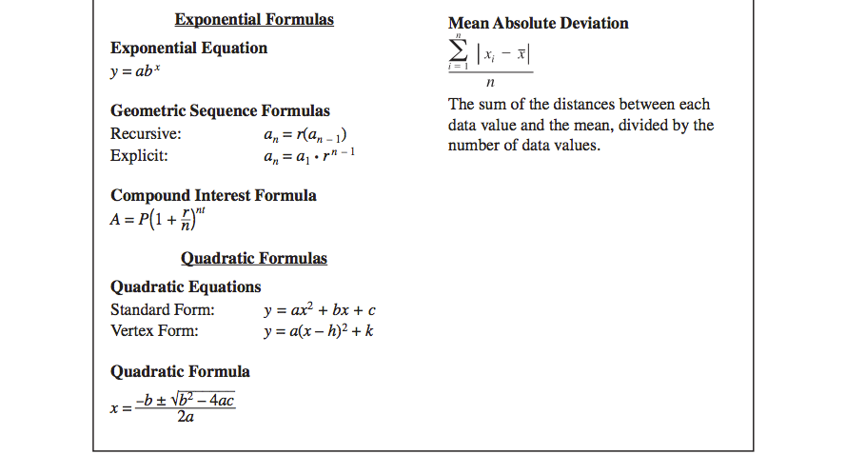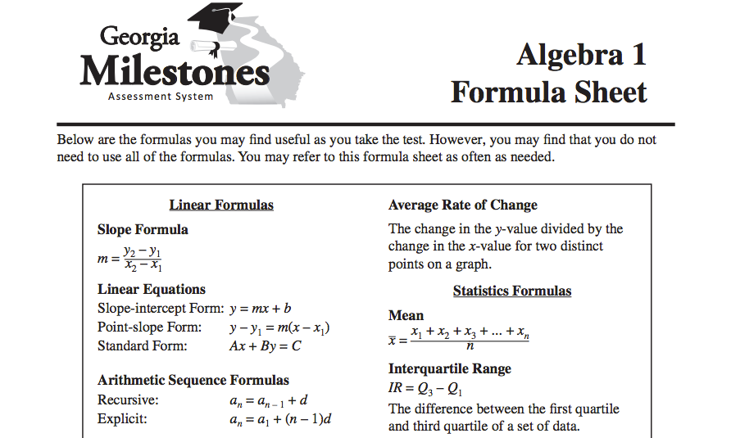

**Lesson 1 – 1: Function Notation and Evaluating Expressions**

Vocabulary:

* Algebra
* Equation
* Evaluate
* Expression
* Function
* Ordered Pair
* Variable

Write your Questions here!

**Learning Target(s):**

* **I can read and write functions in function notation.**
* **I can use the order of operations to evaluate expressions**

F.IF.1, F.IF.2, A.APR.1

Begin 1-1 Video 1

A is a special type of relationship between two sets of numbers that makes it possible for us to know what value will be produced when a specific value is plugged in. It’s like a machine that you feed numbers into and get answers back out.

In past math courses, most equations you have dealt with have been written with x’s and y’s. When writing equations for functions, we often use a specific format called .

We are used to writing equations where is a function of .

In function notation, we write equations where  is a function of .

Really, the only difference between function notation and what we are used to writing is that we use *f(x)* instead of y.

So if we had the equation $y=5x+9$, in function notation we would write this as .

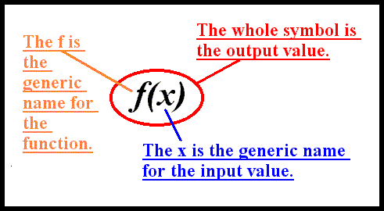

Often times, we are asked to evaluate functions at a specific point using function notation. Let’s take a look at an example.

**Example 1:**

If $f\left(x\right)=7x$, find *f(2).*

**You try:**

Write your Questions here!

1. If , find $f\left(-4\right)$ 2. If $g\left(x\right)=\frac{x}{3}$, find $g\left(27\right)$

Begin 1-1 Video 2

We can also write ordered pairs in function notation.

**Example 2:**

Write the following order pair in function notation: (9,-7).

**Example 3:** Translate the following statement into an ordered pair: $h\left(3\right)=12$.

**You try:**

Write the following ordered pairs in function notation.

1. (0, 0) 2. (2, -3) 3. (-6,7)

Translate the following statement into an ordered pair.

4. 5. 6.

Begin 1-1 Video 3

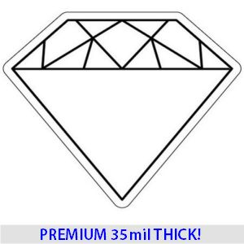

**Example 4: ${\left(3-5\right)}^{2}+\frac{20}{2}-3(3)$**

**G.E.M.S.**

**G**

**E**

**M**

**S**

**You Try:**

Write your Questions here!

1. 2.

Begin 1-1 Video 4

An expression containing variables, numbers, and operation symbols is called an _____________________. $5x+3y+8$ is an example of an algebraic expression. Expressions do not have . Algebraic expressions can be evaluated for given values. To evaluate for a given value, we the given number for the matching .

**Example 5: $f\left(x\right)=3x^{2}+1$** ; find $f(4)$**Example 6: $m(p – 7^{2}- 10 ÷2 )$** ;

use $m=5$ and $p=-2$

**You try:**

Evaluate each expression or equation for the given value.

1. ; use , , and

2. If ,find $k\left(3\right)$

**Practice 1-1 Order of Operations & Evaluating Expressions:**

**Use the functions below to answer questions 1 – 6.**

1. Find . 2. Find . 3. Find .

4. Find . 5. Find $k\left(-5\right)$. 6. Find $m\left(18\right)$.

**Translate the following statements into ordered pairs.**

Write your Questions here!

7. 8.

9. 10.

**Simplify the following expressions:**

11. 12.

13. Add parentheses to the expression below so that it equals 6 when simplified.

14. Add parentheses to the expression below so that it equals 16 when simplified.

15 + 9 ÷ 3 – 2 15 + 9 ÷ 3 – 2

**Evaluate the following expressions using the values given:**

15. ; use , , and

17. ; use and

16. ; use and

18. ; use and

19. use , , and

20. if

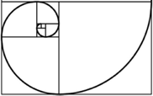

**This WILL be on your mastery check!**

Spiral Practice

Write your Questions here!

1. We can rewrite subtraction problems as addition problems by doing what?

(example: 3 – 8 and 2 – -5)

1. Describe the rules for adding integers (positive and negative numbers):
   1. Positive + Positive = ________________
   2. Negative + Negative = _______________
   3. Positive + Negative (this one requires a little more explanation)
2. Tell the rules for multiplying or dividing integers:
   1. Positive • Positive or Positive ÷ Positive = ________________
   2. Negative • Negative or Negative ÷ Negative = _______________
   3. Positive • Negative or Positive ÷ Negative = _______________
3. Mt. Everest, the highest elevation in Asia, is 29,028 feet above sea level. The Dead Sea, the lowest elevation, is 1,312 feet below sea level. What is the difference between these two elevations? (write an expression to represent the situation and evaluate)

**Review your practice and notes to prepare for the mastery check.**

**Lesson 1 – 2: Parts of an Expression**

**Learning Target(s):**

* **I can identify parts of an expression.**

Vocabulary:

* Binomial Expression
* Coefficient
* Constant Term
* Expression
* Monomial Expression
* Standard Form of a Polynomial
* Term
* Trinomial
* Variable
* **I can translate English phrases and sentences into algebraic expressions.**

A.SSE.1

Begin 1-2 Video 1

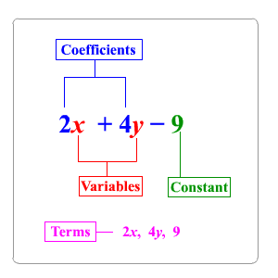Recall from lesson 1 that an expression containing variables, numbers, and operation symbols is called an ____________ ______________. $5x+3y+8$ is an example of an algebraic expression. Expressions do not have .

–

Each expression is made up of . A term can be a , a , or a ________ multiplied by a variable or variables. Each term in an algebraic expression is separated by a + sign or - sign. In $5x+3y+8$, the terms are: , , and .

__________: An expression with one term. eg $4x^{2}$

Write your Questions here!

__________: An expression with two terms. eg $4x^{2}+3$

__________: An expression with three terms. eg $4x^{2}+2x+3$

__________: An expression with multiple terms. eg $4x^{2}+3xy+2x+3$

A number with a fixed value is called a __________. In simple terms, it will be the number that’s all by itself.

When a term is made up of a constant multiplied by a variable or variables, that constant is called a __________. In the term 5*x*, the coefficient is . If a variable does not appear to have a number in front of it, we say that there is an _________ coefficient of .

**Example 1:** What are the names for each part of the algebraic expression

1.8x +32 + y?

Terms: , and Coefficient: and Constant:____

**You Try:**

1. Identify the terms, coefficients and constants of the given expressions.
   * + terms:
     + coefficients:
     + constants:
 $3x-15x^{2}+9+42x^{3}$

    + terms:
     + coefficients:
     + constants:

Begin 1-2 Video 2

In some terms, the variables will have exponents, such as $8x^{2}$. This exponent determines the of that term.

• The degree of $8x^{2}$ is . The degree of $8x^{3}$ is .

• If the variable does not have an exponent, the degree is . For instance, the degree of 8x is 1.

• If a term has more than one variable, the degree is equal to the ________

__________ of all its variables. The degree of $8x^{3}y^{2}z$ is .

• If a term does not contain any variable, the degree is . For instance, the degree of 9 is . This is due to the fact that $x^{0}=1$.

**Example 2:** List the terms, coefficients, and degree of each term in the following

Write your Questions here!

expression: $4x^{3}y^{2}+2x^{2}-3x+4$.

Terms: ,, and

Coefficients: , and

Constant: ___

Degree of $4x^{3}y^{2}$ is

Degree of $2x^{2}$ is ­___

Degree of $3x$ is ___

Degree of $4$ is ___

In a polynomial, we typically list the terms in descending order of degree. Meaning, you will rarely see an expression written like this: $7x^{2}-x^{3}-9+4x$. We would much prefer to see it “in order” like this: ${-x}^{3}+7x^{2}+4x-9$. When a polynomial has been put in order, we call this .

Once the polynomial has been written in descending order, the coefficient of the term with the highest degree is referred to as the .

Additionally, if asked for the degree of the entire expression it will be the degree of that first term, which is the .

**Example 3:** Give the leading coefficient and the degree of the following polynomials.

a. $1.8x+32$ b. $4x^{3}y^{2}+2x^{2}-3x+4$ c. $-2x^{2}+2x^{4}+3-4x$

**You try:**

1. For the following expressions, identify the degree of each term, the leading coefficient and the degree of the polynomial.

a.

* + - degree of each term:
    - leading coefficient:
    - degree of polynomial:

b.

* + - degree of each term:
    - leading coefficient:
    - degree of polynomial:

Begin 1-2 Video 3

Write your Questions here!

Terms in which the same variable is raised to the same power are called _______ and may be combined. $8x^{2}$ and $10x^{2}$ are like terms.

When combining like terms, you simply add or subtract the _______ as the problem instructs.

**Before** identifying parts of an expression, you should always simplify it by combining like terms and putting resulting terms in descending order (standard form).

**Example 4:** Simplify the following polynomials.Tell whether the resulting expressions are monomials, binomials, etc.

a. $8x^{2}+10x^{2}$ b. $5x-8x^{2}+10x^{2}$

**You try:** Simplify the following polynomials. Be sure to combine like terms and put your answer in standard form. Tell whether the resulting expressions are monomials, binomials, etc.

1. b.

Begin 1-2 Video 4

Before starting the video, brainstorm and record words that signify the operations below. For example, the word “add” would go in the plus sign.

Write your Questions here!

|  |  |  |  |  |  |
| --- | --- | --- | --- | --- | --- |
| Equality and Inequalities | | | | | |
| = | ≠ | > | ≥ | < | ≤ |
|  |  |  |  |  |  |

**Example 5:** Six less than the product of a number and 7

**Example 6:** 5 more than a number is less than 2

**Example 7:** Twice the difference of a number and three totals twelve

**Practice 1-2 Parts of an Expression:**

1. Identify and combine the like terms in this expression: $4x^{2}+2x-6x+3y$.
2. How many terms are in each of the following algebraic expressions? Is it a monomial, binomial, trinomial or polynomial?
$6x^{3}$

$15xy^{3}+21x^{2}-16$

$2ab+7$

3. Identify the coefficients in each expression.

Write your Questions here!

$81x^{3}+7xy^{2}-14x$

$4x^{3}+8x^{2}-24$

$28a^{2}-17ab$

1. Identify the degree for each term.
$12x^{3}y^{2}$

$62x^{4}$

$2x^{2}y$

$-12$

2. Write an expression with 4 terms, containing the coefficients 2, 4, and 6.

**Simplify each expression. Once simplified, identify each part of the expression listed.**

6. 7.

* + - terms:
    - coefficients:
    - constants:
    - degree of polynomial:
    - leading coefficient:
    - terms:
    - coefficients:
    - constants:
    - degree of polynomial:
    - leading coefficient:

**Translate the following phrases into mathematical expression or equations.**

8. Five times a number is 75 ________________________________________

9. Sixteen less than twice a number __________________________________

10. The difference of a number and eight divided by ten ____________________

11. 10 times a number is more than 60 _______________________________

12. Half the sum of a number and three is 4 _____________________________

13. Six less than twice a number is forty-five ________________________

14. The total of six and some number _________________________________

15. Six subtracted from a number____________________________________

Write your Questions here!

16. A number less than 90 is at least 28 _______________________________

17. Three-fourths of a number is no more than 5 _______________________

**Write an expression to model the following situations. Then evaluate the expression for the given value.**

18. An Ubyr driver charges a $2.20 flat fee and then $0.26 per mile. How much would it cost to take a taxi ninety-five miles from the Ninth Grade Academy to Hartsfield Jackson Airport?

19. Hank is signing up for a membership at a gym. The gym charges a $10 initiation fee and then charges $5 per month. If Hank wants to buy a year membership, how much should he expect to pay?

20. Gerald currently weights 250 pounds. Under his current workout, he is losing an average of 2.5 pounds a week. How much would he weigh after 16 weeks?



**This WILL be on your mastery check!**

Spiral Practice

1. If –2 means the opposite of 2 and – -2 means the opposite of negative 2, then what does –x mean?
2. Evaluate when x= –2

hint: you should get two different answers

* 1. (– x)2 b. – x2

Why do you think the () make a difference in the problem?

Write your Questions here!

1. Rewrite each exponent in expanded form. In other words, rewrite using repeated multiplication.
   1. (– x)2 b. – x2
2. Given f(x) = 2x2 – 3. Evaluate (You should get different answers. If you didn’t what did you do wrong)
   1. f(6) b. f(-6)
3. Find the perimeter and area of the given figure:

Area of a Triangle:

$A=\frac{1}{2}bh$

3cm

7cm

3cm

2cm

Perimeter_______________ Area _________________

**Review your practice and notes to prepare for the mastery check.**

**Lesson 1 – 3: Adding and Subtracting Polynomials**

**Learning Target(s):**

* **I can add and subtract polynomials.**

Terms can only be added or subtracted when they have the same variable and degree!

Begin 1-3 Video 1

A.APR.1

Adding polynomials is just a matter of  , with some _________________ considerations thrown in.

**Example 1:** Simplify (2*x* + 5*y*) + (3*x* – 2*y*)

**You try:**

1. (–4x2 +4x – 5) + (8x2 –x – 7) 2. (2p2 – 3p + 7) + (7p2 + 8p + 7)

Write your Questions here!

Begin 1-3 Video 2

One possible application for this skill is found in geometry.

**Example 2:** In a given triangle, the largest side is twice the length of the smallest side. The other side (that is not the smallest or the largest) is 2 units longer than the shortest side. Write an expression that represents the perimeter of the triangle. Let *x* represent the length of the smallest side.

**You try:**

1. Write an expression for the perimeter of the following rectangle.

*x* - 5

3*x* + 1

Subtracting polynomials is quite similar to adding polynomials, but you have that pesky minus sign to deal with.

Begin 1-3 Video 3

The first thing I have to do is ______________ that negative through the parentheses. You might find it helpful to put a "1" in front of the parentheses, to help them keep track of the minus sign:

**Example 3:**

Simplify (*x*3 + 3*x*2 + 5*x* – 4) – (3*x*3 – 8*x*2 – 5*x* + 6)

**You try:**

1. (–4x2 +7x –5) – (8x2 –x – 7) 2. (2p2 – 3p + 7) – (7p2 + 8p + 7)

**Practice 1-3 Adding and Subtracting Polynomials**

Write your Questions here!

**Add the following polynomials. Simplify answers by combining like terms and putting answers in standard form.**

1. (–5 – 4x2 + 4x) + (–x + 8x2 – 7) 2. (–3 + 3x2 + 8x) + (5x +1 – 4x2)

3. (x + 4) + (–3x2 – x + 5) + (8x2 +2x) 4. (7b2 + 3 + 2b) + (5 + 5b)

5. Write an expression for the perimeter of the given triangle.

3x

2x+4

3x

x

6. The length of a rectangle is 5 inches longer than its width. Write an expression to represent the perimeter. Let *x* represent the width.

**Subtract the following polynomials. Simplify answers by combining like terms and putting answers in standard form.**

7. (–11 – 7x2 + 7x) – (–x + 8x2 – 7) 8. (–3 + 3x2 + 8x) – (11x +1 – 7x2)

9. (–2n2 – 6) – (–7n2 + 8n) – (–8 + 7n2) 10. (–1 – 11m) – (–7m +7m2)

**Add or Subtract the following polynomials. Simplify answers by combining like terms and putting answers in standard form.**

Write your Questions here!

11. (–2n2 – 6 – 5n) + (–4n2 + 8n) 12. (x2 – 7x +7) + (-3 – 5x –2x2)

13. (x2 – 7x ) – (–3 – 11x – 2x2) 14. (7b2 + 3) + (2b) – (11 + 11b)

15. (x – 11x2 ) – (– x + 1) + (–2 + 8x2) 16. (6 – 6n) + (–n – 11n2 – 3)



**This WILL be on your mastery check!**

Spiral Practice

1. Change $\frac{16}{6}$ to a mixed number. _______________

Change $6\frac{3}{4}$ to an improper fraction. ________________

1. What portion of the stones are white? Write your answer as a fraction **in lowest terms**, a decimal, and a percent.

Fraction: __________Decimal: __________Percent: __________

1. What is 5% of $120?
2. Show your steps for dividing fractions: 2/3 ÷ 1/6
3. Look at these 10 terms. Let's find all the like terms that can be combined.

Write your Questions here!

|  |  |
| --- | --- |
|  | all these terms have**x2y** |
|  | all these terms have **xy2** |
|  | this is the only **x2yz** term |
|  | this is the only **xy** term |
|  | all these terms have**x2y2** |
|  | this is the only **xy2z** term |

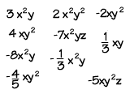

**Review your practice and notes to prepare for the mastery check.**

Vocabulary:

* Equation
* Inverse
* Solution

**Lesson 1 – 4: One- and Two-Step Equations**

**Learning Target: I can solve one- and two-step equations.**

A.CED.1, REI.3 & REI.1

Begin 1-4 Video 1

**See Appendix A**

*HINT:*

*Appendix A (found at the back of your packet) has tables that list the properties we use when isolating our variable. If at any point, I reference a property you do not remember, check the appendix for clarification.*

An _______ is a number sentence that contains an ________ symbol. It is made up of two __________.

To solve equations, we _____ the variable. This means that we rearrange the equation so that the variable we are looking for is all by itself on one side of the equation.

Think of equations like scales. When two sides are balanced, if you change something on one side, you have to make the same change on the other side to keep the scale balanced.

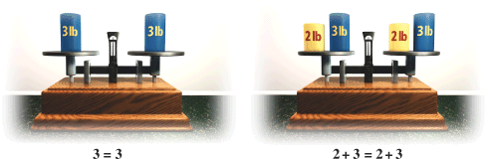

We use _________________ operations to help us isolate the variable.

Write your Questions here!

|  |  |
| --- | --- |
| **(If you see) Operation** | **(Then you do) Inverse** |
| Addition | Subtraction |
| Subtraction | Addition |
| Multiplication | Division |
| Division | Multiplication |

**Example 1:** Solve for x:

-3+x=15

**Example 2:**  Solve for n:

$\frac{1}{14}n=\frac{2}{7}$

**You try:**

1. 2.

Begin 1-4 Video 2

Sometimes you need to use more than one step to solve an equation. When you are trying to solve an equation,

1st: Identify what operations are being done to the variable you are trying to isolate.

2nd: Use the inverse of each operation to “undo” it and get the variable by itself.

Hint: Since you are working backwards to solve for the variable, you will often find that you are working through the ________________backwards.

**Example 3:** Solve for x.

$$3x+4=14$$

**Example 4:** Solve for y:

$$\frac{y+4}{3}=9$$

**You try:**

Write your Questions here!

1. 2.

Begin 1-4 Video 3

**Example 5:** If $f\left(x\right)=\frac{12}{x}$, find $x$ if $f\left(x\right)=-2$.

**You try:** If $g\left(x\right)=x+7$, find $x$ if $g\left(x\right)=23$.



**You try:**

1. The area of a triangle is 28 in2. The base is 8 inches. What is the height of the triangle?

Area of a Triangle:

$A=\frac{1}{2}bh$

**Example 5:** Percy’s Bikes rents bikes for $10 plus $4 per hour. Annabeth paid $30 to rent a bike. For how many hours did she rent the bike?

Begin 1-4 Video 4

Begin 1-4 Video 5

Write your Questions here!

**Example 5:** You want to buy a thingamajig. It costs 123.45 plus 6% sales tax. You already have 12.34 and you are earning 5.67 per week. How long will it take you to get your thingamajig?

a. How much sales tax?

b. What is the total cost?

c. Let *w* stand for weeks and write an equation.

d. Solve your equation and check your answer.

**Practice 1-4: Solving One and Two Step Equations**

**Solve each equation using inverse operations.**

2. If , find x if

1. If , find x if $f\left(x\right)=-2$.

5. $5+k=23$

3. $-11=-6-m$

4. $-\frac{7}{5}n=\frac{63}{40}$

6. $-5=\frac{8+r}{2}$

7. $-\frac{1}{3}\left(-1+n\right)=-\frac{8}{9}$

Write your Questions here!

8.

9. The sum of 38 and twice a number is 124. Find the number.

11. Hermione is collecting Chocolate Frog Cards. She starts with a collection of 20 cards and gets 2 more per week. After how many weeks will she have 64 cards?

10. A square has a perimeter of 32 centimeters. What is the length of its side?

12. If , find x if .

13. If , find x if .

14. If , find .

* 1. How much sales tax will he have to pay?
  2. What is the total cost?
  3. Let *w* be the number of weeks that it will take to save enough money to buy the skateboard. Write the algebraic equation that will help you solve the problem.
  4. Solve your equation for *w* and check your answer.

15. Rolando wants to buy a new skateboard. He is hoping to be able to save enough money to buy it in time to take a class in which he would learn how to do many fancy tricks. The Tony Hawk board he wants costs $69.99 plus 7% sales tax. Rolando has already saved $12.25, and he is earning $6.20 a week by doing odd jobs and chores. How many weeks will it take him to save enough money for the new skateboard?

1. How much sales tax will she have to pay?

16. Otilia is saving for a new pair of cleats. She is hoping to be able to save enough money to buy them in time for soccer tryouts. The Adidas style she wants cost $149.99 plus 6% sales tax. Otilia has already saved $56.75, and she is earning $15 a week by tutoring her friend Rolando in math. How many weeks will it take her to save enough money for the new shoes if she puts all her tutoring money towards them?

Write your Questions here!

1. What is the total cost?
2. Let *w* be the number of weeks that it will take to save enough money to buy the shoes. Write the algebraic equation that will help you solve the problem.
3. Solve your equation for *w* and check your answer.



**This WILL be on your mastery check!**

Spiral Practice

1. Simplify : $\frac{1}{3}b+\frac{7}{6}b$
2. Simplify:

38x2 – 4(-10x – 5) + x – 38x2

1. Simplify:

4(x + 7) – (9x + 7)

1. Evaluate f(x) = x – 3/8 for f(1/4)
2. Rewrite $\frac{n-6}{5}$ using ( ) instead of the fraction bar.

**Review your practice and notes to prepare for the mastery check.**

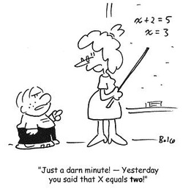**Lesson 1-5: Multi-step Equations**

Write your Questions here!

**Learning Target(s):**

* **I can solve multi-step equations.**

A.CED.1

Begin 1-5 Video 1

**Solving multi-step equations:**

1) ________________

2) Combine________________

3) Get variables _____________________________

4) ________the variable by using _______________

**Example 1:** Solve for *y*

$\frac{y+1}{2}+7=19$

**Example 2:** Solve for *k*

$$–(1+7k) – 6(–7 – k) = 36$$

**You try:**

1. Solve for n

2. Solve for *x*.

$12=-4(–6x–3)$

Begin 1-5 Video 2

This section is going to hone in on problems that deal with step #3 in the process.

**Example 3:** Solve for *n:*

$-10\left(1+n\right)=-8n-30$

**Example 4:** Solve for *x*:

$-10x+6x=13+2x-9-7x$

**You try:**

1. Solve for *m:*

2. Solve for *n*:

$9n-2=-4n-15$

Write your Questions here!

Begin 1-5 Video 3

You may recall from previous math courses that we don’t always get one solution. In fact, we have ____ different possibilities that we may encounter when solving a linear equation. Let’s take a look!

Linear equations are equations in which the highest degree is 1…more on that in later units…

**Example 5**: One Solution

$-2\left(8+m\right)=-4(4+6m)$

|  |  |  |
| --- | --- | --- |
| **What you think.** | **What you see.** | **What it means.** |
| Typical Result | x = 3 | One solution |
| Well, duh… | x = x or 2 = 2 | Infinitely many solutions |
| No it doesn’t… | 2 = 3 | No solution |

**Example 6:** No Solution

$4x+27=4(x+5)$

**Example 7:** Infinitely Many Solutions

$3\left(x+7\right)=3x+21$

**You try:**

1. $5+3r=3r-5$

2. $3\left(9+n\right)=27+3n$

Begin 1-5 Video 4

**Example 8:** The sum of two consecutive integers is 91. What are the two integers?

**Example 9:** Find the two consecutive even integers whose sum is 258.

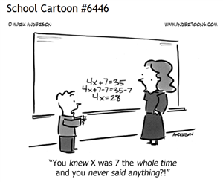

**Example 10:** A rectangle is 12 m longer than it is wide. Its perimeter is 68 m. Find its length and width.

**You try:**

Write your Questions here!

1. Find the two consecutive odd integers whose sum is 160.

2. A rectangle is 2 inches wider than it is long. Its perimeter is 30 inches. Find its length and width.

**Practice 1-5 Multistep Equations**

**Solve each equation for the variable.**

1.

2.

3.

4.

5. Find the two consecutive even integers whose sum is 182.

6.

7.

8.

9.

10.

11. Tris has twice as much money as Caleb. Caleb has $6 less than Tobias. Together they have $54. How much money does each person have?

12. $-7\left(3x+4\right)=-4\left(x-3\right)-6$

Write your Questions here!

13. Find three consecutive integers whose sum is 171.

14. $–\left(4m+7\right)=-\left(m+2\right)-8m$

15.

16.

17.

18. The length of a rectangle is 4 cm more than the width and the perimeter is 48 cm. What are the dimensions (length and width) of the rectangle?

19. $1+4x-8=-23$

2020. $-7+3\left(6m-1\right)=13$

21. $-102=-6(2x+3)$

22. $-2k+8k=-7+5k$

23. $4\left(3v+7\right)=-12+7v$

24. $-16=4-4a$

25. $\frac{1}{2}b+\frac{13}{4}b=\frac{15}{4}$

26. $7\left(6-p\right)=20+4p$

Write your Questions here!

27. $-\left(-6x-5\right)=7x$

28. $12+4n=4\left(n+3\right)$



**This WILL be on your mastery check!**

Spiral Practice

1. Which point on the number line shown below appears to be located at ?

a 
numberline

1. Between which two benchmarks does the fraction $\frac{3}{5}$ fall?
   1. Between 0 and $\frac{1}{2}$
   2. Between $\frac{1}{2}$ and 1
   3. Greater than 1
2. Show the location of each number on the number lines below.

A = –1, B = , C = , D = – 0.5, E = –1.75

1

0

-1

-2

1. **Translate each of the following inequalities.**

There are at least 25 cars in the parking lot ____________________

The number of tissues in the box exceeds 100 ____________________

There can be no fewer than 7 students in the class ____________________

The number is no less than -11 ____________________

There are at most 8 markers on the board ledge ____________________

33. Is n = 20 a solution to 19 ≥ n ? Show all the solutions possible solutions on the number line.

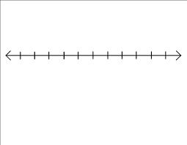

**Review your practice and notes to prepare for the mastery check.**

**Lesson 1-6 Solving Inequalities with Number Lines**

Write your Questions here!

Vocabulary:

* Inequality

**Learning Target: I can solve inequalities and represent their solution set on a number line.**

Begin 1-6 Video 1

A.REI.3

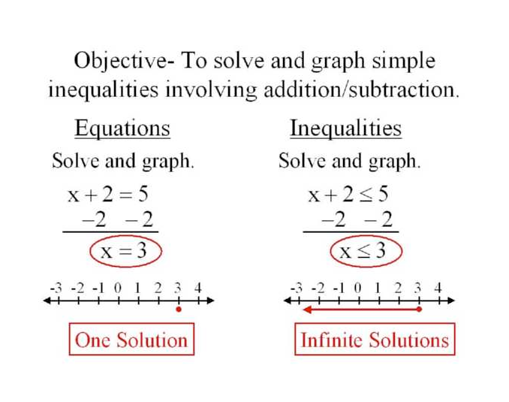

An inequality is similar to an equation. However, instead of an equal sign, it has _____________ _________. The examples shown here do a good job of illustrating the difference between solving an equation and solving an inequality. The process is _____ ______. The differences are all in how we interpret and display the ________________.

When dealing with inequalities, you have more symbols to deal with than simply an equal sign. We touched on these in lesson 2 as well. You may find it helpful to go back and review those notes in addition to using this list.

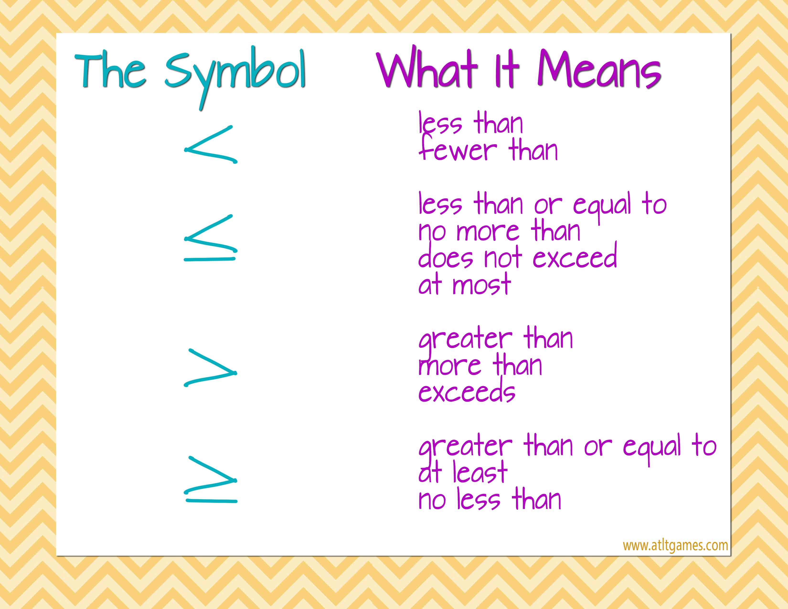

**is**

**is**

**is**

**is**

**is**

**is**

**is**

**is**

**is**

**is**

The most important difference between an inequality and an equation is that every inequality has an ______ number of solutions. Whereas most equations we deal with at this point have only one solution.

Write your Questions here!

Since inequalities have an infinite number of solutions, we typically show the solutions to an inequality on a __________. The direction we shade and how we represent the starting value depends upon what kind of inequality we are dealing with. The table below can ONLY be used if the variable is on the

|  |  |  |  |
| --- | --- | --- | --- |
| < | > | ≤ | ≥ |
| open circle | open circle | closed circle | closed circle |
| shade left | shade right | shade left | shade right |

________side of the inequality.

**Example 1:** Solve and graph the following inequality.

$2x+4<8$

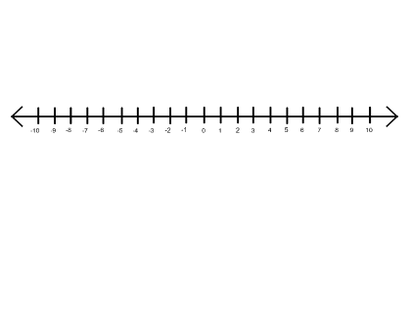

**You try:** Solve and graph the following inequality.



$4x+5<-19$

Begin 1-6 Video 2

One important thing to note about solving inequalities is that when we _______________by a _______________, we must switch the direction of the inequality sign.



**Be careful! This is a common misstep for students. And you WILL be asked questions like this!**

**Example 2:** Solve and graph the following inequality.



$-3x-4≥11$

**You try:** Solve and graph the following inequality.

Write your Questions here!



$-2x-7>5$

Begin 1-6 Video 3

**Example 3:** Solve and graph the following inequality



$157>x+3(8+6x)$

**You try:** Solve and graph the following inequality



$-7\left(m+3\right)≥2m+6$

**Example 4:** Esteban has a $20 gift card to the Art-Full Barn, where 4 oz tubes of paint are $4.30 each. What are the possible numbers of tubes that he could by? Write an inequality to model the situation.

Begin 1-6 Video 4



**1-6 Solving Inequalities Practice**

Write your Questions here!

**Solve each inequality and graph its solution set.**

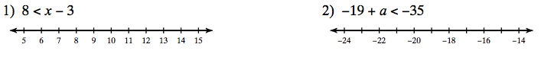

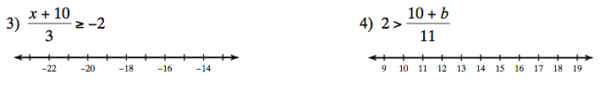

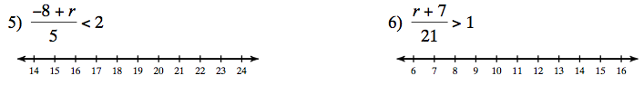

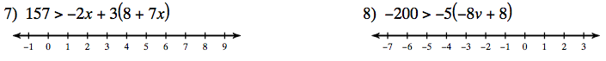

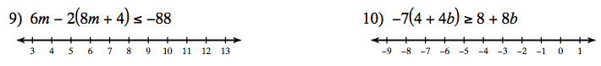

11. Jason has a gift card to El Patron. He has already used $24 on the gift card’s value, which was $30. Write, solve, and graph an inequality to show how much more he has to spend.

Write your Questions here!



**This WILL be on your mastery check!**

Spiral Practice

SOLVE THE FOLLOWING EQUATIONS FOR X (make sure you work across before down)

|  |  |  |
| --- | --- | --- |
| A | B | C |
| 12) |  |  |
| 13) |  |  |
| 14) |  |  |
| 15) |  |  |

**Review your practice and notes to prepare for the mastery check.**

Write your Questions here!

**Lesson 1–7: Literal Equations**

**Learning Target: Given an equation in two or more variables, I can solve for a specified variable.**

Vocabulary:

* Literal Equations

**A.CED.4**

Begin 1-7 Video 1

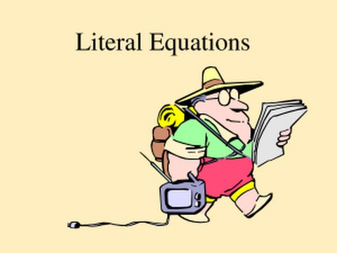________________are equations with ________________ variables.

Sometimes when we are given formulas, it is helpful to rearrange the formula to highlight a specific variable.

To solve a literal equation for a given variable, we use the same method as when we solve our tradition equations. We must use ___________ ________________.

**Example 1:** The formula for the circumference of a circle is $C=2πr$. Solve for *r.*

**Example 2:**

$12=2x+3y$ (*y)*

**You try:**



$P=2L+2W \left(W\right)$

$V=\frac{M}{D} (M)$

Begin 1-7 Video 2

**Example 3:** The cost, in dollars, of a single-story home can be approximated using the formula C = klw, where l is the approximate length of the home and w is the approximate width of the home. Find the units for the coefficient k. (Assume the home is measured in feet.)

**Practice 1-7 Literal Equations**

Write your Questions here!

**Solve each of the following literal equations for the indicated variable**

$P=IRT (T)$

$10x-2y=12 (y)$

$\frac{x+y}{3}=5 (y)$

$ax+by=c (y)$

$V=LWH (L)$

$x=\frac{yz}{6} (y)$

$14x+7y=28 (y)$

$P=2L+2W \left(L\right)$

$2x-3y=8 (y)$

$A=\frac{1}{2}bh \left(h\right)$

2. The formula $F=m*a$ is used to describe the relationship between Force, mass and acceleration. The units for force are $\frac{kg*m}{\sec^{2}}$. Mass is typically measured in kilograms. Based on this information, what are the units of acceleration?
3. In science, the amount of work is found by multiplying the Force times the distance. Using the information from the previous problem and measuring distance in meters, find the units for work.
4. Find x such that the two shapes have equal perimeter.



**This WILL be on your mastery check!**

Spiral Practice

Write your Questions here!

**5x + 1**

**3x + 1**

**2x**

**4x**

**x + 13**

1. Translate the following statements into ordered pairs.
   1. $-1=g(1)$ b. $h\left(2\right)=7$
2. Solve for x, if f(x) = 5 in the function $f\left(x\right)=\frac{x+7}{3}$
3. Solve for x, if f(x) = 21 in the function 
4. 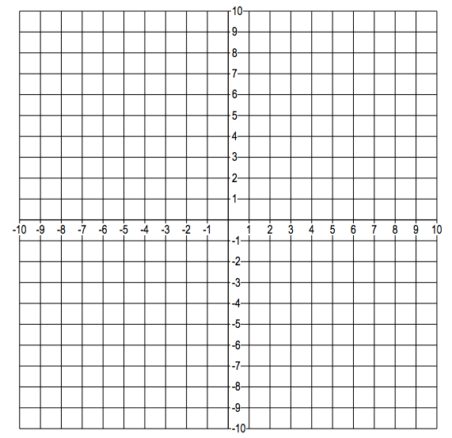Label the following on the coordinate plane :
   1. Origin
   2. X-axis
   3. Y-axis
   4. Quadrants
   5. Signs of the coordinates in each quadrant



**This WILL be on your mastery check!**

Spiral Practice

**Review your practice and notes to prepare for the mastery check.**

Write your Questions here!

**Lesson 1-8 Graph on the Coordinate Plane**

Vocabulary:

* Coordinate Plane

**Learning Target: I can graph linear equations and inequalities on the coordinate plane.**

A.CED.2, A.REI.12

Begin 1-8 Video 1

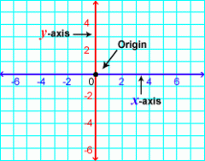Recall from middle school that the coordinate plane is used to graph lines and plot points. It is comprised of two __________that intersect at a point called the _____.

The horizontal (right to left) number line represents the independent variables and typically we use the variable x for these values. Thus, this is called the __________.

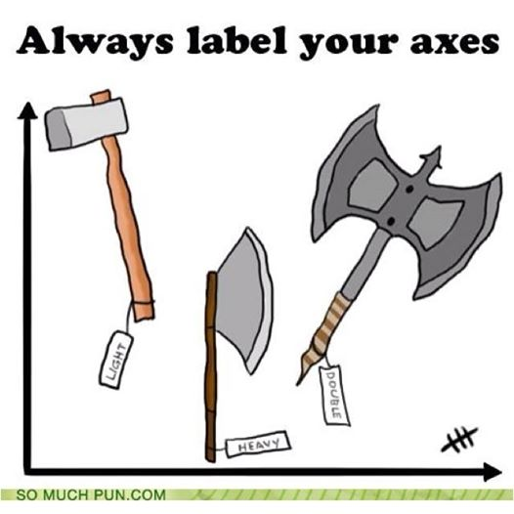

Historical Note:

You may see the coordinate plane referred to as the Cartesian Plane in some places. This is because it was first developed by a mathematician and philosopher named René Descartes in the 1630’s.

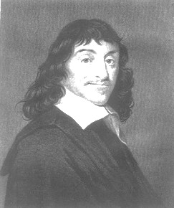The vertical (up and down) number line represents the dependent variables and we typically use the variable y for these values. Therefore, this line is called the ____.

Remember that y is the same as f(x). So you may sometimes see this axis labeled as f(x).

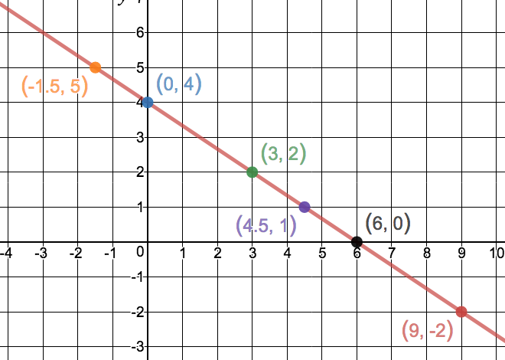In this lesson, we will be graphing lines on the ________________. When an equation with two variables is graphed on the coordinate plane, it represents all the possible ________ for that equation. Basically, that means that every moment on that line is an ordered pair that could be plugged into the equation and the two sides would remain ________________.

**Example 1: $2x+3y=12$** .

Write your Questions here!

Begin 1-8 Video 2

When we solve the equation of a line for y, we call the resulting form __________ ____________. It is a useful form to have an equation in as it makes certain parameters more easily identifiable. 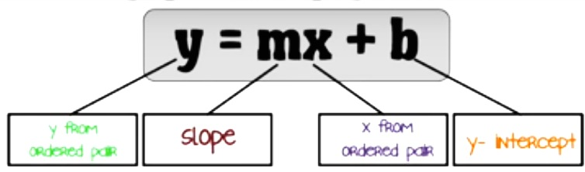

Formula

Sheet!

The two pieces of this formula that will typically have numbers plugged in are the m (_____) and the b (________). Before we can really start graphing, you need to have a solid understanding of both of these concepts.

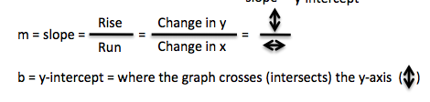

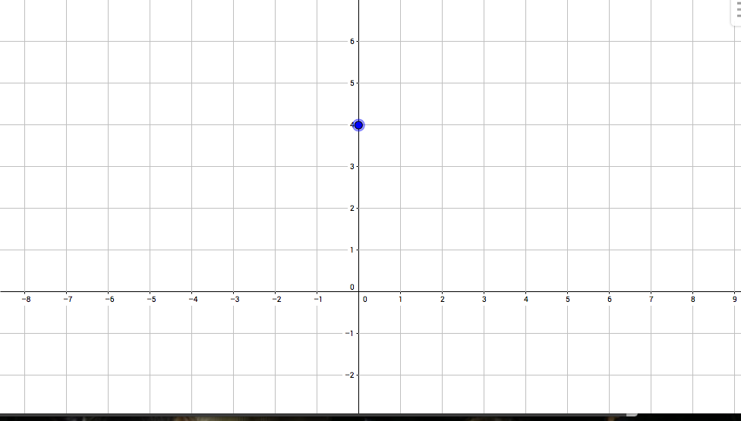**Example 2: $y=\frac{-2}{3}x+4$**

The y-intercept gives us an initial coordinate to plot. The x-value for a y-intercept will always be ________________.

In our example, $y=\frac{-2}{3}x+4$, the y-intercept would be 4.

So we put a point at (0,4).

When asked for a y-intercept, always give it as an ordered pair of the form (0,*b*)*.*

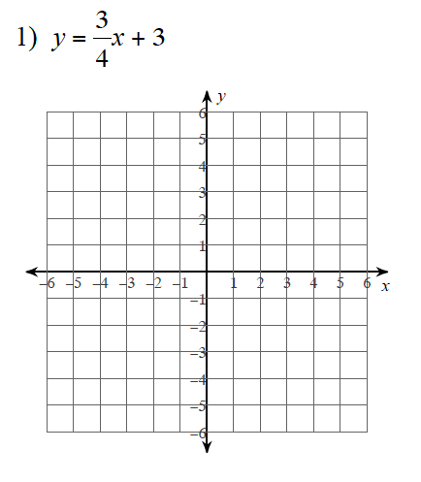

**You try:** Identify the y-intercept of each equation and plot the y-intercepts on the coordinate plane given.

1. y-intercept:________

2. y-intercept:________

Begin 1-8 Video 3

Write your Questions here!



**“A rose by any other name…”**

Slope goes by many names in mathematics. A few that you may see in this course are:

* Rate of Change
* Average Rate of Change
* Rate of Increase
* Rate of Decrease
* Steepness
* Cost per unit
$m=\frac{y_{2}-y_{1}}{x_{2}-x_{1}}$

* speed

The slope tells us how the graph changes and is located with the x variable. Slope can be interpreted as the difference in rise (________) divided by the difference in run (________).

Formula

Sheet!



Hint* When graphing, you will want this value to

be in fraction form.

**Example 3: $y=\frac{-2}{3}x+4$**

****The numerator (top number) of the slope tells us how much we are supposed to go up or down.

• If the number is positive, we go .

• If it is negative, we go .

The denominator (bottom number) tells us whether to go left or right.

• If the bottom number is positive, we move to the .

• If the bottom number is negative, we move to the .

**\*Last Step: Connect the dots!\*** Note that at the end of the line we put arrows. These arrows indicate that the line goes on forever and ever and ever and ever!

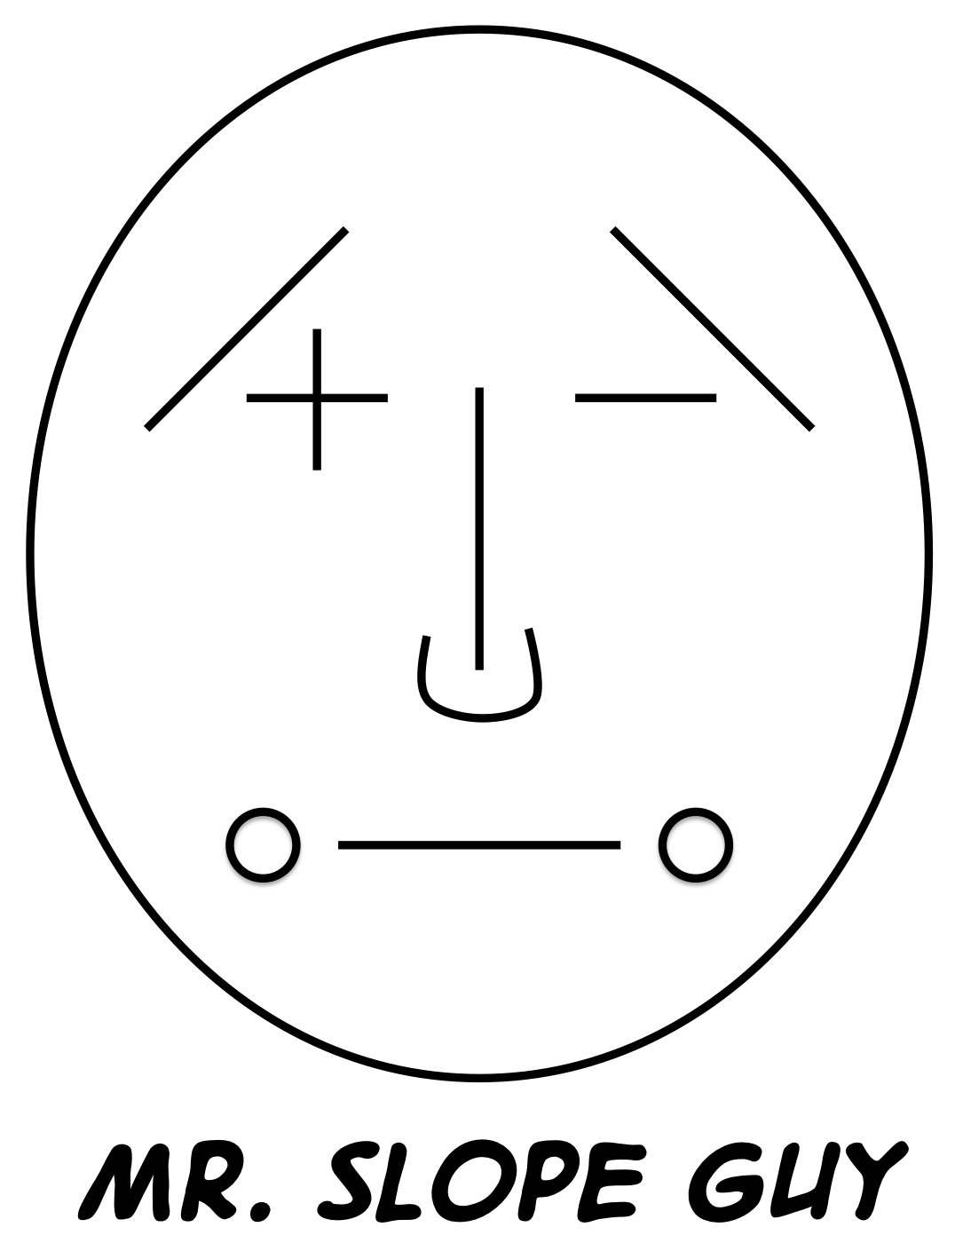

A line that has a positive slope looks like it is going _____ when viewed from left to right.

A line that has a negative slope looks like it is going ___________ when viewed from left to right.

A line with a slope of zero makes a ____________.

A _____________is said to have an undefined slope.

You can use Mr. Slope Guy to help you remember these facts.

**You try:** Identify the y-intercept and the slope of each equation. Plot at least 2 points for each on the coordinate plane provided and connect the dots!

Write your Questions here!

1. $y=\frac{-1}{5}x+2$

y-intercept:______ slope: ______

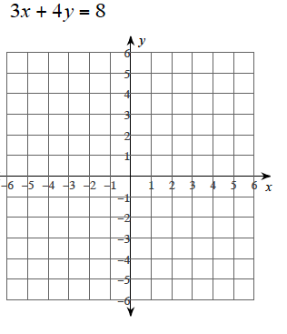

Begin 1-8 Video 4

2. $y=\frac{1}{5}x-2$

y-intercept:______ slope: ______



Sometimes, you may be given an equation that is not in slope-intercept form.

**Example 4:**

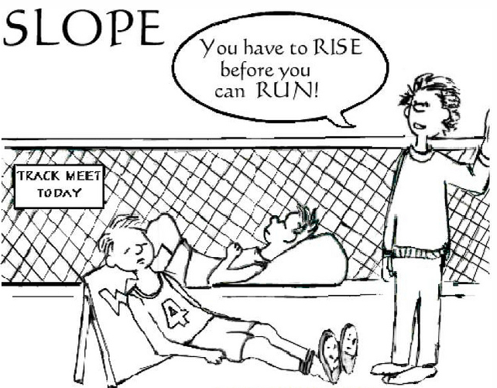

m =

b =

**Steps for graphing a line from Slope-intercept form:**

1. If the equation is not in slope-intercept form (y on a side by itself), solve for so that it is in slop-intercept form. (Revisit lesson 7 for examples of this.)

2. Pull out your *m* and *b*.

a. ***m*** is always ***m***arried to x…they are always touching.

b. ***b***is always ***b***y itself.

3. Graph.

a. Begin with __

* this is your __________.
* It will be the ordered pair (0, *b*)

b. From your intercept, use your rise over run () to find a second point.

* You can find additional points using your slope if you’d like.

c. Draw a that connects these two points.

**You try:** Graph the given equations on the coordinate plane provided.

2.

Write your Questions here!

1.

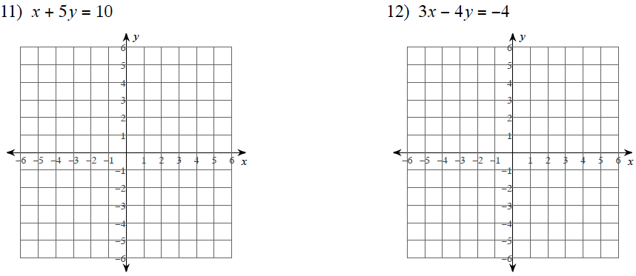



Begin 1-8 Video 5

Of course, there are always special cases. Little snowflake equations that don’t look like the others.

What if there is no m or b?

**Example 5:** Graph $y=x$

What if there is no x??

**Example 6:** Graph $y=3$

What if there is no y???

**Example 7:** Graph $x=-2$

**Insert HOY VUX foldable here!**

**You try:**

Write your Questions here!

1. Graph

2. Graph

3. Graph



Begin 1-8 Video 6

**Example 8:** Trinity is working at Jaemor Farms to earn some extra money over the summer. She started the summer with $52 in her savings account and plans to add $20 per week.

1. 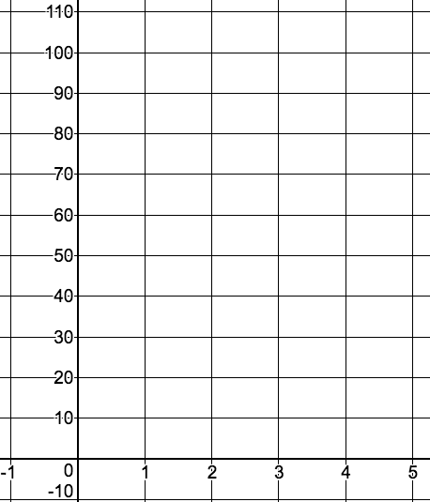Write an equation to represent the relationship between time and Trinity’s account balance.
2. Graph the line that represents your equation.
3. In the context of this problem, what does the y-intercept represent?
4. In the context of this problem, what does the slope represent?

Begin 1-8 Video 7

**Pause here and go do the first section of practice. (Page 41)Then come back and for video 7! The Mastery Check will cover all 8 videos! ☺**

The steps for graphing inequalities on the coordinate plane are essentially the same as graphing equations. The difference? Rather than a single line of ordered pairs that make the equation true, an inequality has a whole region of ordered pairs. To display this, we incorporate _____________, just as we did when solving inequalities with a single variable.

**What kind of line to draw and where to shade…**

Write your Questions here!

|  |  |  |  |
| --- | --- | --- | --- |
| < | ≤ | > | ≥ |
|  |  |  |  |
|  |  |  |  |

**Example 9:** Graph the following inequality on the coordinate plane.

$y≥2x-1$

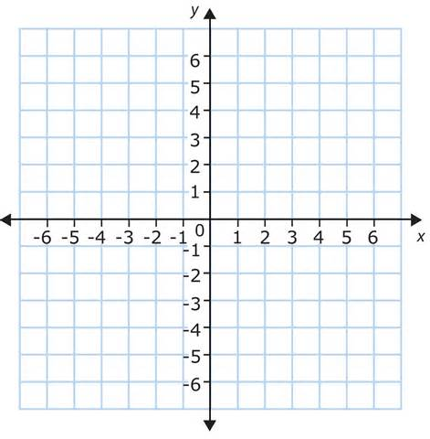

What kind of line did we draw?_____________ Why?_______________

Where did we shade?________________ Why?_______________

Give two possible solutions:______________

Give two ordered pairs that are **not** possible solutions:_________________

**Example 10:** Graph the following inequality on the coordinate plane.



$3x+2y<8$

What kind of line did we draw?_____________ Why?_______________

Where did we shade?________________ Why?_______________

Give two possible solutions:______________

Give two ordered pairs that are **not** possible solutions:_________________

**You try:**

1. Graph the following inequality on the coordinate plane.

$$y<-3x+1$$



Begin 1-8 Video 8

Write your Questions here!

**Example 11:** Sami works two jobs to help pay for her college tuition. At Zaxby’s she earns $8 an hour (y). She also babysits and earns $16 an hour (x). She must earn at least $240 per week to make her necessary payments. Write and graph an inequality to model this situation.

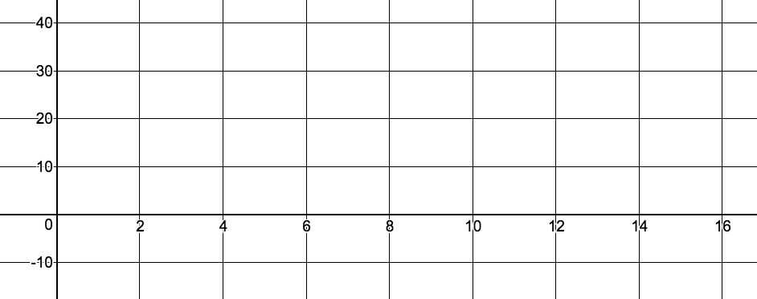

What are two possible combinations Sami could work?

**The second section of practice will cover inequalities. (Page 47)**

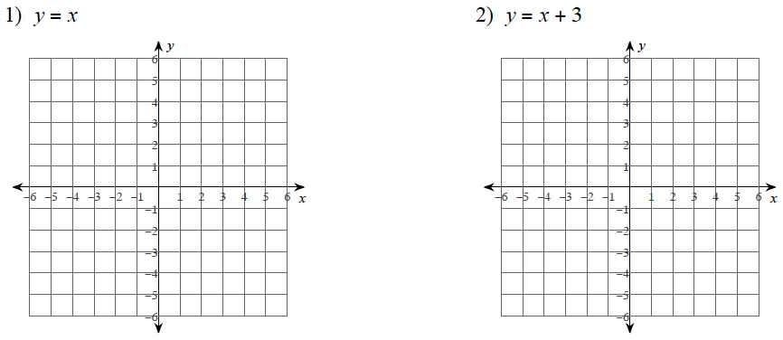**Practice 1-8: Graphing on the coordinate plane (Videos 1-6)**

**Sketch the graph of each line.**

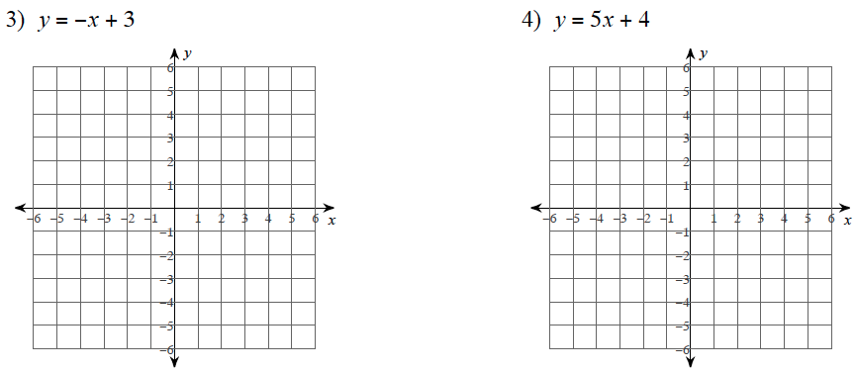

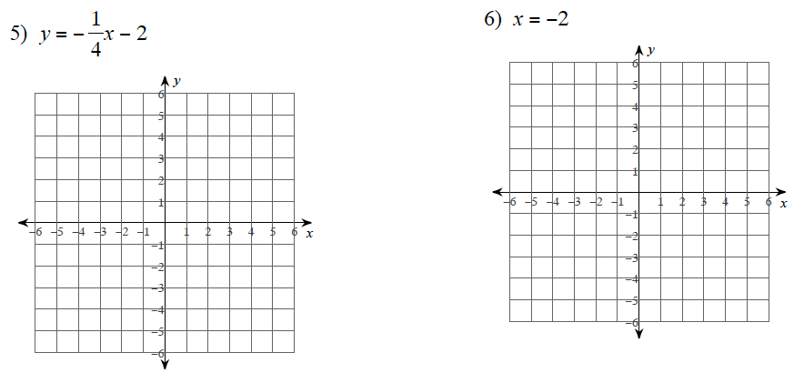

Write your Questions here!

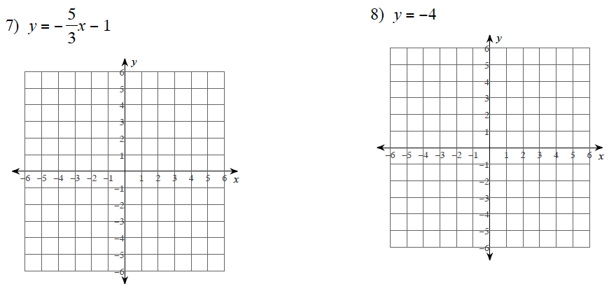

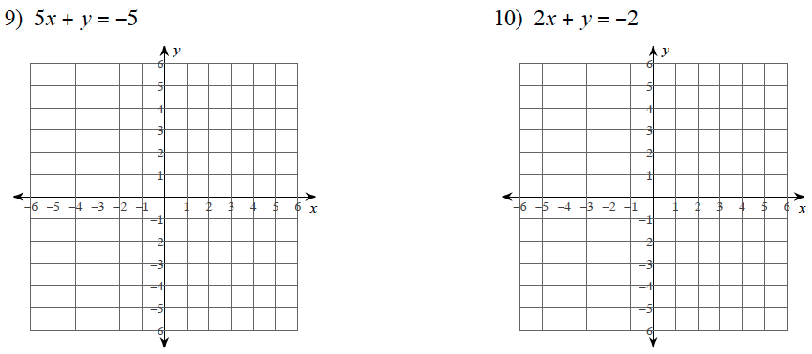

11. Melissa McCarthy is going on a diet. In 2012, she was reported to weigh 265 lbs. She has lost an average of 10 lbs per year since then and would like to continue this trend until the year 2020.

Write your Questions here!

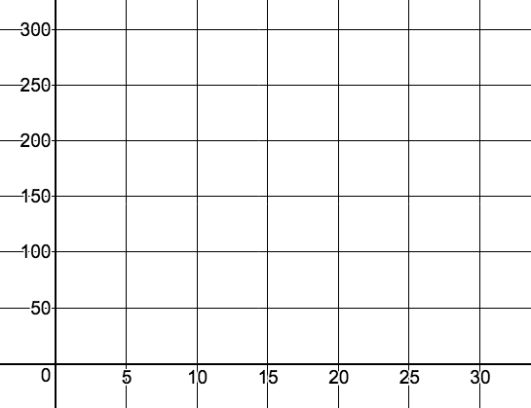

1. Write an equation to represent Mrs. McCarthy’s weight loss.
2. Graph the line that represents your equation.
3. In the context of this problem, what does the y-intercept represent?
4. In the context of this problem, what does the slope represent?

12. Trey has started playing Pokémon GO. He catches an average of 6 Pokémon a day.

1. 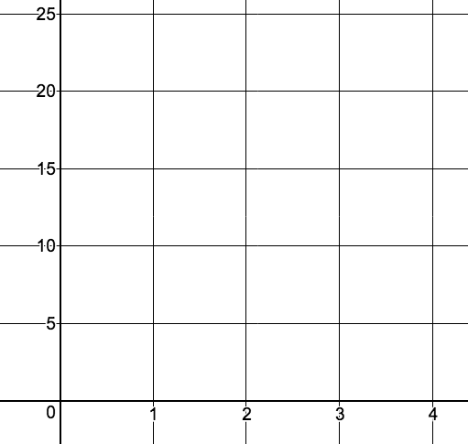Write an equation to represent the relationship between days and the number of Pokémon Trey has caught.
2. Graph the line that represents your equation.
3. In the context of this problem, what does the y-intercept represent?
4. In the context of this problem, what does the slope represent?

**Don’t forget to go back for videos 7 and 8! (Page 42)**

**Practice 1-8: Graphing on the coordinate plane (Videos 7-8)**

Write your Questions here!

**Sketch the graph of each inequality. Shade the appropriate region to represent the solution set.**

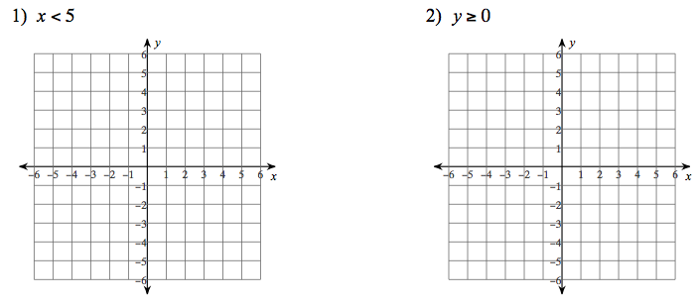

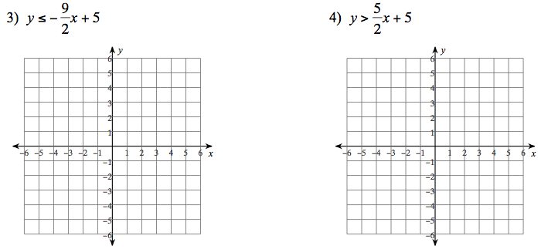

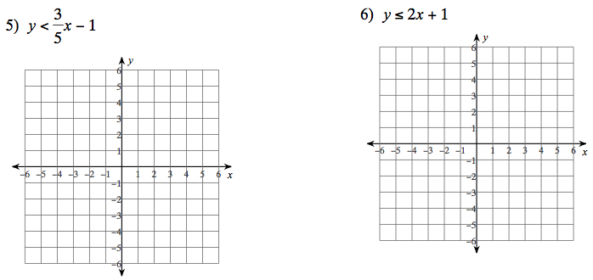

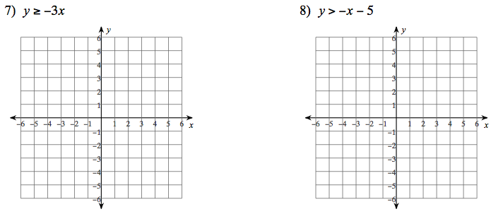

$$4x-2x≥8$$

$2x+3y≥9$

Write your Questions here!

9. Jericho spends time each week at both football and ballet class. In total between the two practices, he can spend at most 15 hours a week practicing. Write and graph the inequality. What are two possible combinations that he could practice?

1. 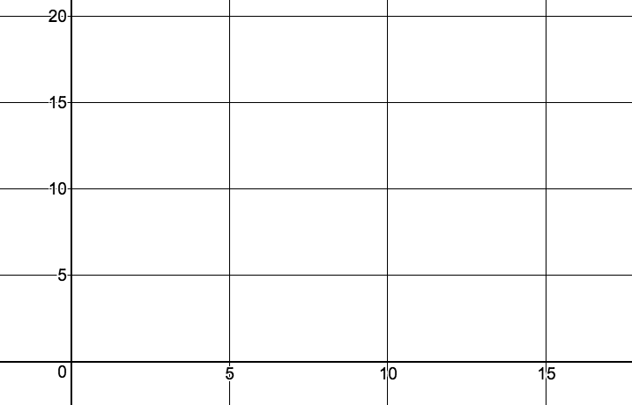Write an inequality to represent Jericho’s practice time.
2. Graph the line that represents your inequality.
3. Give two combinations of practice times that would work for him.

10. The Band Of Blue is doing a fundraiser to raise money to pay for an upcoming competition. They plan to sell t-shirts (x) for $10 and hoodies (y) for $20. They need to raise at least $2,500. Write and graph an inequality that models the situation. What are two possible combinations that they can sell to meet their goal.

1. 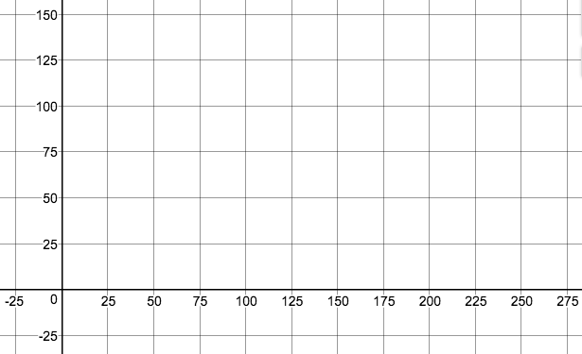Write an inequality to represent The Band of Blue’s sales.
2. Graph the line that represents your inequality.
3. Give two combinations of sales that allow the band to reach their goal.
4. Jane’s cell phone plan is $40 per month plus $0.15 per minute for each minute over 200 minutes of call time. If Jane’s cell phone bill is $58.00, for how many extra calling minutes was she billed? Write and solve an equation. Only an algebraic solution will be accepted

Write your Questions here!



**This WILL be on your mastery check!**

Spiral Practice

1. Lopez spent  of his vacation money for travel and  of his vacation money for lodging. He spent $1100 for travel and lodging. What is the total amount of money he spent on his vacation? Write and solve an equation. Only an algebraic solution will be accepted
2. Suppose your club is selling candles to raise money. It costs $100 to rent a booth from which to sell the candles. If the candles cost your club $1 each and are sold for $5 each, how many candles must be sold to break even? Write and solve an equation. Only an algebraic solution will be accepted
3. Hans needs to rent a moving truck. Suppose Company A charges a rate of $40 per day and Company B charges a $60 fee plus $30 per day. For what number of days is the cost the same? Write and solve an equation. Only an algebraic solution will be accepted
4. Use Appendix A on page 51 to state the property we used to perform each action.

|  |  |  |
| --- | --- | --- |
| Statement | Action we performed | Property |
| 2(x – 1) = 4 | Wrote the given problem | Given |
| 2x – 2 = 4 | Multiplied 2 times everything in ( ) |  |
| 2x – 2 + 2 = 4 + 2 | Added 2 to both sides |  |
| 2x = 6 | Basic addition | simplify |
| X = 3 | Divided both sides by 2 |  |

**Review your practice and notes to prepare for the mastery check.**

**Unit 1 Study Guide**

Solve each of the following equation or inequality.

1) 2) 3) -9 = -6x+3

4) 5x – 3 = x +13 5) 7x + 3 +3x = 2(5x + 5) 6) 4x + 6 = 2(2x + 3)

7) 3x > 12 8) -2x – 1 < 5 9) 5x + 2 < 2x – 4

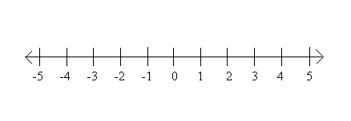

10) Marty’s Gym charges a minimum of $35 each month and $5 per visit. This month you spent $95 at the gym. How many times did you visit the gym?

11) Leanna’s cell phone company charges $40 plus $0.40 for each text over her maximum number. Last number, her phone bill was $62.00. How many texts over her maximum number did she send?

12) Which property is illustrated in each of the following?

a) 4 + 3 = 3 + 4 b) 2 + (3 + 5) = (2 + 3) + 5

c) 4(x – 3) = 4x – 12 d) 4 + (-4) = 0

13) The sum of two consecutive odd integer is 204. Find the pair of integers.

14. The length of a rectangle is 5 meters more than its width. The perimeter is 54. Find the length and width of the rectangle. Draw a picture to help you solve the problem.

15. Solve the following formula for the L. P = 2L + 2W

16. Solve the following formula for r.

17. Convert the following equations into slope-intercept form.

A) 2x + 3y = 18 B) -3x + 2y = 24

18. Marty wants to buy a guitar. He is hoping to save enough money to buy it in time to participate in music competition. The guitar cost $350 plus 9% sales tax. Marty has already saved $100, and he earns $20 per hour mowing grass. Let x be the number of hours that Marty will need to work to save enough money to buy the guitar.

19. Marco wants to order a custom polo with his name on it. The shirt cost $15 plus $.60 per letter(or numbers) that he has placed on the polo. He has $24 or less to spend on the shirt.

a) Write an inequality to model this situation.

b) Solve the inequality to determine how many letters (or numbers) he can get on his shirt.

20. The Jackson family wants to buy a new home. They have saved $15,000 and can afford to save $500 per month. They need $25,000 for a down payment on the new house before the bank will give them a loan. They want to have $30,000 before they get the loan to cover any extras expenses such as insurance and taxes. How many months do they need to wait until they have enough money to cover the down payment and extras?

a) Write an inequality to model this situation.

b) Solve the inequality to determine how long the Jackson family needs to save before reaching their goal of $30,000.

21. Graph the following:

a) b) y = 2x - 1

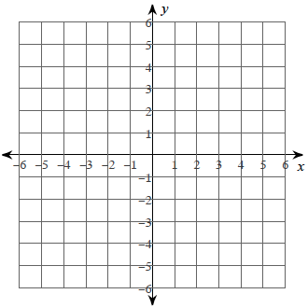



22. Evaluate the function for f(10)

23. Simplify the expression 10 – 7(3y + 5)

24. Simplify the following expression:

(9a2 + 7 – 6a) – (8 + 3a2 – a)

25. Expand and simplify the following expression:

–3(x2 + 5x) + 4(3x2 – 7) + 9x

26. First simplify the following expression

22x+14x2 −10x2 +3x +7, then state the number of terms and the leading coefficient for the simplified expression.

27. In a given triangle, the smallest side is half the length of the largest side. The other side (that is not the smallest or largest) is 3 units shorter than the longest side. Write an expression to represent the perimeter of the triangle if *x* represents the length of the smallest side.

28. It took Marisol 12 minutes less than twice Jesus’s time to run a marathon. Which expression would represent Marisol time in minutes in relation to Jesus?

29. What is the perimeter of the following rectangle?

30. Determine an expression that would

represent the **perimeter** of the figure shown to the right.

Write answer in simplest form.

**4x**

Perimeter **=____________________________**

**5x-3**

31) Justify each step in the solution of this equation with a property from the word bank provided.

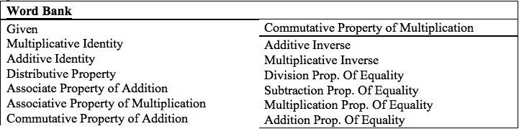

|  |  |
| --- | --- |
| 2(3x – 1) = x + 3 | Given |
| 6x – 2 = x +3 |  |
| 6x – 2 + 2 = x + 3 + 2 |  |
| 6x = x + 5 | Simplify |
| 6x – x = x-x + 5 |  |
| 5x = 5 |  |
| X = 1 |  |

**Glossary**

Algebra: The branch of mathematics that deals with relationships between numbers, utilizing letters and other symbols to represent specific sets of numbers, or to describe a pattern of relationships between numbers.

Average Rate of Change: The change in the value of a quantity by the elapsed time. For a function, this is the change in the y-value divided by the change in the x-value for two distinct points on the graph.

Binomial Expression: An algebraic expression with two unlike terms.

Coefficient: A number multiplied by a variable in an algebraic expression.

Constant Rate of Change: With respect to the variable x of a linear function y = f(x), the constant rate of change is the slope of its graph.

Constant Term: A quantity that does not change its value.

Coordinate Plane: The plane determined by a horizontal number line, called the x-axis, and a vertical number line, called the y-axis, intersecting at a point called the origin. Each point in the coordinate plane can be specified by an ordered pair of numbers.

Domain: The set of x-coordinates of the set of points on a graph; the set of x-coordinates of a given set of ordered pairs. The value that is the input in a function or relation.

Equation: A number sentence that contains an equals symbol.

Expression: A mathematical phrase involving at least one variable and sometimes numbers and operation symbols.

Inequality: Any mathematical sentence that contains the symbols > (greater than), < (less than), ≤ (less than or equal to), or ≥ (greater than or equal to).

Linear Function: A function with a constant rate of change and a straight line graph.

Linear Model: A linear function representing real-world phenomena. The model also represents patterns found in graphs and/or data.

Monomial Expression: An algebraic expression with one term.

Ordered Pair: A pair of numbers, (x, y), that indicate the position of a point on a Cartesian plane.

Parameter: The independent variable or variables in a system of equations with more

than one dependent variable.

Polynomial Expression: An algebraic expression with multiple terms.

Range: The set of all possible outputs of a function.

Slope: The ratio of the vertical and horizontal changes between two points on a surface or a line.

Standard Form of a Polynomial: To express a polynomial by putting the terms in descending exponent order.

Term: any of the monomials that make up a polynomial.

Trinomial: An algebraic expression with three unlike terms.

Variable: A letter or symbol used to represent a number.

X-intercept: The point where a line meets or crosses the x-axis. (x,0)

Y-Intercept: The point where a line meets or crosses the y-axis. (0,y)

**Appendix A**

Here, *a, b,* and *c* stand for arbitrary numbers in a given number system. The properties of operations apply to the rational number system, the real number system and the complex number system.

**Properties of Equality**

|  |  |  |
| --- | --- | --- |
| **Name of Property** | **Statement of Property** | **Example of Property** |
| **Addition Property of Equality** | If a = b, then  **a + c = b + c** | x = 2, therefore  **x + 3 = x + 3** |
| **Subtraction Prop. of Equality** | If a = b, then  **a – c = b – c** | x = 2, therefore  **x – 3 = 2 – 3** |
| **Multiplication Prop. of Equality** | If a = b, then  **ac = bc** | x = 2, therefore  **x * 3 = 2 * 3** |
| **Division Prop.**  **of Equality** | If a = b and c ≠ 0, then  **a / c = b / c** | x = 2, therefore  **x / 3 = 2 / 3** |
| **Distributive Property of Equality** | For any real numbers *a*, *b*, and *c*:  ***a* (*b* + *c*) = *ab* + *ac*** | ***2* (*x* + *3*) = *2x* + *2*3*** |
| **Simplify (Combine Like Terms)** | For any real numbers *a*, *b*, and *x*:  ***ax* + *bx* = (*a* + *b*)*x*** | ***2x* + *3x = (2+3)x***  **= 5x** |
| **Symmetric Prop. of Equality** | If a = b, then  **b = a** | x = 2, therefore 2 = x |
| **Substitution Prop. of Equality** | If a = b, then **a can be substituted for b** in any expression or equation. | Evaluate **2x+3** when **x=5**  **2(5)+3** |

**Addition Properties**

|  |  |  |
| --- | --- | --- |
| **Name of Property** | **Statement of Property** | **Example of Property** |
| Commutative | a+b = b+a | 2 + 3 = 3 +2 |
| Associative | a+(b+c) = (a+b)+c | 2 + (3+4) = (2+3) +4 |
| Identity | a+0=a | 2 + 0 = 2 |
| Inverse | a + (-a)=0 | 2 + (-2) = 0 |

**Multiplication Properties**

|  |  |  |
| --- | --- | --- |
| **Name of Property** | **Statement of Property** | **Example of Property** |
| Commutative | ab=ba | 2 x 3 = 3 x 2 |
| Associative | a*(bc) = (ab)*c | 2 x (3 x 4) = (2 x 3) x 4 |
| Identity | a*1=a | 2 x 1 =2 |
| Inverse | a $\frac{1}{a}$*=1 | 2 x $\frac{1}{2}$ =1 |