**Algebra 1 Unit 4**

**The Toolbox Unit**

**Table of Contents**

**Title Page #**

**Formula Sheet…………………………………………………………………….2**

**Lesson 4-1 Exponent Properties/Multiplying Polynomials/GCF.………..3**

**Lesson 4-2 Multiply and Simplify Radicals..……………….…………..… 12**

**Lesson 4-3 Adding and Subtracting Radicals..……………………….… 17**

**Lesson 4-4 Unit Analysis.……………………….……………………………22**

**Unit 4 Study Guide…………………………………………………………….31**

**Appendix A: Perfect Squares……………………………………………….34**

**Appendix B: Conversion Chart……………………………………………..35**

**Glossary…………………………………………………………………………36**

**This packet belongs to:**

**__________________________________________________________**



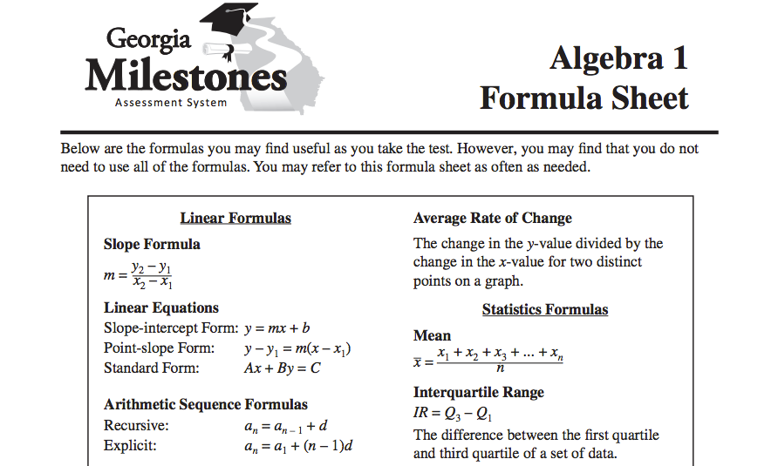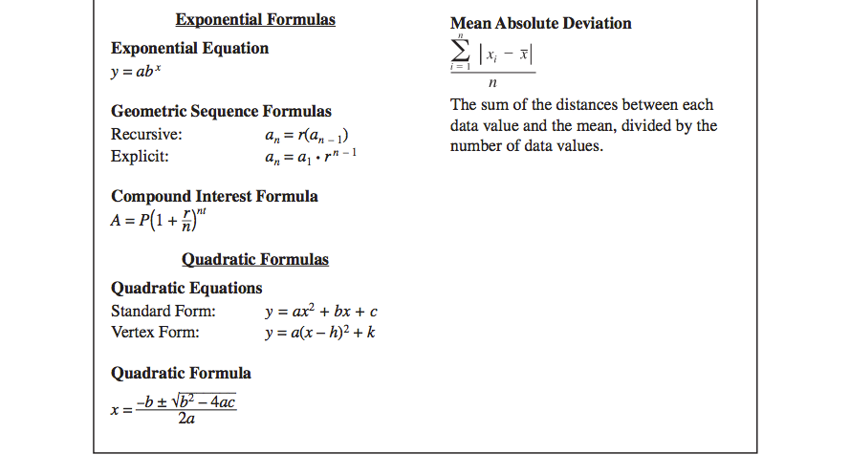

**Lesson 4-1: Exponent Properties/Multiplying Polynomials/GCF**

Write your Questions here!

**Learning Targets:**

* **I can use the properties of exponents to simplify algebraic expressions.**

Vocabulary:

* Greatest Common Factor
* **I can multiply polynomials.**
* **I can find the greatest common factor of a set of algebraic terms.**

A.APR.1, F.IF.8

Begin 4-1 Video 1

Unit 4 is all about developing our mathematical tool belt. While these lessons may seem a little disconnected, each lesson will provide us with valuable tools that we will be able to use in our future math endeavors.

|  |  |  |
| --- | --- | --- |
| Property Name | Definition | Example |
| Exponent of 1 | $$a^{1}=a$$ |  |
| Zero Exponent | $$a^{0}=1$$ |  |
| Product of Powers | $$a^{m}•a^{n}=a^{m+n}$$ |  |
| Negative Exponent | $$a^{-m}=\frac{1}{a^{m}}$$ |  |

**Exponent Properties**

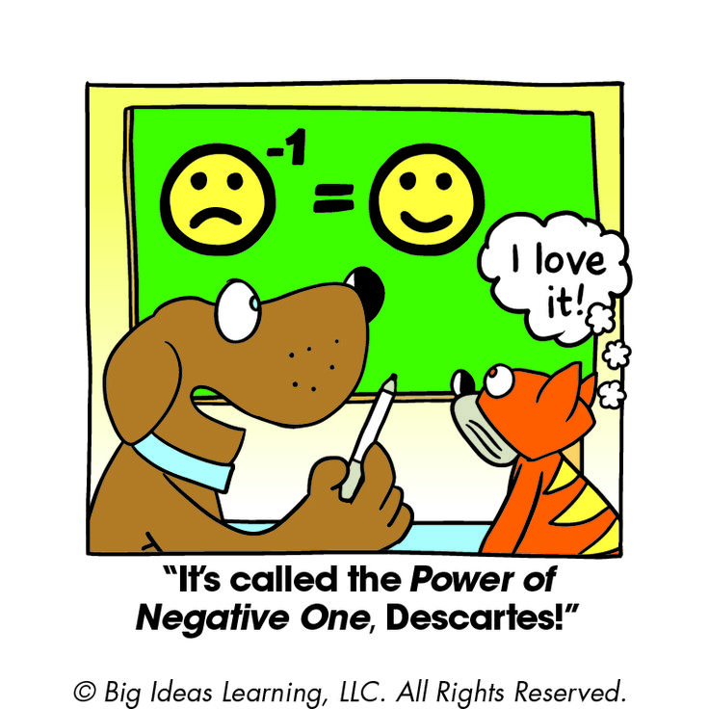**You Try!**

1. 2.

3. 4.

Historical Note:

The first recorded modern use of an exponent in mathematics was in a book called *Arithemetica Integra*, written in 1544 by English author and mathematician Michael Stifel.

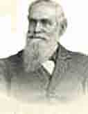

Begin 4-1 Video 2

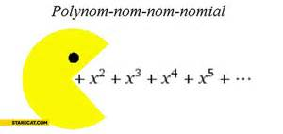**Multiplying Polynomials**

Write your Questions here!

Remember way back to Unit 1 where we talked about adding and subtracting polynomials. In this unit, we are going to throw in another operation to our repertoire of polynomial skills: multiplying polynomials.

The very simplest case for polynomial multiplication is the product of two ___________________. For instance:

**Example 1:** Simplify ($5x^{2}$)($-2x^{3})$

We’ve already done this type of multiplication when learning about exponents.

The next step up in complexity is a ______________ times a multi-term __________________. For example:

**Example 2:** Simplify –3x($4x^{2}– x + 10$)

To do this, we have to distribute the –3x through the [parentheses](http://www.purplemath.com/modules/simparen.htm):

–3x($4x^{2}– x + 10$)

**You try!**

1. 2. 3. 4.

Begin 4-1 Video 3

The next step up is a ____________ times a _________. This is one of the most common polynomial multiplications that you will be doing.

Write your Questions here!

**Example 3:** Simplify (*x* + 3)(*x* + 2)

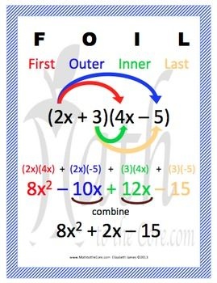

**FOIL only works when you are multiplying a binomial times a binomial!**



**You Try!**

1. 2.

3. 4.

Write your Questions here!

Finally, we will multiply a _____________ times a ____________________. Just like in a binomial times a binomial, we will ___________________ the terms in the first binomial to those in the trinomial.

Begin 4-1 Video 4

**Example 4:**

$$(2b+4)(5b^{2}-3b-1)$$

**You Try!**

1. 2.

Begin 4-1 Video 5

**Example 5**

1. Determine an expression that would represent the area of the figure shown below:

3*x*+7

6*x*-5

**Example 6**

2. Determine an expression that would represent the area of the shaded region below:

12 Units

7 Units

x

x

x

x

**You Try!**

Write your Questions here!

1. Determine an expression that would represent the area of the figure shown below:

4x-3

5*x+*3

2. Determine an expression that would represent the area of the shaded region below:

15 Units

x

x

x

x

5 Units

Begin 4-1 Video 6

**Greatest Common Factor**

Another tool you will need in your mathematician’s tool belt is finding the Greatest Common Factor (GCF) of a set of numbers.

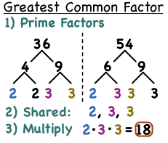Remember, a ________ is anything that is being multiplied by something else in math.

There are 3 simple steps to finding the GCF:

1. Find the __________________ of each number.
2. Identify the ____________ that are present in each number.
3. Multiply the ______________ together.

**Example 2:**

Find the GCF: 2x2, 6x and 8

**Example 1:**

Find the GCF: 12v2 and 18v

**You try!**

Write your Questions here!

1. 36 18 42 2.

3. 4.

**Practice 4-1**

**Simplify each exponential expression:**

1. 2. 3x3 • x2 3. 3x0 4. 3x-7

5. (3x)-7 6. 7. 8.

**Multiply and simplify each polynomial expression:**

9. (2n + 8) (2n–6) 10. (p–3) (3p–2) 11. (2x–3) (6x +7)

12. (8r – 5)2 13. (1 + 3m)2 14. (6n + 3) (6n – 3)

15. (–3b + 9) (–10a–8b –7) 16. (3n + 9) (5m–4n +10)

17. (8x – 5y) (–2x + 6xy + 4y) 18. (–5j + k) (–4j – 5jk – 4k)

Write your Questions here!

19. (–3r + 10) (8r2 + 8r – 2) 20. (–3b2 – 6b +10) (–5b –1)

21. Determine and simplify an expression that would represent the area of the figure shown below:

5x-4

4*x*-3

5 Units

3 Units

x

x

x

x

22. Determine and simplify an expression that would represent the area of the shaded region below:

23. Write an expression that would represent the area of the triangle below.

**(A=1/2bh)**

3x

2x+4

3x

x+6

**Find the greatest common factor of the following expressions:**

24. 63 25. 19x 23x

26. -15x 45 27. -36x -81

28. -28x -40 29. -108 240

30. Harry was working on his math homework and encountered the following problem:

Write your Questions here!

$$\left(4x^{2}-3x+ 2\right)-(3x^{2}-4x+7)$$

Harry’s work is shown below:

$$\left(4x^{2}-3x+ 2\right)-(3x^{2}-4x+7)$$

$$4x^{2}-3x+ 2-3x^{2}-4x-7$$

$$x^{2}-7x-5$$

Explain to Harry what mistake he made on his homework and explain to him how to find the correct solution.

31) Ron is working on his math homework and encountered the following problem.

$$-3x(4x-3)$$

Ron’s work is shown below:

$-12x+9$ x

-3x

Explain to Ron what mistake he made and explain to him how to find the correct solution.

32) Hermione is working on her math homework and encounters the following problem.

$$(2x-3y)(4x-2xy+5y)$$

Hermione’s answer is shown below

$$8x^{2}-4x^{2}y-12xy+6xy^{2}+5y$$

Explain to Hermione what mistake she made and explain to her how to find the correct solution.

1. List all the perfect square numbers from 1 to 225. (Remember 22=4 so 4 is a perfect square).

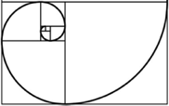

**This WILL be on your mastery check!**

Spiral Practice

Write your Questions here!

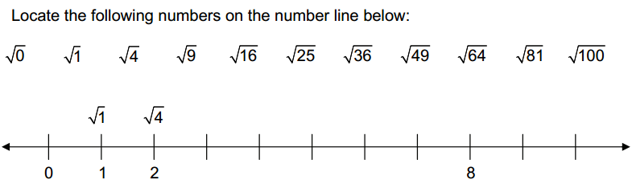

2.

Then estimate and label where the following numbers would be located on the same number line.

1. b) c) d) e)

3. Beyonce has 50 pairs of shoes that she wants to take to her new house. The boxes she has to carry them in can hold 3 pairs of shoes each. How many boxes will she completely fill and how many pairs of shoes will be left over?



4. Marsha is buying plants and soil for her garden. The soil cost $4 per bag, and the plants cost $10 each. She wants to buy at least 5 plants and can spend no more than $100. Write and graph a system of linear inequalities to model the situation.

**Review your practice and notes to prepare for the Mastery Check.**

**Lesson 4-2: Multiplying and Simplifying Radicals**

Write your Questions here!

**Learning Target:**

* **I can simplify radicals.**

Vocabulary:

* Radical
* Radicand
* **I can multiply radicals.**

Standard: N.RN.2

Begin 4-2 Video 1

The next set of tools that we will add to our tool belt is multiplying and simplifying radicals.

Historical Note:

The Babylonians were one of the first cultures to develop a system to find square roots Their method may have been developed as early as 1900 BCE. They recorded their calculations on cuneiform tablets like that below.

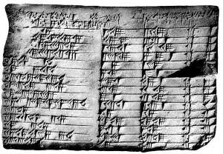

We will talk about how to simplify radicals in a moment, but first lets focus on the basics of multiplying radicals.

To multiply radicals, multiply the radicand by the ___________ and the coefficient by the _________

**Example 1 $4\sqrt{3}• 5\sqrt{8}$**

Note: When multiplying radicals, you will need to simply your answer. For now, let’s just practice the basics of multiplying radicals.

**Example 2 Example 3**

$5\sqrt{5x}•\sqrt{3y^{2}}$ $\left(\sqrt{3}+\sqrt{2x}\right)(\sqrt{3}+\sqrt{4x^{2}})$

**You try:**

1. 2. 3. )

Write your Questions here!

Begin 4-2 Video 2

Alright, now that we’ve gotten the basics of multiplying down, let’s take a look at simplifying radicals.

|  |  |
| --- | --- |
| Instructions | **Example 3: $\sqrt{18}$** |
| Step 1: Complete a factor tree for the radicand. |  |
| Step 2: Identify any pairs of numbers. These signify a square factor. |  |
| Step 3: Under the radical, separate the radicand into square factors and non-square factors. $$\sqrt{ab}=\sqrt{a}•\sqrt{b}$$ |  |
| Step 4: Pull perfect squares out and multiply them by the radical. This is now the coefficient. |  |

**Example 4: $\sqrt{100x^{3}}$**

**See Appendix A**

See Appendix A for a handy list of perfect squares that may help you in your simplifying adventures.

**You try!**

1. 2. 3. 4.

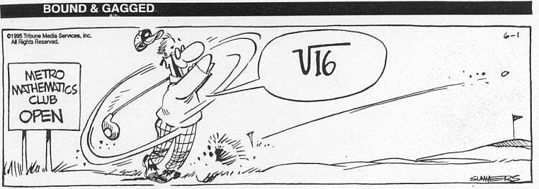

Write your Questions here!

Now that we have discussed how to simplify, let’s go back and revisit one of our examples from the first video:

Begin 4-2 Video 3

**Example 1 (Revisited) $4\sqrt{3}• 5\sqrt{8}$**

**Example 2 (Revisited) $5\sqrt{5x}•\sqrt{3y^{2}}$**

**You try (Revisited)!**

1. 2. 3. )

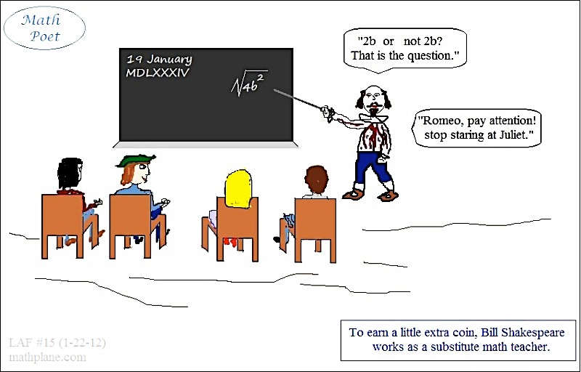

**Practice 4-2 Multiplying and Simplifying Radicals**

Write your Questions here!

**Simplify the following radicals:**

1. 2. 3. 4.

5. 6. 7. 8.

9. 10. 11. 12. $\sqrt{80x^{3}y^{2}}$

**Multiply and simplify the following radicals:**

13. $\sqrt{28}• -10\sqrt{2}$

15. $\sqrt{10}• \sqrt{6}$

17. $-10\sqrt{45 }•9\sqrt{40}$

19. $2\sqrt{63}• \sqrt{35}$

21. $-8\sqrt{8 }•-7\sqrt{12}$

23. $\sqrt{14x^{3}}• \sqrt{20x^{3}}$

14. $8\sqrt{12n^{3}}• \sqrt{30n^{3}}$

16. $5\sqrt{6m}• \sqrt{7m}$

18. ${(\sqrt{8})}^{2}$

20. ${(6\sqrt{19})}^{2}$

22. $\sqrt{7}(8+ \sqrt{35v})$

24. $\sqrt{70}\left(\sqrt{20}+\sqrt{15b}\right)$



**This WILL be on your mastery check!**

Spiral Practice

Write your Questions here!

1. Last year, Devon grew 3 ¼ inches and her brother grew 1½ inches. How much more did Devon grow than her brother?

1. Simplify
   1. (6y – a + 1) – (-7y + 3a) – (-8y – 1) b. (3x –2) (5x + 20)
2. A rectangular field is (4x + 6) long and (3x + 4) wide.
3. How much greater is the length than the width?
4. Find the perimeter
5. Erin is e years old. Her older brother Bill is (2e – 3) years old.
6. Write an expression for the sum of their ages.
7. Write an expression to describe how much older Bill is than Erin.

**Review your practice and notes to prepare for the Mastery Check.**

Write your Questions here!

**Lesson 4–3: Adding and Subtracting Radicals**

**Learning Target:**

* **I can add radicals.**
* **I can subtract radicals**

N.RN.2

Begin 4-3 Video 1

Just as with "regular" numbers, square roots can be added together. But you might not be able to simplify the addition all the way down to one number.

Just as you must have ____________ to add in an algebraic expression, so you also cannot combine "unlike" radicals.

To add radical terms together, they have to have the same ___________.

**Example 1: $2\sqrt{3}+3\sqrt{3}$** **Example 2: $\sqrt{50}+\sqrt{2}$**

**You try!**

1. 2.

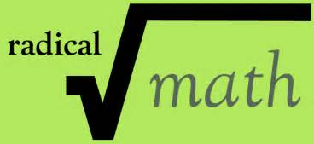

Begin 4-3 Video 2

Write your Questions here!

Just like when you add radicals, before you subtract radicals you must make sure you have _______________.

Once you have ***like bases***, subtract the ___________________.

**Example 3 Example 4 Example 5**

$8\sqrt{3}-5\sqrt{3}$ $3\sqrt{11}-\sqrt{176}-\sqrt{11}$ $3x\sqrt{80}-5\sqrt{125x^{2}}$

**You try!**

$3\sqrt{20}-2\sqrt{5}$ $3\sqrt{5}-3\sqrt{45}-2\sqrt{5}$ $2x\sqrt{54}-2\sqrt{24x^{2}}$

Now that we have covered adding, subtracting, and multiplying radicals, lets put these skills together to help us find the area of some polygons.

Begin 4-3 Video 3

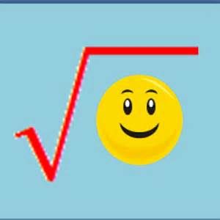

Find the area. A=1/2*bh*

$$\sqrt{15}$$

$$5+ \sqrt{15}$$

**You try!**

Write your Questions here!

1) Find the area. A=L•W

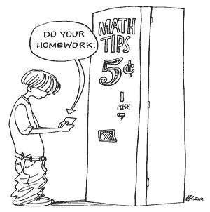

$$\sqrt{6}$$

$$5\sqrt{3}+10$$

**Practice:**

**Simplify the following expressions**

1. 2.

3. 4.

6. 8.

9. 10. 11.

12. 13. 14.

15. 16. 17.

18. 19. 20.

21) Find the area the triangle 22) Find the area of the rectangle.

Write your Questions here!



$$\sqrt{75}+5$$

$$\sqrt{30}$$

$$15\sqrt{70}$$

$$\sqrt{35}+4$$

**This WILL be on your mastery check!**

Spiral Practice

|  |  |  |  |  |
| --- | --- | --- | --- | --- |
| Number of Songs | 2 | 6 | 8 | 10 |
| Cost | 6.50 | 9.50 | 11 | 12.50 |

1) Mike and Bill both have website subscriptions to download music. The equation c = 0.50s + 10, where c is the total cost and s is the number of songs downloaded, can be used to represent the amount that Mike has spent on songs. Bill’s amounts can be seen in the table below.

a) What are the y intercepts for both Mike and Bill?

b) What do the y-intercepts represent?

c) What is the rate of change for each function?

d) What do the rates of change represent?

e) If both Mike and Bill each buy 15 songs, who has spent more money?

2) The cost of renting a vacation home consists of a deposit and then a daily fee. The cost to rent a vacation home can be seen in the graph below. Create a function to represent the situation. Find and interpret the rate of change and the initial value.

Write your Questions here!

Cost

Days Rented

**Review your practice and notes to prepare for the Mastery Check.**

**Lesson 4 – 4: Unit Analysis**

Write your Questions here!

**Learning Target: I can convert units of measure to other units of measure.**

N.Q.1

Begin 4-4 Video 1

Next in our mathematical toolkit, we are going to look at how to convert units of measure into other units of measure. First we will take a look at converting within the metric system.

In the metric system of measurement there is only __________ unit of measurement for each type of quantity.

______________ are the base unit for length.

____________ are the base unit for mass.

_______________ are the base unit for volume.

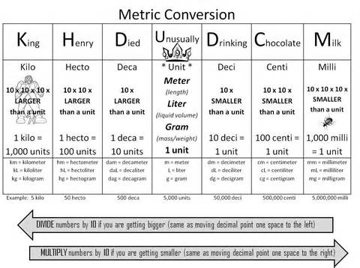

**Example 1:** Convert 2.5 centimeters to meters.

Write your Questions here!

**Example 2:** How many meters are in 0.4 kilometers?

**You try!**

1) Convert 175 meters to centimeters.

2) Convert 2,300 meters to kilometers.

Begin 4-4 Video 2

You can also convert units using multiplication of ratios if you know the ____________________

The following conversion factors are used in measuring time in the United States:

1 year = 365 days

1 year = 12 months

1 week = 7 days

1 day = 24 hours

1 hour = 60 minutes

1 minute = 60 seconds

When converting between units with a conversion factor, _________ should be set up to help you __________ and/or _____________ in the right places.

$$\frac{What you want}{What you^{'}ve got}$$

**Example 3:** How many days are in 15 years?

$\frac{15 yrs}{1}•\frac{ }{ }=$_______ years?

Write your Questions here!

**You try!**

How many seconds are in one day?



The United States is one of only three countries that use the standard measurement system. The other two countries are Liberia and Myanmar.

Begin 4-4 Video 3

Next we will discuss converting units in the Standard Measurement system.

Converting standard units of measure works much the same as converting time. You will need to know ___________________ to be able to set up _____________.

Don’t forget: $\frac{What you want}{What you^{'}ve got}$

Standard to Standard Conversion factors:

**Length Conversions:** **Volume Conversions:**

1 mile = 5,280 feet 1 gallon (gal) = 4 quarts (qt)

1 yard = 3 feet 1 quart = 2 pints (pt)

1 foot = 12 inches 1 pint = 2 cups (c)

1 cup = 8 ounces (oz)

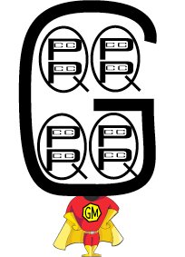**Weight Conversions:** 1 cup = 16 tablespoons (tbsp)

1 ton (T) = 2,000 pounds (lbs)

1 pound (lb) = 16 ounces (oz)

**Example 4:** 20 cups makes how many pints?

$\frac{20 cups}{1}•\frac{ }{ }=$

**Example 5:** How many inches are in 1 mile?

Write your Questions here!

$\frac{1 mile}{1}•\frac{ }{ }•\frac{ }{ }=$

**You try!**

1) How many cups are in a gallon? 2) Convert 3600 inches to yards.

Begin 4-4 Video 4

Finally, we are going to look at converting between metric and standard and visa versa.

Converting between two systems of measurement, such as metric to standard will always require ________________. The easiest way to set these problems up will be to use _____________. Some of the most common conversion factors are listed below. A more detailed list of conversion factors can be found in Appendix B.

**See Appendix B**

Conversion Factors: (These will all be approximations)

Length Conversions: Volume Conversions:

1 inch (in) ≈ 2.54 centimeters (cm) 1 gallon (gal) ≈ 3.79 Liters (L)

Don’t forget: $\frac{What you want}{What you^{'}ve got}$

Weight Conversions:

1 kilogram (kg) ≈ 2.20 pounds (lbs)

**Example 6:** 120 lbs is how many kilograms?

$\frac{120 lbs}{1}•\frac{ }{ }=$

**Example 7:** How many centimeters are in 4 feet?

Historical Note:

The earliest know systems of measure are thought to have originated some time in the 3rd or 4th century BCE among the ancient peoples of Egypt, Mesopotamia, and the Indus Valley.

Write your Questions here!

$\frac{4 ft}{1}•\frac{ }{ }•\frac{ }{ }=$

Converting Rates works exactly the same as converting between units.

Rate: a ratio of two different _____________.

**Example 8:** Convert 35 miles per hour to feet per second.

$\frac{35 miles}{1 hr}•\frac{ }{ }•\frac{ }{ }•\frac{ }{ }=$

**You try!**

1. How many inches are in one meter?

2. How many ounces are in 10 kg?

3. Convert 35 kilometers per minute to miles per hour.

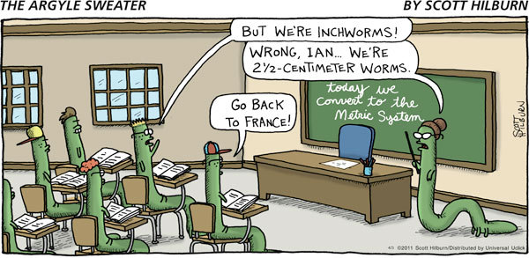

Write your Questions here!

**Example 9:**

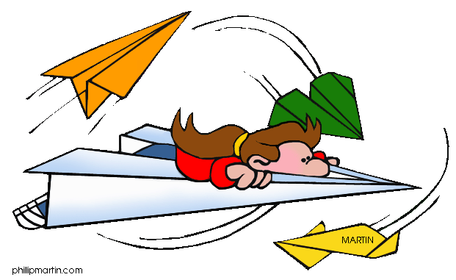Ethan lives at one end of Park Avenue. Brian lives at the other end of the avenue. It is 5.8 kilometers from one end of Park Avenue to the other. If Ethan walks 279 meters toward Brian’s house, how many **meters** does he have to walk to get there?

**You try!**

Begin 4-4 Video 5

Aaron and Noah wanted to have a contest to see which of their paper airplanes could fly the longest distance. Aaron’s plane flew four meters. Noah’s plane only flew seventy-nine centimeters. How many meters further did Aaron’s plane fly?

**4-4 Practice**

**Complete the following conversions.**

1. 10,000 meters to kilometers

3. 12,346 millimeters to centimeters

5. 54 Liters to milliliters

7. 15,800 grams to kilograms

9. 1 years to minutes

11. 5 miles to feet

2. 8 gallons to quarts

4. 16 pounds to ounces

6. 65 miles per hour to feet per

second

8. 24 gallons to liters

10. 62 Liters to gallons

12. 124 feet to centimeters

Write your Questions here!

13. 60 miles per hour to kilometers per second

14. 40 kilometers per hour to feet per second

15. Jasmine is watching a Youtube video on a science experiment. The video calls for 5 liters of dihydrogen monoxide. How many milliters of dihydrogen monoxide will she need for her experiment?

16. Farmer Dell just harvested his crop of green beans. In total, he harvested 45 kilograms of green beans. He sells the green beans in batches of 75 grams. How many batches did his harvest yield?

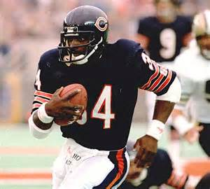

**Are the following conversions done correctly? If not, explain the error.**

17. Walter Peyton has been clocked at 4 seconds in the 40 yard dash. What was his speed in miles per hour?

$\frac{40 yds}{4 sec}•\frac{3 ft}{1 yd}•\frac{1 mile}{5,280 ft}•\frac{60 sec}{1 min}•\frac{60 min}{1 hr}=\frac{40•3•1•60•60}{1•5280•1•1}=\frac{432,000}{5,280}=81 mph$

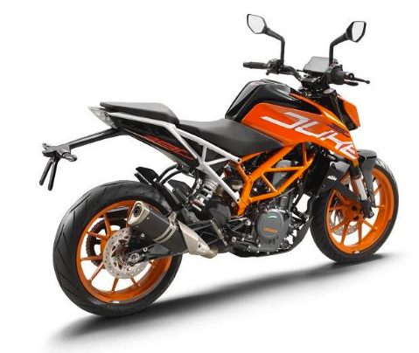18. You are driving your motorcycle in Germany; the speed limit is 90km/hr. Your speedometer only has miles per hour. How fast can you go?

$\frac{90 km}{1 hr}•\frac{1 km}{0.6214 mi}=\frac{90}{0.6214}=144.8 mph$

19. You are planning on building your dad a new bookshelf for his birthday. You need to cut the shelves to be a uniform thickness. Which level of accuracy would be the most appropriate for this task?

Write your Questions here!

* 1. Inches
  2. Feet
  3. Yards
  4. Miles

20. A pack of 18 candies costs $1.75.  Which of the answers given is the most appropriate way of representing the cost of one single candy?

1. 10 cents
2. $1
3. $32
4. 18 cents
5. 17 cents



**This WILL be on your mastery check!**

Spiral Practice

What mixed number or fraction is shown on each number line below?





1. 

Write your Questions here!

1. What mixed number or fraction and decimal are shown on each number line below?

0

-1

-2

-3

-4

1

2

3

Fraction: ___________________ Decimal: ___________________

0

5)

0

Fraction: ___________________ Decimal: ___________________

**Review your practice and notes to prepare for the mastery check.**

**Unit 4 Study Guide**

Write your Questions here!

**Simplify the radicals:**

1. 2. 3.

**Simplify**

4. 5. 6.

**7.** Find the area of the triangle. (Hint

8. A racing boat is traveling at a speed of 150 km/hr. Convert the speed of the boat to meters per second.

9. The speed, or rate can be described by the formula $r=\frac{d}{t}$ where

**d**=distance (in kilometers)

**t**=time (in hours)

What is the unit of measure for speed?

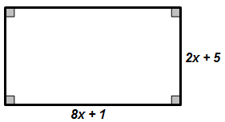

8x+9

2x+4

10. Determine and expression that would represent the area of the figure shown below.

11. The Department of Transportation was doing a study and found that at the intersection in front of the school that an average of 13 cars per minute go through the intersection. Based on this statistic, how many cars would you estimate go through that intersection in a year?

(Assume it is a non-leap year with 365 days)

**Simplify**

12. 13.

14.

15. What is the area of the following rectangle? (Hint: A=lw)

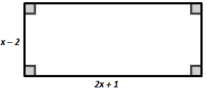

16. Convert 55 miles per hour to kilometers per second. (1 mile =1.61 km)

**Simplify**

17. 18. 19. 20.

**Find the GCF**

21. 22. x 23.

24. Bartholomew is working on his math homework and encounters the following problem:

$$-6x(5x-3)$$

Bartholomew’s work is shown below

$$-30x+18x$$

$$-12x$$

Explain to Bartholomew what mistake he made and explain to him how to find the correct solution. A.APR.1

Correct Answer:__________________

Explanation:______________________________________________________

25. Determine an expression that would represent the **area** of the shaded region shown below:

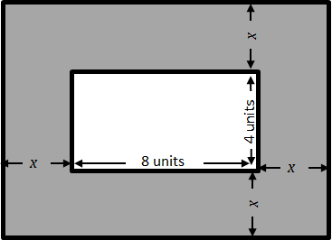

12 units

9 units

26. Jess lives at one end of New York Avenue. Sam lives at the other end of the avenue. It is 8.40 kilometers from one end of New York Avenue to the other. If Jess walks 234 meters toward Sam’s house, how many **meters** does she have to walk to get there?

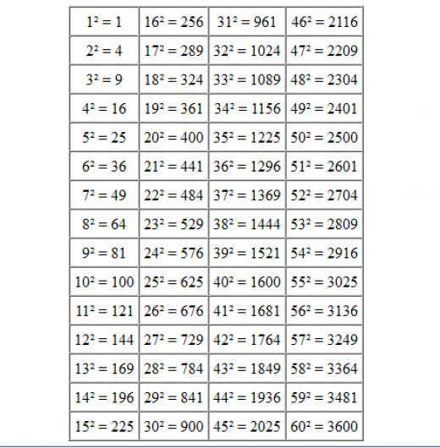**Appendix A: Perfect Squares**

**Appendix B: Conversion Chart**

|  |  |
| --- | --- |
| Length Conversions | |
| 1 inch | 2.54 cm |
| 1 foot | 0.3048 meters |
| 1 yard | 0.9144 meters |
| 1 mile | 1.6093 km |
| 0.03937 inches | 1 millimeter |
| 0.3937 | 1 centimeter |
| 39.37 inches | 1 meter |
| 0.62137 miles | 1 kilometer |





|  |  |
| --- | --- |
| Volume Conversions | |
| 1 fluid oz | 29.573 milliliters |
| 1 cup | 230 milliliters |
| 1 quart | 0.94635 liters |
| 1 gallon | 3.7854 liters |
| 33.814 fluid oz | 1 liter |

|  |  |
| --- | --- |
| Weight Conversions | |
| 0.353 ounces | 1 gram |
| 1 pound | 454 grams |
| 2.2046 pounds | 1 kilogram |

**Glossary**

**Greatest Common Factor-** The highest number that divides exactly into two or more numbers.

**Radical-** an expression that has a square root, cube root, etc. Also may refer to the symbol over the radicand.

**Radicand-** The number under the radical sign.