**Unit 5**

**Introducing Quadratic Functions**

**Table of Contents**

**Title Page #**

**Formula Sheet…………………….2**

**Lesson 5-1 Graphing by Intercept Form……………………….………..3**

**Lesson 5-2 Solving by Factoring..………….…………..…7**

**Lesson 5-3 Factoring..…………………………9**

**Lesson 5-4 Solving by Square Root.………….……….……………18**

**Lesson 5-5 Solving by Completing the Square .……………………..…23**

**Unit 5 Study Guide……………………………….26**

**Glossary……………………………29**

**This packet belongs to:**

**__________________________________________________________**

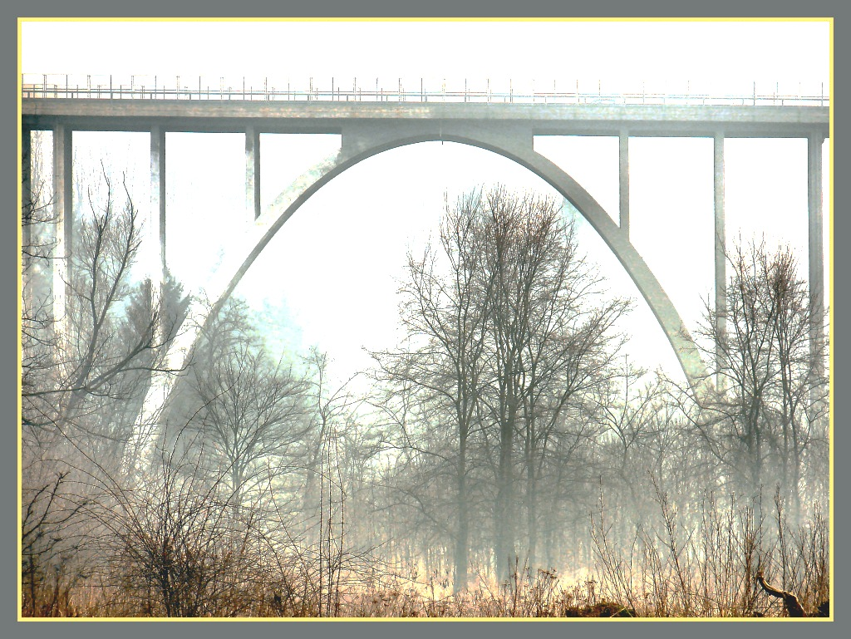

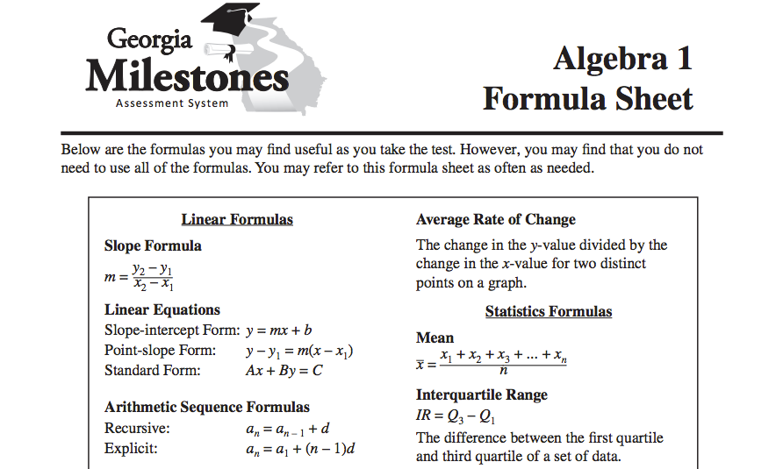

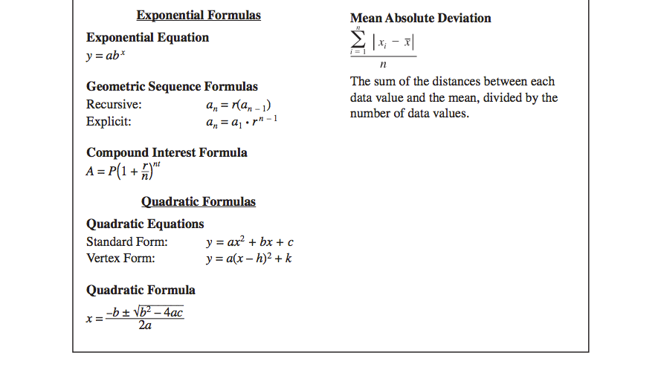

**Lesson 5 – 1: Intercept Form**

Write your Questions here!

**Learning Target: I can use intercept form to graph a quadratic function.**

F.IF.8a

Begin 5–1 Video 1

Intercept Form of a Quadratic Equation is

$$f(x) = a(x – p)(x – q)$$

**General Rules for Graphing Quadratics of the Form**

1. Identify the x-intercepts and plot them

* 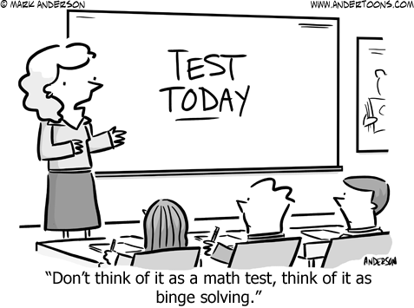x-intercepts for $f(x) = a(x – p)(x – q)$ are and .

2. Find the vertex and _______________

* The x-coordinate of the vertex is $x=\frac{p+q}{2}$

(think about it – it’s located halfway between the zeros)

* Plug in the x-coordinate of the vertex to find its _________; plot point
* Axis of symmetry is

3. Find the y-intercept; reflect over axis of symmetry

* Calculate $f(0)$ to find the y-intercept

4. Find one or two other points if needed, reflecting over axis of symmetry

5. Sketch curve

y

x

10

-8

-4

2

6

-10

-10

-6

-2

4

8

-10

-2

8

-8

2

-10

4

-4

-6

6

10

**Example 1:** Graph

$f\left(x\right)=(x-2)(x-4)$

x-intercepts: ______ and ______

vertex:________

axis of symmetry:____________

y-intercept:_______

**You try’s will be after video 2!**

Write your Questions here!

Begin 5–1 Video 2

y

x

10

-8

-4

2

6

-10

-10

-6

-2

4

8

-10

-2

8

-8

2

-10

4

-4

-6

6

10

**Example 2:** Graph

$f\left(x\right)=-\frac{1}{2}(x+2)(x-4)$

x-intercepts: ______ and ______

vertex:________

axis of symmetry:____________

y-intercept:_______

**You Try:**

**Use Intercept form to graph the following quadratic equations.**

2. f(x)=

1.

y

x

10

-8

-4

2

6

-10

-10

-6

-2

4

8

-10

-2

8

-8

2

-10

4

-4

-6

6

10

y

x

10

-8

-4

2

6

-10

-10

-6

-2

4

8

-10

-2

8

-8

2

-10

4

-4

-6

6

10

x-intercepts: ______ and ______

vertex:________

axis of symmetry:____________

y-intercept:_______

x-intercepts: ______ and ______

vertex:________

axis of symmetry:____________

y-intercept:_______

**5-1 Practice**

Write your Questions here!

**Use Intercept form to graph the following quadratic equations and answer the accompanying questions.**

2. $f\left(x\right)=-2(x+1)(x-2)$

1. $f\left(x\right)=2(x-3)(x-1)$

y

x

10

-8

-4

2

6

-10

-10

-6

-2

4

8

-10

-2

8

-8

2

-10

4

-4

-6

6

10

y

x

10

-8

-4

2

6

-10

-10

-6

-2

4

8

-10

-2

8

-8

2

-10

4

-4

-6

6

10

x-intercepts: ______ and ______

vertex:________

axis of symmetry:____________

y-intercept:_______

x-intercepts: ______ and ______

vertex:________

axis of symmetry:____________

y-intercept:_______

4. $f\left(x\right)=(x+4)(x-2)$

3. $y=(x+3)(x-2)$

y

x

10

-8

-4

2

6

-10

-10

-6

-2

4

8

-10

-2

8

-8

2

-10

4

-4

-6

6

10

y

x

10

-8

-4

2

6

-10

-10

-6

-2

4

8

-10

-2

8

-8

2

-10

4

-4

-6

6

10

x-intercepts: ______ and ______

vertex:________

axis of symmetry:____________

y-intercept:_______

x-intercepts: ______ and ______

vertex:________

axis of symmetry:____________

y-intercept:_______

5. $f\left(x\right)=4(x+3)(x+1)$

y

x

10

-8

-4

2

6

-10

-10

-6

-2

4

8

-10

-2

8

-8

2

-10

4

-4

-6

6

10

Write your Questions here!

y

x

10

-8

-4

2

6

-10

-10

-6

-2

4

8

-10

-2

8

-8

2

-10

4

-4

-6

6

10

6. $y=2(x-3)(x-1)$

x-intercepts: ______ and ______

vertex:________

axis of symmetry:____________

y-intercept:_______

x-intercepts: ______ and ______

vertex:________

axis of symmetry:____________

y-intercept:_______

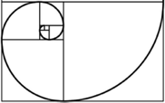

**This WILL be on your mastery check!**

Spiral Practice

1)  *f(x)* = $\frac{5}{6}$ ( - 3x + 6), find f(4).

2)Solve for L in the perimeter formula P = 2L + 2W

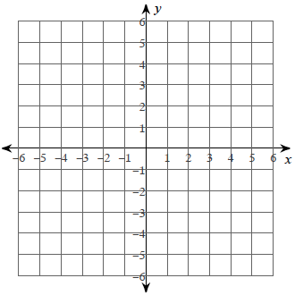

3) Solve the system using any method you would like.

6x – y = –4

x – y = 1

4) Simplify (2x – 3)2

**Review your practice and notes to prepare for the mastery check.**

**Lesson 5 – 2: Solving Quadratics − Factoring**

Write your Questions here!

**Learning Target: I can solve quadratic equations by factoring.**

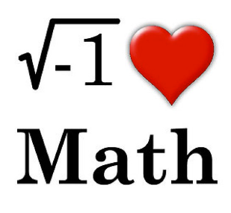A.REI.4b

Begin 5–2 Video 1

In this lesson you will learn how to solve quadratic equations in *___________*. A polynomial is in factored form if it is written as the _________ of two or more linear factors. This is the same basic idea as intercept form.

**Zero-Product Property**: Let *a* and *b* be real numbers. If $ab=0$, then $a=0$ or $b=0$.

***nom de plume***

* zeros
* x-intercepts
* solutions
* roots

**Steps for Solving Quadratic Equations Using Factoring**

1. Make sure each equation is in ____________.
2. Set each factor equal to _______.
3. _________ each equation.

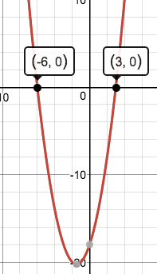

**Example 1:** **Example 2:**

Solve: $\left(x+6\right)\left(x-3\right)=0$ Solve: ${\left(2x-3\right)}^{2}=0$

**Example 3:** **Example 4:**

Solve: $\left(x+6\right)\left(x-6\right)=0$ Solve: $3x\left(x+6\right)=0$

**You Try:**

**Find the zeros of each function.**

1. 2. 3.

**5 – 2 Practice**

Write your Questions here!

**Find the zeros of each function.**

1. *h(x)* = -3(x + 2)(x – 3) 2. *f (x)* = (x – 5)2 3.

4. (3x + 4)(x + 5)=f(x) 5. 6.

7. 8. 9.

10. 11. 12.



**This WILL be on your mastery check!**

Spiral Practice

1) Find the greatest common factor 60 and 40.

2) Rewrite 4•x•x•x using exponents.

3) Write 3x3y2 in expanded form (as repeated multiplication)

4) Simplify 2x(x – 2)2 5) Simplify (2x – 3) (2x + 3)

**Review your practice and notes to prepare for the mastery check.**

**Lesson 5 – 3: Factoring**

Write your Questions here!

**Learning Target: I can factor a polynomial.**

A.SSE.3a

Begin 5 – 3­ Video 1

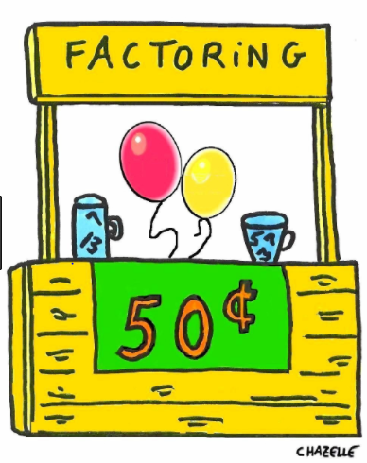In the previous two lessons we’ve covered how to graph a quadratic that is in factored form as well as how to solve them. But what if the equation is given to you in a different form? What if you don’t have nice pretty factors that can be set equal to zero? In this lesson we will show you how to factor a quadratic equation and therefore be able to use those skills from lesson 5­–1 and 5–2.

Vocabulary:

- Complete Factorization over the Integers

**Expression Factors**

4x2y 4, x2 (x and x), and y

(x-2)(x+3) (x-2) and (x+3)

**________** is the process of breaking down algebraic expressions into the most simplified form of all of its factors. To Factor a quadratic expression means to write it as the product of two linear expressions.

There are many strategies to factoring, and we will learn several of them in this unit. No matter what strategy we use, we will **ALWAYS** first look for a **______**, *greatest* *common factor,* and ________ that out before proceeding with other strategies.

**Example 1:**

Factor $6x^{2}+2x$

**______ ( )**

**______ ( + )**

This is the “factored form”.

1. Find the _______ of all terms.

2. Write down your _____, then a set of parenthesis.

3. To find out what goes in the parenthesis, you can _____________ _________________!

**Steps for Solving Quadratic Equations Using Factoring (Extended Edition)**

1. Make sure each equation is equal to _______.
2. Check to see if there is a _____ that can be factored out.
3. _________.
4. Set each factor equal to ______.
5. ________ each equation.

**Example 2:**

Factor and solve:

$$3x^{2}-27x=y$$

**You try:**

What are the factors of:

1. -2x2 2. x(x−1)(2x+3)

Write your Questions here!

Factor and solve the following equations.

3. 12a2 – 18a = 0 4. 9x2 – 27x = y

Begin 5 – 3­ Video 2

**Factoring $ax^{2}+bx+c=y$ when a ≠ 1**

Quadratics in the form $y=ax^{2}+bx+c$ are in Standard Form.

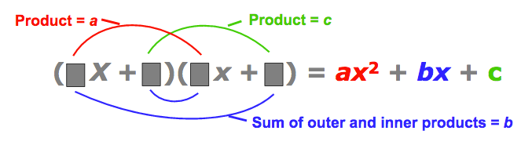Think about where our numbers come from when we multiply binomials. Factoring trinomials is like multiplying in reverse!

**Example 3:**

|  |  |
| --- | --- |
| Ask yourself: | 6x² + 62x + 72 = f(x) |
| **Is there a GCF?** – Better factor that out. |  |
| **Is *a* or *c* prime? If so,** **“lock in” those factors** –we won’t erase those! |  |
| **What should our signs be–same or different?** |  |
| Try factors of c remembering these two things to make your life easier (note: if you forget them, it’s ok–it just makes you have to check more)   1. **Factors that are closer together are luckier. (I don’t think there’s a reason; they just are.)** 2. **If the original does not have a GCF, *none of the factor binomials can have a GCF.*** | |
| So we want to multiply to equal 36….6 and 6 are closest. | But wait! (3x + 6) has a GCF so it can’t work! |
| Ok, how about 9 and 4? And I better not put the 9 with the 3! Now I’ll check!  Yippee‼ ☺ |  |

**Now we can solve!**

**You try’s will be after video 4.**

Write your Questions here!

Begin 5 – 3­ Video 3

**Example 4:**

|  |  |
| --- | --- |
|  | 25x² − 30x + 9 = y |
| Oh, poop. No primes! At least we know we’ll need two negative signs! |  |
| Let’s see…5 and 5 are the closest factors of 25. −3 and −3 are the closest for 9.  It’s our lucky day! Got it on the first try‼ ☺ |  |

**Now Solve!**

**Side Note:**

If the two binomials are identical, you may see it written as

$${(5x-3)}^{2}=(5x-3)(5x-3)$$

**You try’s will be after video 4.**

Begin 5 – 3­ Video 4

**Example 5:**

|  |  |
| --- | --- |
|  | 3x² + 11x – 4 = 0 |
| Let’s “lock in” 3x and x |  |
| What should our signs be–same or different? |  |
| So we want to multiply to equal 4….2 and 2 are closest. And I can pair them anywhere. |  |
| Ok, guess I’ll try 4 and 1. |  |
| Well, guess it wasn’t my lucky day….I’ll switch 4 and 1.  Ok, it did take me 3 tries, but I got it! ☺ |  |

**Now Solve!**

**You try:**

Write your Questions here!

**Factor and solve each of the following equations.**

1. $2x^{2}+x-28=0$ 2. $y=48x^{2}-88x+40$

Begin 5 – 3­ Video 5

**Factoring special cases**

This is one situation where the special cases are actually going to be a bit simpler than the typical problem. Let’s look at what happens when some of our trinomial values are missing.

**Example 6:**

|  |  |
| --- | --- |
|  | x2 – 3x = 28 |
| We really need to fix this so that all terms are together before we start.  Basically, set it equal to zero. |  |
| Um…where is my a? That must mean a = 1. We can handle that. |  |
| Let’s “lock in” x and x. |  |
| What should our signs be–same or different? |  |
| Ok, so what adds to −3 and multiplies to −28. 4 and 7 are closest. And I want the sum to be negative. So lets try putting the negative with 7.  Another factoring problem done! ☺ | **MaTh SoNg** |

**Now Solve!**



**You try problems will be after video 7.**

Write your Questions here!

Begin 5 – 3­ Video 6

**Example 7: $ax^{2}+bx…c=0$**

|  |  |
| --- | --- |
|  | x² + 9x = y |
| What the what?! No c? Oh, that just means c=0. |  |
| Let’s “lock in” x and x. |  |
| What should our signs be–same or different? |  |
| Ok, so what adds to 9 and multiplies to 0. Well, 0 times anything is 0, so one of my numbers has to be 0. The other one has to be 9 since 0 plus a number is that same number. |  |

**Now Solve!**



Wait just one second! Couldn’t I have done this more easily?

Yep. Don’t forget to be on the lookout for GCF’s of all shapes and sizes! It’s a great time-saving tool!

Begin 5 – 3­ Video 7

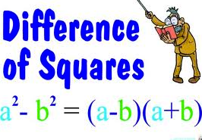

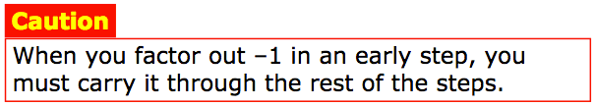**Example 8: $x^{2}+c…b=0$**

|  |  |
| --- | --- |
|  | −2x² + 98 = y |
| GCF!!!! |  |
| No b value means b=0. |  |
| Let’s “lock in” x and x. |  |
| What should our signs be–same or different? |  |
| Ok, so what adds to 0 and multiplies to equal -49. The only way to add to 0 is to have opposites. So what numbers are opposites and multiply to equal -49? |  |

**Now Solve!**

**Are all quadratic equations factorable? Nope! And that is super annoying…**

Write your Questions here!

Let’s try $3x^{2}-7x+12$….

**You try: Factor and identify the roots of each of the following quadratics.**

1. $4v^{2}+8v=y$ 2. $9x^{2}-16=f(x)$ 3. $x^{2}+8x+12=0$

Begin 5 – 3­ Video 8

**Want to do a word problem? Okay, if you insist.**

**Example 9:** Jocelyn throws a ball up with an initial velocity ($v_{0}$) of 32 ft/sec at an initial height ($h_{0}$) of 240 ft. Use the equation $h(t) = -16t^{2} + v_{0}t + h_{0}$.

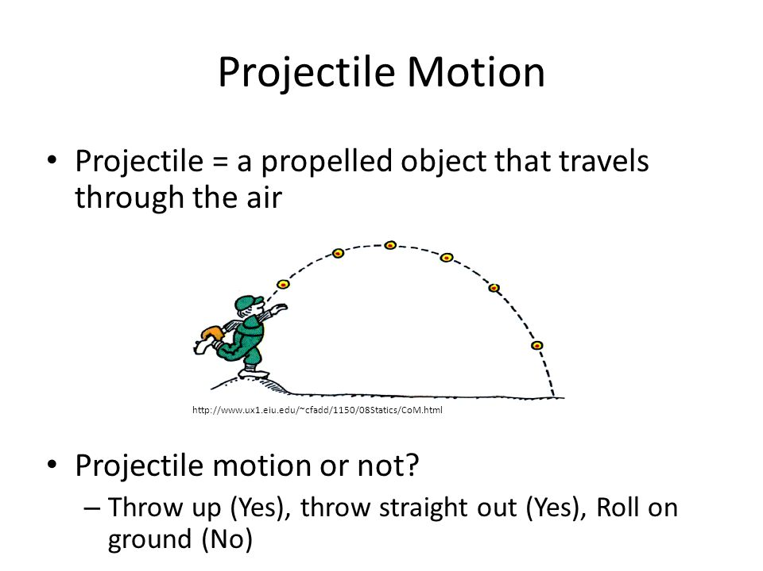

a) When will the ball hit the ground?

b) Based on your answer, what domain

makes since in this scenario?

c) If Jocelyn wanted to catch the ball at the same height at which she threw it from, how many seconds would it take for the ball to reach that height?

**Practice 5 – 3**

Write your Questions here!

**Factor the following expressions.**

1. 2. 3.

**Factor each of the following quadratic expressions.**

4. 5. 6.

7. 8. 9.

10. 11. 12.

**Factor and identify the zeroes of each of the following equations.**

13. 14. 15.

16. 17. 18.

19. 20. 21.

22. Write a quadratic equation (in intercept form) that would have x-intercepts at $(3,0)$ and $(-5,0)$.

Write your Questions here!

23. Write a quadratic equation (in standard form, hint: just multiply your binomials) that would have x-intercepts at and .

24. Bill throws a water balloon from his hotel balcony with an initial velocity of 32 ft/sec at a height of 128 feet. When will the balloon reach his friend whose balcony is at 80 feet above the ground? Use $h(t) = -16t^{2} + v_{0}t + h_{0}$ to answer.

25. Write a polynomial to represent the area of the shaded region. Solve for x given that the area of the shaded region is 48 square units.

$$x+3$$

$$3x$$

$$4$$

**Hint: Total area – area of inner rectangle = area of shaded region**

**Hint number 2: Can you have a negative height?**

26. A ball is thrown with an initial velocity of 64 ft/sec from a start height of 192 feet. Use $h(t) = -16t^{2} + v_{0}t + h_{0}$ to answer the following questions.

a) When does the ball hit the ground? Based on your answer, what domain makes sense in this scenario?

b) When is the ball at a height of 112 feet?



**This WILL be on your mastery check!**

Spiral Practice

Write your Questions here!

1) Simplify -b( -4 - 7b)

2) Solve x2 = 4

3) Solve x2 – 2 = 2

4) Mr. Bean buys a plant at the nursery when it is 8 cm high. He measures the height of the plant at the end of every week and finds that it grows at a rate of 2 cm per week. Make a table and sketch the graph.

|  |  |  |  |  |  |  |  |  |  |
| --- | --- | --- | --- | --- | --- | --- | --- | --- | --- |
| weeks |  |  |  |  |  |  |  |  |  |
| height |  |  |  |  |  |  |  |  |  |

Write an equation to represent this situation.

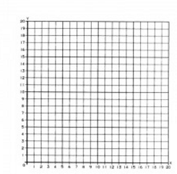

What is the domain and range of this function?

Would this be continuous or discrete function? Why?

What is the rate of change?

Does it have an X and Y intercept? If so, what are they?

What is the interval of increase and the interval of decrease?

**Review your practice and notes to prepare for the mastery check.**

**Lesson 5 – 4: Solving Quadratics – Square Roots**

Write your Questions here!

**Learning Target: I can solve simple quadratic equations by taking square roots.**

Vocabulary:

- Root

A.REI.4b

Begin 5−4 Video 1

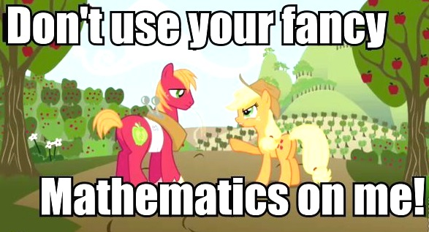When solving linear equations in Unit 1 we relied heavily on inverse operations. This will remain true when solving quadratics. The problem is that isolating the x value becomes a bit more complicated with quadratics since there is more than one. We’ve talked about solving by factoring. However, this assumes that your quadratic is either in intercept form, $f(x) = a(x – p)(x – q)$, or standard form, $f\left(x\right)=ax^{2}+bx+c$.

Things are actually a bit simpler if you are missing that middle term. This lesson will give you a method for solving quadratics of the form $f\left(x\right)=ax^{2}+c$.

Recall that the inverse operation of squaring a number is taking the ___________.

So $\sqrt{x^{2}}=±x$, $\sqrt{4}=±2$ and $\sqrt{{4x}^{2}}=±2x$

We can use this fact to solve simple quadratic equations.

**Example 1:** x2 = 49 **Example 2:** x2 = 50

Every square root, with the exception of $\sqrt{0}$, will have TWO answers. Both a positive and negative root.

**You try:** Solve the following equations for x.

1. x2 = 12 2. x2 = 81

Begin 5−4 Video 2

Not every quadratic equation will be a one-step solution. At times, we have to work to get the x2 _________ before taking the _________.

**Steps for Solving Quadratic Equations Using Square Roots**

1. Simplify each side of the equation by _________ and _________________.
2. Move all ____________ to one side of the equation.
3. Get  by itself using _________________.
4. Take the ________________ of both sides of the equation.
5. There will ALWAYS be a ____________ AND a ___________ answer.

**Example 3: ${(4x-6)}^{2}+3=12$** **Example 4: ${2(x}^{2}-5)=-x^{2}-1$**

Write your Questions here!

**You try:** Solve the following equations for x.

$1. {(x+2)}^{2}-4=0$ 2. ${2x}^{2}-331=7$

Begin 5−4 Video 3

The height of a falling object can be found using the formula below.

$$h=-16t^{2}+h_{0}$$

where $h_{0}$ is the initial height.

and *h*  is the ending height.

**Example 5:** The tallest building in the USA is in the One World Trade Center in New York City. It is 1776 feet tall. If you accidentally dropped your Mountain Dew bottle off the roof, how long would it take to hit the ground?

Begin 5−4 Video 4

Sometimes there are extra variables. Recall from lesson 1−7: “ Literal equations are equations with two or more variables.”

Just as with previous examples, we will solve quadratic literal equations using inverse operations.

**Example 6:**

$h=-16t^{2}+v_{0}t+h_{0}$ Solve for $h_{0}$

**Example 7:**

$V=\frac{1}{3}πr^{2}h$ Solve for *r*

**5-4 Practice**

Write your Questions here!

**Solve each quadratic equation.**

1. 2. 3.

4. 5. 6.

7. 8. 9.

**Solve for the indicated variable:**

10. for *r* 11. for *b*

12. for *x* 13. for *j*

14. for h 15. for x

16. for *m* 17. for *r*

18. The second tallest building in the USA is in Chicago, Illinois. It is 1450 ft. tall. How long would it take a penny to drop from the top of the building to the ground? Use $h=-16t^{2}+h_{0}$

Write your Questions here!

19. Angel Falls in Venezuela is the tallest waterfall in the world. Water falls uninterrupted for 2421 feet before entering the river. The height above the river in feet of water going over the edge of the waterfall is modeled by

$h\left(t\right)=-16t^{2}+2421$, where *t* is the time in seconds after the initial fall.

a) Estimate the time it takes for the waters to reach the river.

b) Ribbon Falls in California has a height of 1612 ft. Approximately how much longer does it take water to reach the bottom when going over Angel Falls than when going over Ribbon Falls?

20. If a tightrope walker falls, he will land on a safety net. His height h in feet after a fall can be modeled by $h\left(t\right)=60-16t^{2},$ where t is the time in seconds. The safety net is 11 feet off the ground. How many seconds will the tightrope walker fall before landing on the safety net.

21. You drop a rock from a cliff that is 520 feet high. How long will it take to hit the ground?

22. You drop a pencil off your desk that is 3 feet high. How long will it take for the pencil to hit the floor?

1)In order to calibrate beakers, it is necessary to know how the height of the liquid depends on the volume in the beaker. The sketch graphs below represent the height-volume relationship for each beaker on the same system of axes. Which graph best represents the height-volume relationship for each beaker. Explain your choice in each case.



**This WILL be on your mastery check!**

Spiral Practice

Write your Questions here!

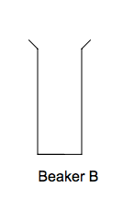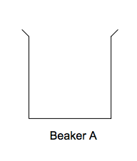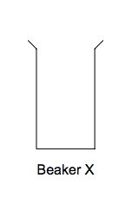

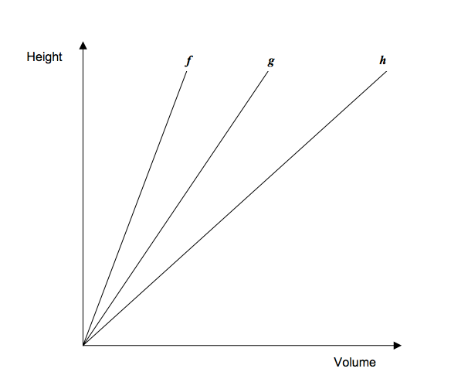

2) The school that Jacob attends is selling tickets to a choral performance. On the first day of ticket sales the school sold 7 senior adult tickets and 1 student ticket for a total of $28. The school took in $80 on the second day by selling 8 senior adult tickets and 8 student tickets. What is the price of one senior adult ticket? What is the price of one student ticket?

**Review your practice and notes to prepare for the mastery check.**

**Lesson 5 – 5: Solving Quadratics – Completing the Square**

Write your Questions here!

**Learning Target: I can solve quadratic equations by completing the square.**

A.REI.4a & A.REI.4b

Begin 5−5 Video 1

Vocabulary:

- Complete the Square

Many quadratic equations contain expressions that are not _____________ AND cannot be easily _______. These equations require us to learn yet another method of solving.

In this lesson, we are going to be using algebraic properties to rewrite any quadratic expression as a perfect square.

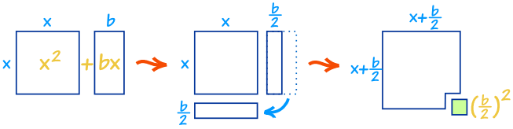

**Steps for Solving Quadratic Equations by Completing the Square**

1. [image]Move the _________ to the other side.
2. Find the number that “completes the square” using the formula,
3. _____ that number to **______** sides!
4. ________. NOTE: ${\left(x+\frac{b}{2}\right)}^{2}$ = #

Just cut the middle number in half and square it!

1. Take the ______________ of each side.
2. Solve for x.

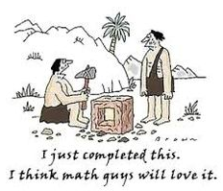

**Example 1:** **You try:**

Solve: $x^{2} = 6x + 4$ Solve: $x^{2}-2x-1=0$

**Example 2: You try:**

Solve: ${4x}^{2}+32x+16=0$ Solve: $2x^{2}+4x-4=0$

**5-5 Practice**

Write your Questions here!

Solve each equation

1. 2. 3.

4. 5. 6.

7. 8. 9.

10. 11. 12.

13. If is added to $x$, the sum is 20. Give at least one possible value of .

14. If is added to $x$, the sum is 56. Give at least one possible value of $x$.

Write your Questions here!



**This WILL be on your mastery check!**

Spiral Practice

Word Bank:

Coefficient, Equation, Inequality, Terms, Variable, Expression, Variable, Constant, Exponent, Consecutive

1. ____________________: an unknown quantity or expression whose value can change.

2. ____________________: parts of an expression separated by + or – signs

3. ____________________: the part of math sentence whose value is always the same, represented by numeral.

4. ____________________: A numerical quantity placed before and multiplied by the variable in an algebraic expression.

Write the proportion and solve:

5) A recipe calls for 1/3 cup of milk for every 1 and ½ cups of flour. If you increase the recipe to use 3 cups of flour, how many cups of milk are needed?

**Review your practice and notes to prepare for the mastery check.**

**Study Guide**

Factor.

**(Lesson 5−3)**

1. 81x2 -100y2 2. 6x2 -3x – 9 3. 8x2 - 6x - 20

4. 25x2 – 36y2 5. 6x2 -4x -10 6. 10x2 -16x – 8

Solve each of the equations for the indicated variable.

**(Lesson 5−4)**

7. Solve for h 8. Solve for h 9. Solve for r

V = $πr^{2}h$ SA = $2πr^{2}$ + $2πrh$ B = $r^{2}h$

Factor each of the following:

**(Lesson 5−3)**

10. x2 – 10x + 25 11. 4x2 + 28x + 49 12. x2 + 7x + 12

What are the solutions (roots or zeroes) to the following quadratics? (Try factoring 1st. If not factorable use completing the square.)

**(Lesson 5−2, 3 and 5)**

13. 2x2 -14x =-24 14. 15. x2 + 4x = -1

Find the zeroes.

**(Lesson 5−4)**

16. (x – 1)2 = 25 17. (x + 7)2 = 8

18. If x2 is added to 10x, the sum is 24. What is the possible value(s) of x?

**(Lesson 5−5)**

19. Marcus threw a ball into the air (to pass the ball) to Jacob. Jacob caught the ball as it was coming back down at 5 feet. The following function describes the height of the ball as a function of time (t seconds after the ball was thrown). How many seconds passed until Jacob caught the ball.

h = −16t2 + 32t +5

**(Lesson 5−3)**

20. What is the GCF of the expression? 48x2 – 24xy + 60x

**(Lesson 5−3)**

21. The expression –x2 +19x -90. Find when the expression equals 0.

**(Lesson 5−3)**

22. What number should be added to each side of the following equation in order to complete the square?

**(Lesson 5−5)** x2 + 20x = 7

23. Solve by completing the square: x2 + 20x = 7

**(Lesson 5−5)**

24. Solve using the method of your choice x2 -4 = 21

**(I recommend Lesson 5−4)**

25. Write a polynomial to represent the area of the shaded region. Solve for x given that the area of the shaded region is 23 square units.

$$2x+3$$

**Hint: Total area – area of inner rectangle =**

$$x+3$$

$$3$$

**Area of shaded region**

$$2x$$

**(Lesson 5−3)**

26. Solve the following equation by completing the square.

**(Lesson 5−5)** x2 + 10x − 3 = 0

27. Graph the following function and answer the corresponding questions.

**(Lesson 5−1)**

$$y=\frac{1}{2}(x-2)(x+4)$$

y

x

10

-8

-4

2

6

-10

-10

-6

-2

4

8

-10

-2

8

-8

2

-10

4

-4

-6

6

10

x-intercepts: ______ and ______

Vertex:________

Axis of Symmetry:____________

y-intercept:_______

**Glossary**

Complete Factorization over the Integers: Writing a polynomial as a product of polynomials so that none of the factors is the number 1, there is at most one factor of degree zero, each polynomial factor has degree less than or equal to the degree of the product polynomial, each polynomial factor has all integer coefficients, and none of the factor polynomial can written as such a product.

Completing the square: Completing the Square is the process of converting a quadratic equation into a perfect square trinomial by adding or subtracting terms on both sides.

Difference of two squares: A squared (multiplied by itself) number subtracted from another squared number. It refers to the identity 𝑎2 − 𝑏2 = (𝑎 + 𝑏)(𝑎 − 𝑏) in elementary algebra.

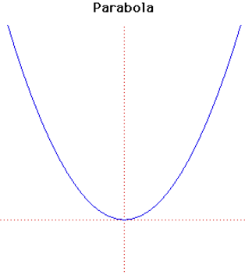

Parabola: The graphical representation of a quadratic ($x^{2}$) equation.

Perfect square trinomial: A trinomial that factors into two identical binomial factors.

Quadratic equation: An equation of degree 2, which has at most two solutions.

Quadratic function: A function of degree 2 which has a graph that “turns around” once, resembling an umbrella–like curve that faces either right–side up or upside down. This graph is called a parabola

Root: The x–values where the function has a value of zero.

Standard form of a quadratic function: $ax^{2}+bx+c$