**Unit 6**

**Delving Deeper Into Quadratics**

**Table of Contents**

**Title Page #**

**Formula Page…………………………………………………………………………2**

**Lesson 6-1 Quadratic Formula..…………………………………………………...3**

**Lesson 6-2 Standard Form .………………………………………………………10**

**Lesson 6-3 Vertex Form.……………………………………………………….…. 16**

**Lesson 6-4 Converting Between Forms…………….…………………………..21**

**Study Guide……………………………………………………………………….…28**

**Glossary.……..………………………………………………………….……..…… 32**

**This packet belongs to: ___________________________**



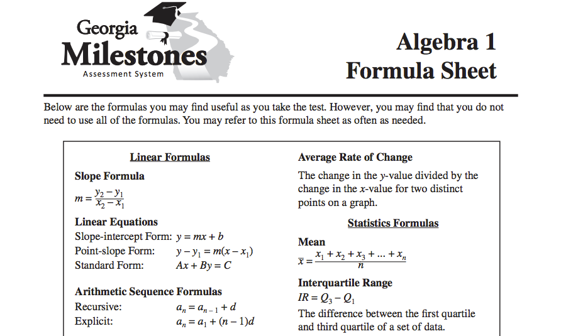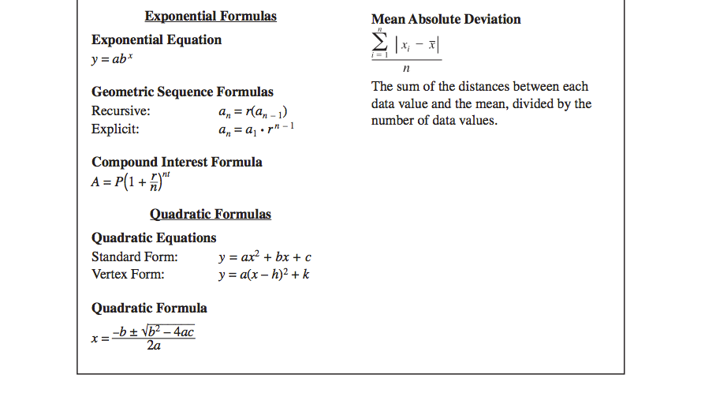

Begin 6-1 Video 1

Write your Questions here!

**Lesson 6-1 The Quadratic Formula**

**Learning Target: I can solve quadratic equations using the quadratic formula.**

Vocabulary:

-Discriminant

-Quadratic Equation

- Standard Form of a Quadratic Equation

A.REI.4b

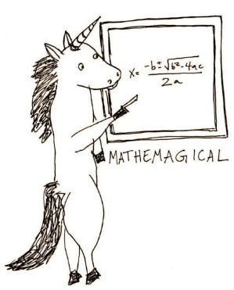We have learned several methods for solving quadratic equations now. We are going to show you one last method before moving on. This final method can be used on ___________ quadratic equation as long as it is written in ______________.

When we say standard form of a quadratic, we mean it looks like this: 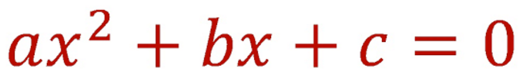

The quadratic formula, in case you can’t read the unicorn’s handwriting (or Mrs. Blalock’s), is:



**MaTh SoNg**

Formula

Sheet!

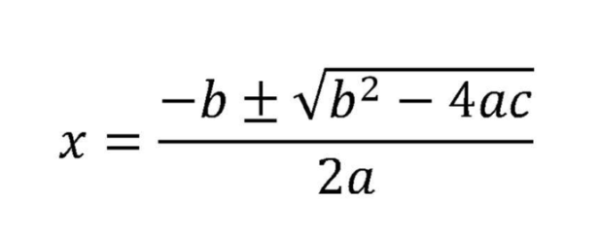

**Steps for Solving Quadratic Equations by using the Quadratic Formula**

1. Write the equation in _______________.
2. Determine the value for ____________.
3. Plug these numbers into the _______________.
4. Simplify.

**Example 1:** **Example 2:**

Find the zero(s): $x^{2}-9x-14=0$ Solve: $-x^{2}+3x=-4$

**You Try:**

1. $3x^{2}=6x+9$**2. $8k^{2}-12k=19$**

Begin 6-1 Video 2

Although we have come to expect two solutions for every quadratic formula, there are scenarios where this is not the case. It is possible for a quadratic equation to have only _____________ or even ___________.

Write your Questions here!

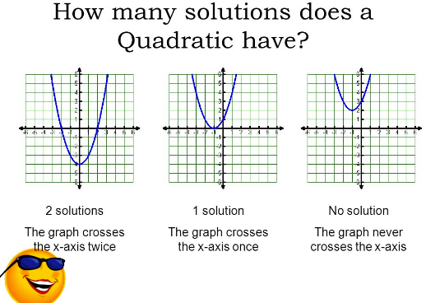

One Real Solution

No Real Solutions

To figure out how many solutions we will have, we look at something called the ______________. The discriminant is a small piece of the ________________.

Remember that the quadratic formula looks like this:

Indian mathematician Brahmagupta is often credited as the first to explicitly define the quadratic formula.



The discriminant is the portion of the quadratic formula that is underneath the ____________. Therefore, the discrimant can be found using:

$$b^{2}-4ac$$

**Example 3:** Find the discriminant of the following quadratic:

$$3x^{2}+3=10x$$

Now, how can we use the discriminant to answer our original question of how many solutions will a quadratic have? Glad you asked!

We have three possible outcomes.

**Find the discriminant and identify how many solutions the function has.**

**Example 4 Example 5 Example 6**

$9x^{2}=20$ $x^{2}-2x+1=0$ $12m^{2}=3m-3$

Write your Questions here!

|  |  |  |
| --- | --- | --- |
| $$b^{2}-4ac=Positive$$ | $$b^{2}-4ac=0$$ | $$b^{2}-4ac=Negative$$ |
| **Two Real Solutions** | **One Real Solution** | **No Real Solutions** |

**You Try!**

**Find the discrimant and identify how many solutions the function has.**

**1. ${2x}^{2}-12x=-18$** 2. $x^{2}-6x+11=0$

Begin 6-1 Video 3

Example 7: A golf ball is hit with an initial vertical velocity of 80 fps.

 models the situation where *h* is the height at any given time (t).

1. How high is the ball after 2 seconds?
2. How many seconds would it take the ball to hit the ground (the height would be h=0)?
3. When will the ball reach 48 feet?

You Try:

Write your Questions here!

A baseball is hit with an initial vertical velocity of 121 fps and the ball was struck 1 foot above ground.



1. How high is the ball after 2 seconds?



1. 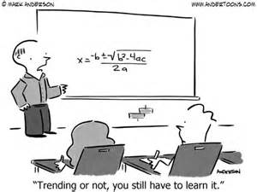How many seconds would it take the ball to hit the ground (the height would be h=0)?
2. When will the ball reach 30 feet?



**6-1 Practice**

**Use the discriminant to identify how many real solutions each quadratic function has.**

1. 2.

3. 4.

**Solve each equation using the Quadratic Formula.**

5. 6.

7. 8.

9 10.

11. 12.

Write your Questions here!

13. 14.

15. 16.

17. 18.

19. A golf ball is hit with an initial vertical velocity of 40 fps

$h\left(t\right)=-16t^{2}+40$ t

1. How high is the ball after 1 seconds?
2. How many seconds would it take the ball to hit the ground (the height would be h=0)
3. When will the ball reach 25 feet?

A punter punts a football hit with an initial vertical velocity of 140 fps and the ball was struck 3 foot above ground.

Write your Questions here!

$$h=-16t^{2}+140t+3$$

1. How high is the ball after 3 seconds?
2. How many seconds would it take the ball to hit the ground (the height would be h=0)?
3. When will the ball reach 200 feet?

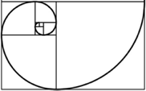

**This WILL be on your mastery check!**

Spiral Practice

1) f(x) = 2x2 + 3x – 4 find f(-2)

2) f(x) = 3(x – 3)2 – 27 if f(x)=0 find the value of x

3) How many terms are in the following polynomial, tell the degree of the polynomial, the leading coefficient, and the constant.

2x – 4x2 + 3x3 – 5 – 3x3 + 14x

Write your Questions here!

4) Find the area the triangle 5) Find the area of the rectangle.

$$\sqrt{75}+5$$

$$\sqrt{30}$$

$$10\sqrt{7}$$

$$\sqrt{7}+4$$

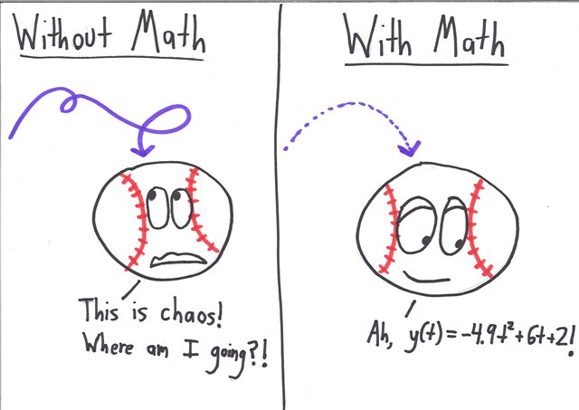

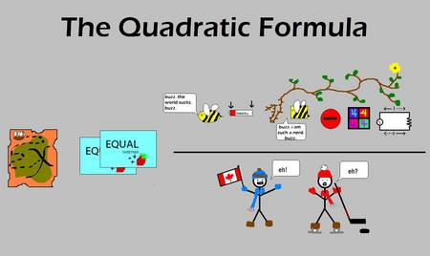

Begin 6-1 Video 3

**Lesson 6-2: Graphing Quadratic Equations – Standard Form**

Begin 6-2 Video 1

Write your Questions here!

**Learning Target: I can graph quadratic equations from standard form.**

F.IF.7

Vocabulary:

- Axis of Symmetry

- Parabola

- Roots

- Standard Form

- Vertex

**Guided Notes:** Recall that standard form of a quadratic is

Formula

Sheet!

$$y=ax^{2}+bx+c$$

**Steps for Graphing a Quadratic Equation in Standard form:**

1. Put the equation in standard form: _______________
2. Identify the values of _______________
3. ****Find the axis of symmetry: $________________$
4. Construct a table of values for x and y. You need a total of 5 points!
5. Plot the points and connect them with a __________________ and arrows.

|  |  |
| --- | --- |
| x | y |
|  |  |
|  |  |
|  |  |
|  |  |
|  |  |

* If “a” is positive, the quadratic function will open _____. If “a” is negative, the quadratic function will open ____________.

**Example 1: $y={2x}^{2}-4x-2$**

**A couple of tips for choosing points:**

1. Put x value (from the axis of symmetry) in the ________ of your table. This point will be your _________.

2. Always use ______ as one of your points. This gives you your _________.

3. Remember that your axis of symmetry serves as a ________. Every point you calculate will have a mirror image on the other side of this line

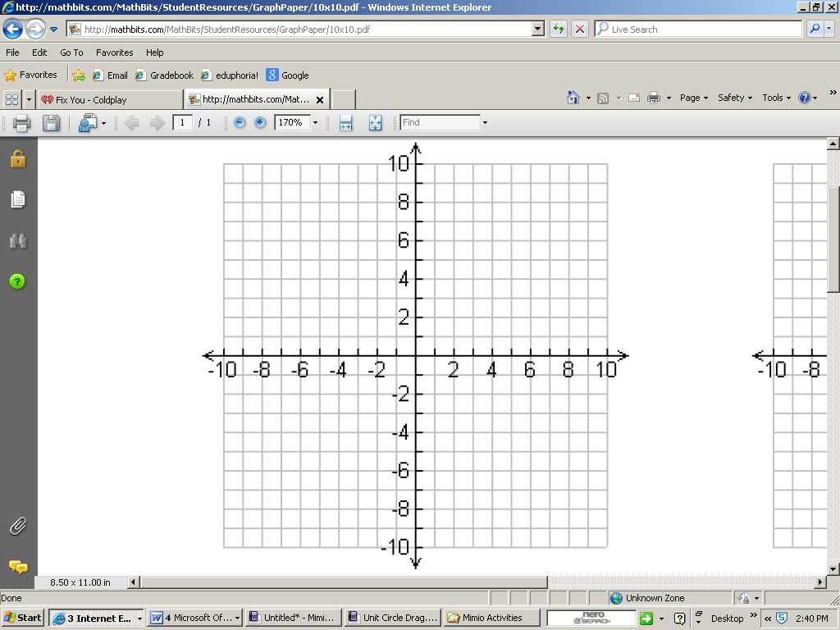

1. 
2. Opens up or down? ______
3. Axis of Symmetry: _______________
4. Vertex: _________

Max: ________ or Min: _______

1. Root(s): _______, ________
2. Y-intercept: ________
3. Domain: _________
4. Range:_________



Write your Questions here!

**Example 2: $y=-2x^{2}+4x+1$**

|  |  |
| --- | --- |
| x | y |
|  |  |
|  |  |
|  |  |
|  |  |
|  |  |

1. 
2. Opens up or down? ______
3. Axis of Symmetry: _______________
4. Vertex: _________

Max: ________ or Min: _______

1. Root(s): _______, ________
2. Y-intercept: ________
3. Domain: _________
4. Range:_________
5. Root(s): _______, ________
6. Y-intercept: ________
7. Domain: _________
8. Range:_________



**Quadratic**

**You Try!**



$y={2x}^{2}+4x+1$

|  |  |
| --- | --- |
| x | y |
|  |  |
|  |  |
|  |  |
|  |  |
|  |  |

1. 
2. Opens up or down? ______
3. Axis of Symmetry: _______________
4. Vertex: _________

Max: ________ or Min: _______

1. Root(s): _______, ________
2. Y-intercept: ________
3. Domain: _________
4. Range:_________
5. Root(s): _______, ________
6. Y-intercept: ________
7. Domain: _________
8. Range:_________

**6-2 Practice - Graphing From Standard Form**

Write your Questions here!

Use the table to graph the given quadratic equations and answer the accompanying questions.

|  |  |
| --- | --- |
| x | y |
|  |  |
|  |  |
|  |  |
|  |  |
|  |  |

 1. $y=-x^{2}$

1. Opens up or down? ______
2. Axis of Symmetry: _______________
3. Vertex: _________

Max: ________ or Min: _______

1. Root(s): _______, ________
2. Y-intercept: ________
3. Domain: _________
4. Range:_________

2. $y=2x^{2}-8x+10$

|  |  |
| --- | --- |
| x | y |
|  |  |
|  |  |
|  |  |
|  |  |
|  |  |

1. Opens up or down? ______
2. Axis of Symmetry: _______________
3. Vertex: _________

Max: ________ or Min: _______

1. Root(s): _______, ________
2. Y-intercept: ________
3. Domain: _________
4. Range:_________

3. $y=-x^{2}+2x-5$

Write your Questions here!

1. 
2. Opens up or down? ______
3. Axis of Symmetry: _______________
4. Vertex: _________

Max: ________ or Min: _______

1. Root(s): _______, ________
2. Y-intercept: ________
3. Domain: _________
4. Range:_________

|  |  |
| --- | --- |
| x | y |
|  |  |
|  |  |
|  |  |
|  |  |
|  |  |

4. $y=x^{2}+4x-3$

1. 
2. Opens up or down? ______
3. Axis of Symmetry: _______________
4. Vertex: _________

Max: ________ or Min: _______

1. Root(s): _______, ________
2. Y-intercept: ________
3. Domain: _________
4. Range:_________



|  |  |
| --- | --- |
| x | y |
|  |  |
|  |  |
|  |  |
|  |  |
|  |  |

5. $y=-2x^{2}+4x+2$

Write your Questions here!

1. 
2. Opens up or down? ______
3. Axis of Symmetry: _______________
4. Vertex: _________

Max: ________ or Min: _______

1. Root(s): _______, ________
2. Y-intercept: ________
3. Domain: _________
4. Range:_________



|  |  |
| --- | --- |
| x | y |
|  |  |
|  |  |
|  |  |
|  |  |
|  |  |

6. $y=-2x^{2}+16x-29$

1. 
2. Opens up or down? ______
3. Axis of Symmetry: _______________
4. Vertex: _________

Max: ________ or Min: _______

1. Root(s): _______, ________
2. Y-intercept: ________
3. Domain: _________
4. Range:_________



|  |  |
| --- | --- |
| x | y |
|  |  |
|  |  |
|  |  |
|  |  |
|  |  |



**This WILL be on your mastery check!**

Spiral Practice

Write your Questions here!

1) Describe the transformations that have occurred to quadratic function f(x) = x2

f(x) = –2(x + 3)2 – 5



2) If a furniture store buys furniture at wholesale cost of *x* and marks up the furniture by 95% to sell on their showroom floor, create a function p(x) that represents the price of the item in the store.

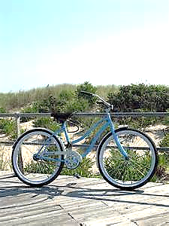

3) To rent a bicycle on the beach boardwalk, the initial cost is $10 plus an additional charge of $5 per hour. A maximum of $30 has been budgeted for this activity. Create a linear function to model the situation and tell the domain and range.

4) Three times a number is six less than twice that number. Find the number.

Begin 6-3 Video 1

**6-3 Graphing Quadratic Equations – Vertex Form**

Write your Questions here!

**Learning Target: I can graph a quadratic equation from vertex form.**

F.IF.8

Vocabulary:

- Vertex Form of a Quadratic Function

**Guided Notes:**

In Lesson 6-2, we discussed graphing from standard form. Sometimes, we may see quadratics written in another form, called vertex form.

Vertex Form: the vertex is 

Formula

Sheet!

1. Start by putting the ____________ in the center of your table.
2. Construct a table of values for x and y. You need a total of 5 points!
3. Plot the points and connect them with a U-shaped curve & arrows

**Example 1:** 

**Vertex: ________________**

**Extrema:_______________**

**AOS:___________________**

**Zeros:__________________**

**y-intercept: _____________**

**Domain:_________________**

**Range:__________________**

y

x

10

-8

-4

2

6

-10

-10

-6

-2

4

8

-10

-2

8

-8

2

-10

4

-4

-6

6

10

|  |  |
| --- | --- |
| *x* | *y* |
|  |  |
|  |  |
|  |  |
|  |  |
|  |  |

**Example 2:**

**Vertex: ________________**

**Extrema:_______________**

**AOS:___________________**

**Zeros:__________________**

**y-intercept: _____________**

**Domain:_________________**

**Range:__________________**

y

x

10

-8

-4

2

6

-10

-10

-6

-2

4

8

-10

-2

8

-8

2

-10

4

-4

-6

6

10



|  |  |
| --- | --- |
| *x* | *y* |
|  |  |
|  |  |
|  |  |
|  |  |
|  |  |

**You Try!**

Write your Questions here!

**1) $y=-2{\left(x-3\right)}^{2}-$ $1$**

y

x

10

-8

-4

2

6

-10

-10

-6

-2

4

8

-10

-2

8

-8

2

-10

4

-4

-6

6

10

**Vertex: ________________**

**Extrema:_______________**

**AOS:___________________**

**Zeros:__________________**

**y-intercept: _____________**

**Domain:_________________**

**Range:__________________**

|  |  |
| --- | --- |
| *x* | *y* |
|  |  |
|  |  |
|  |  |
|  |  |
|  |  |

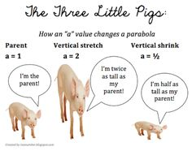



**6-3 Practice - Graphing From Vertex Form**

1 . $y={(x-1)}^{2}+2$



**Vertex: ________________**

**Extrema:_______________**

**AOS:___________________**

**Zeros:__________________**

**y-intercept: _____________**

**Domain:_________________**

**Range:__________________**

|  |  |
| --- | --- |
| x | y |
|  |  |
|  |  |
|  |  |
|  |  |
|  |  |

**2. $y=2{(x+1)}^{2}-5$**

Write your Questions here!



**Vertex: ________________**

**Extrema:_______________**

**AOS:___________________**

**Zeros:__________________**

**y-intercept: _____________**

**Domain:_________________**

**Range:__________________**

|  |  |
| --- | --- |
| x | y |
|  |  |
|  |  |
|  |  |
|  |  |
|  |  |

**3. $y={-(x-1)}^{2}+4$**



**Vertex: ________________**

**Extrema:_______________**

**AOS:___________________**

**Zeros:__________________**

**y-intercept: _____________**

**Domain:_________________**

**Range:__________________**

|  |  |
| --- | --- |
| x | y |
|  |  |
|  |  |
|  |  |
|  |  |
|  |  |

Write your Questions here!

**4. $y=-2{\left(x+4\right)}^{2}-1$**

**Vertex: ________________**

**Extrema:_______________**

**AOS:___________________**

**Zeros:__________________**

**y-intercept: _____________**

**Domain:_________________**

**Range:__________________**



|  |  |
| --- | --- |
| x | y |
|  |  |
|  |  |
|  |  |
|  |  |
|  |  |

**5. $y=-2{\left(x+3\right)}^{2}+3$**

**Vertex: ________________**

**Extrema:_______________**

**AOS:___________________**

**Zeros:__________________**

**y-intercept: _____________**

**Domain:_________________**

**Range:__________________**



|  |  |
| --- | --- |
| x | y |
|  |  |
|  |  |
|  |  |
|  |  |
|  |  |

**6. $y=2{\left(x-2\right)}^{2}-4$**

Write your Questions here!



**Vertex: ________________**

**Extrema:_______________**

**AOS:___________________**

**Zeros:__________________**

**y-intercept: _____________**

**Domain:_________________**

**Range:__________________**

|  |  |
| --- | --- |
| x | y |
|  |  |
|  |  |
|  |  |
|  |  |
|  |  |





**This WILL be on your mastery check!**

Spiral Practice

1. Describe the transformations that have occurred to exponential function f(x) = 4x

f(x) = –2(4 x +3) – 5

Simplify

2) 3(x – 4) (x + 5) 3) 4 (x + 5) (x – 5)

Solve by completing the square.

4) x2 + 10x – 5 = 0 5) 2x2 – 12x + 10 = 4

Write your Questions here!

Begin 6-4 Video 1

**Lesson 6– 4: Converting Between Forms**

**Learning Target: I can convert quadratic equations to different but equivalent forms.**

F.IF.8

**Guided Notes: *Reminder\***

**Vertex Form: $y=a{(x-h)}^{2}+k$**

**Standard Form: $y=ax^{2}+bx+c$**

Converting From **Vertex Form** to **Standard Form**

When you are given a quadratic in vertex form and need it to be in standard form, you should simply _________ and _______________..

**Example 1: Example 2**

$f\left(x\right)={(x-1)}^{2}+8$ $y=2{\left(x+3\right)}^{2}-5$

**You Try!**

1. 2.



Begin 6-4 Video 2

Converting From **Standard Form** to **Vertex Form**

The Goal – Find the Vertex

1. Find the x value (or “h”) of the vertex by using

2. Find the y value (or “k”) of the vertex by _____ into the original equation.

3. “a” will always be the _____________.

4. Write the equation by using your found values for a, h, and k.

Formula

Vertex of a Quadratic: $(\frac{-b}{2a},f\left(\frac{-b}{2a}\right))$

**Example** **3**: $f\left(x\right)=x^{2}+6x+8$**Example 4**: $f\left(x\right)=2x^{2}-8x+4$

Write your Questions here!

**You Try:**

1. 2.



Begin 6-4 Video 3

**Converting to Intercept Form**

To convert a quadratic into ________________, we will need to be able to factor the function. We are already used to factoring quadratics that are written in standard form. However, to be able to factor something in _________________, we will need to first convert it to ___________________. Let’s take a look.

Hint: If you need to review factoring, go back and review lesson 5-2!

**Example 5:**

**Convert to intercept form: $f\left(x\right)=-{\left(x-3\right)}^{2}+4$**

**You Try:**

**Convert to intercept form: $y=2{(x+1)}^{2}-2$**

Examine functions f(x) and g(x) below. Determine whether each function below matches the given graph using vertex, extrema and intercepts.

Begin 6-4 Video 3

Write your Questions here!



$f(x)=x^{2}-5x+4$ $g\left(x\right)=-{\left(x-3\right)}^{2}+2$

• Vertex •Vertex

• Extrema •Extrema

• Roots •Roots

**6-4 Practice - Converting Between Forms**

**Convert the following from vertex form to standard form:**

1. $f\left(x\right)={(x-2)}^{2}+6$

3. $f\left(x\right)=2{\left(x+3\right)}^{2}-5$

5. $f\left(x\right)=-{\left(x-4\right)}^{2}+3$

7. $f\left(x\right)=2{(x+1)}^{2}$

2. $y=-2{\left(x+4\right)}^{2}-1$

4. $y={-(x-1)}^{2}+4$

6. $y=2{(x+1)}^{2}+5$

8. $y={(x-1)}^{2}+2$

Write your Questions here!

**Convert the following from standard form to vertex form.**

9. $f\left(x\right)=6x^{2}+12x+13$

11. $f\left(x\right)=x^{2}-6x+5$

13. $f\left(x\right)=x^{2}+4x$

15. $f\left(x\right)=x^{2}+12x-13$

10. $f\left(x\right)=x^{2}-2x-5$

12. $y=3x^{2}+10x+3$

14. $y=x^{2}-8x+11$

16. $y=2x^{2}+3x-4$

**Convert the following to intercept form.**

17. 18.

19. 20.

21. 22.

23. 24.

Write your Questions here!

**Choose the equation(s) you think best represents the graph. Explain how you know each equation is correct or incorrect. There may be more than one correct answer.**

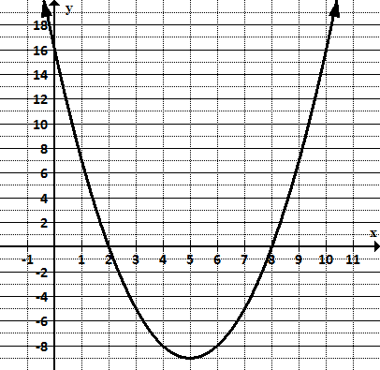a)  

b) 

c) 

d) 

e) 

**Examine the functions below. Which function has the smaller minimum? How do you know?**



$f\left(x\right)=x^{2}-4x+3$

g(x)

Examine functions f(x) and g(x) below. Determine whether each function below matches the given graph using vertex, extrema and intercepts.

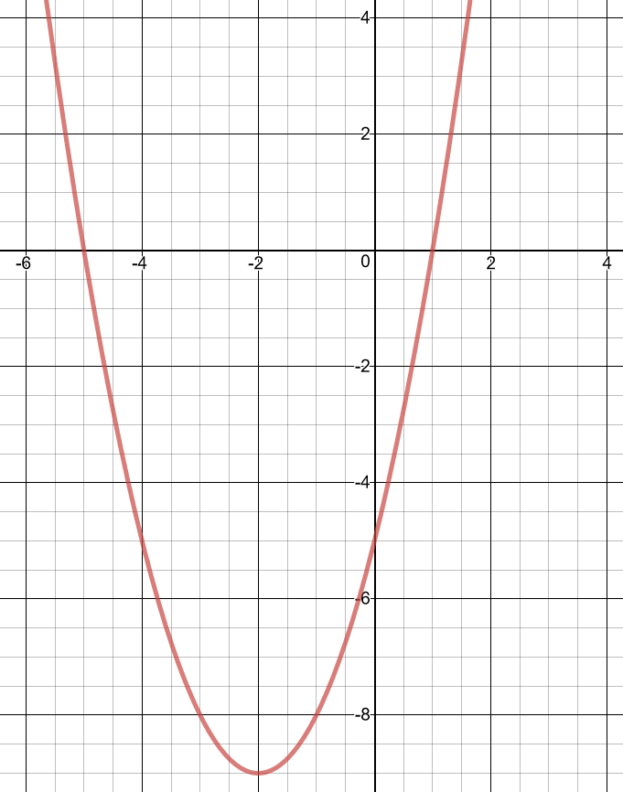

Write your Questions here!

$f\left(x\right)={2x}^{2}+8x-1$ $g\left(x\right)={(x+2)}^{2}-9$

• Vertex •Vertex

• Extrema •Extrema

• Roots •Roots



**This WILL be on your mastery check!**

Spiral Practice

**Convert to Standard Form**

**1) $f\left(x\right)=\left(x-2\right)(x-4)$ 2) $f\left(x\right)=2(x-2)(x+3)$**

3) Aliyah spent half of her weekly allowance on candy. To earn more money her parents let her wash the dog for $10.28. What is her weekly allowance if she ended with $17.11?

Write your Questions here!

X represents ___________________________

Equation: ___________________________

Solution: ___________________________

4) Suppose a video store charges nonmembers $5 to rent each video. A

store membership costs $20 and members pay only $2.50 to rent each video. For what number of videos is the cost the same?



X represents ___________________________

Equation___________________________

Solution: ___________________________

5) The first term of an arithmetic sequence is equal to 200 and the common difference is equal to -10. Find the value of the 20th term.

Formula

Sheet!

The formulas for arithmetic sequences are on your formula sheet!

6) An arithmetic sequence has a common difference equal to 10 and its 6th term is equal to 52. Use this information to write an equation (hint find a1).  Then find its 15th term.

** Unit 6 Study Guide**

Write your Questions here!

What are the solutions (roots or zeroes) to the following quadratics?

**Lesson 6-1**

1) 2x2 -14x =-24 2) 2x2 -10x = -2 3) x2 + 4x = -1

4. Given the expression –x2 +19x -90., find when the expression equals 0.

**Lesson 6-1**

Rewrite the following into standard form. y = ax2 + bx + c.

**Lesson 6-4**

5. f(x) = (x – 4) (x + 5) 6. f(x) = (x – 3)2 + 5 7. f(x) = (x + 5) (2x- 7)

Write in intercept form. $y=a(x-p)(x+q)$

**Lesson 6-4**

8. f(x) = x2 – 10x + 9 9. f(x) = x2 −3x –40 10. f(x) = x2 −9x + 14

Write in Vertex form. .

**Lesson 6-4**

11. 12) 13.

15. How many roots does the quadratic y = x2 – 7x + 10 have?

**Lesson 6-1**

16. Describe how you would tell whether a quadratic has the following amount of **real** solutions. Describe both graphically and based on the discriminant. **Lesson 6-1**

a) No real solution b) one real solution

c) 2 real solutions.

Write your Questions here!

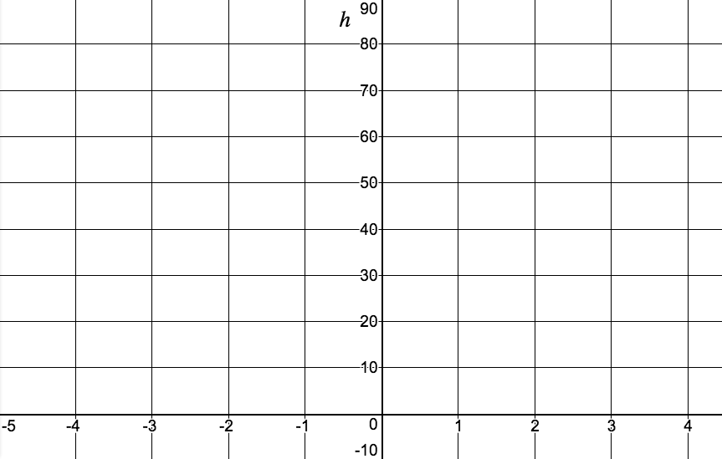

*t*

17. Graph h = -16t2 +40

**Lesson 6-2**

18. Examine the following functions below. Which function has the larger maximum? How do you know?

**Lesson 6-4**

g(x)

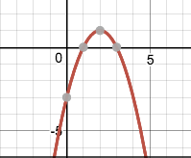

19. A baseball is hit by a batter. The following function describes the height of the baseball as a function of time (t seconds after the ball was struck): **Lesson 6-1**

$$h=-16t^{2}+30t+4$$

a) What was the height of the ball after 0.75 seconds?

b) Approximately when will the ball hit the ground (assuming no one catches it.)?

**Give the vertex and axis of symmetry for the given function**.

**Lesson 6-2, 6**-3

Write your Questions here!

20. 21. 22.

23. How can you tell whether a quadratic opens up or down?

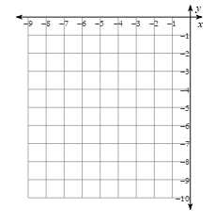24. Graph the following quadratic function:

**Lesson 6-2**

25. Graph the following quadratic function: $y={\left(x+1\right)}^{2}-3$

**Lesson 6-3**

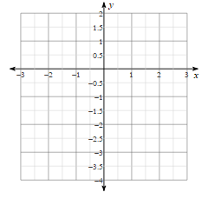

Write your Questions here!

26. Which three equations match the graph to the right? **Lesson 6-4**

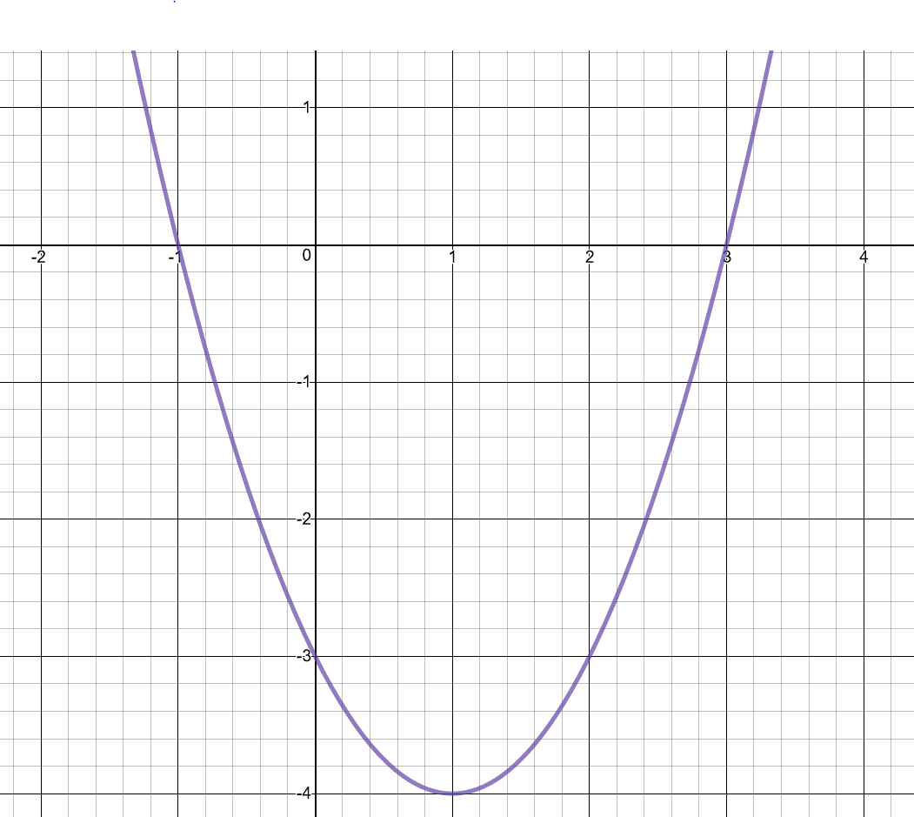

$$y=-\left(x-3\right)\left(x+1\right)$$

$$y=(x-3)(x+1)$$

$$y=x^{2}-2x-3$$

$$f\left(x\right)=({x+1)}^{2}-4$$

$$f\left(x\right)={(x-1)}^{2}-4$$

$$f\left(x\right)=-x^{2}+2x+3$$

**Glossary**

**Axis of Symmetry-** A line that divides the figure into two symmetrical parts in such a way that the figure on one side is the mirror image of the figure on the other side. In a quadratic, the equation for the axis of symmetry is $x=\frac{-b}{2a}$

**Discriminant:-** a function of the coefficients of a polynomial equation whose value gives information about the roots of the polynomial. For a quadratic, the discriminant can be found by finding $b^{2}-4ac$

**Parabola-** The graph of a quadratic function.

**Quadratic Equation-** An equation of a degree 2, which has at most two solutions.

**Roots/Zeros/X-intercepts-** The x-values where the function has a value of zero.

**Standard Form of a Quadratic- $ax^{2}+bx+c$**

**Vertex-** The maximum or minimum value of a parabola, either in terms of y if the parabola is opening up or down, or in terms of x if the parabola is opening left or right. In a quadratic, the vertex is $(\frac{-b}{2a}, f\left(\frac{-b}{2a}\right))$

**Vertex Form:** A formula for a quadratic equation of the form $f\left(x\right)=a{(x-h)}^{2}+k$, where *a* is a nonzero constant and the vertex of the graph is the point $\left(h,k\right).$