**Unit 7**

**Modeling & Analyzing Exponential Functions**

**Table of Contents**

**Title Page #**

**Glossary.……..………………………… 2**

**Formula Sheet.…………………………………… 3**

**Lesson 7-1 Geometric Sequences………………………………4**

**Lesson 7-2 Graphing Exponential Functions…………….………………….6**

**Lesson 7-3 Constructing Exponential Functions…………………………………16**

**Lesson 7-4 Compound Interest & Growth/Decay.……………………………18**

**Lesson 7-5 Solving Exponential Equations……………………….………..25**

**This packet belongs to:**

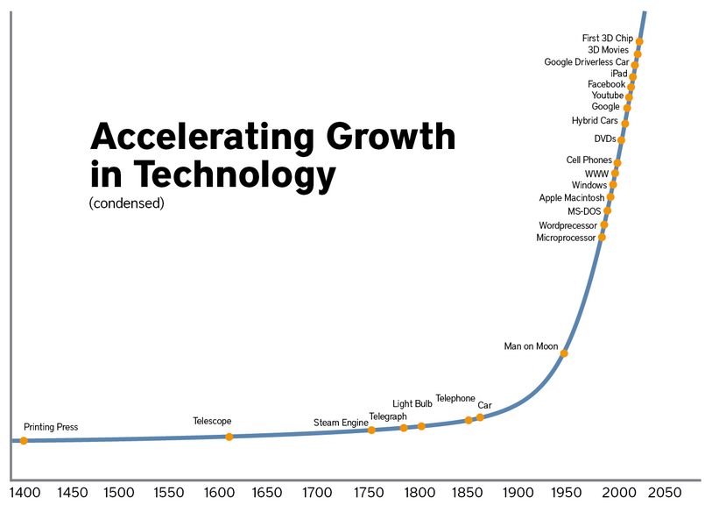

**_________________________________**

**Glossary**

Asymptote: A line that a curve approaches as it heads towards infinity.

Average Rate of Change. The change in the value of a quantity by the elapsed time. For a function, this is the change in the y-value divided by the change in the x-value for two distinct points on the graph.

Continuous. Describes a connected set of numbers, such as an interval.

Discrete. A set with elements that are disconnected.

Domain. The set of x-coordinates of the set of points on a graph; the set of x-coordinates of a given set of ordered pairs. The value that is the input in a function or relation.

End Behaviors. The appearance of a graph as it is followed farther and farther in either direction. • Equation: A number sentence that contains an equals symbol.

Explicit Expression. A formula that allows direct computation of any term for a sequence $a_{1}$, $a_{2}$, $a_{3}$, . . . , $a_{n}$, . . . .

Exponential Function. A nonlinear function in which the independent value is an exponent in the function, as in $=ab^{x}$.

Exponential Model. An exponential function representing real-world phenomena. The model also represents patterns found in graphs and/or data.

Geometric Sequence. A sequence of numbers in which the ratio between any two consecutive terms is the same. In other words, you multiply by the same number each time to get the next term in the sequence. This fixed number is called the common ratio for the sequence.

Growth Factor. The factor by which a quantity multiplies itself over time.

Growth Rate. The percent of increase in a quantity over time.

Interval Notation. A notation representing an interval as a pair of numbers. The numbers are the endpoints of the interval. Parentheses and/or brackets are used to show whether the endpoints are excluded or included.

Natural Numbers. The set of numbers 1, 2, 3, 4, ... Also called counting numbers.

Range. The set of all possible outputs of a function.

Real Numbers. All the rational and irrational numbers; that is, all of the numbers that can be expressed as decimals.

Recursive Formula. A formula that requires the computation of all previous terms to find the value of an.

X-intercept. The point where a line meets or crosses the x-axis.

Y-intercept. The point where a line meets or crosses the y-axis.

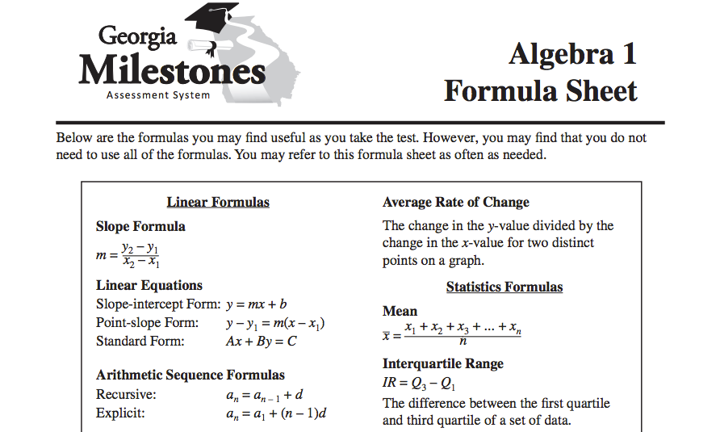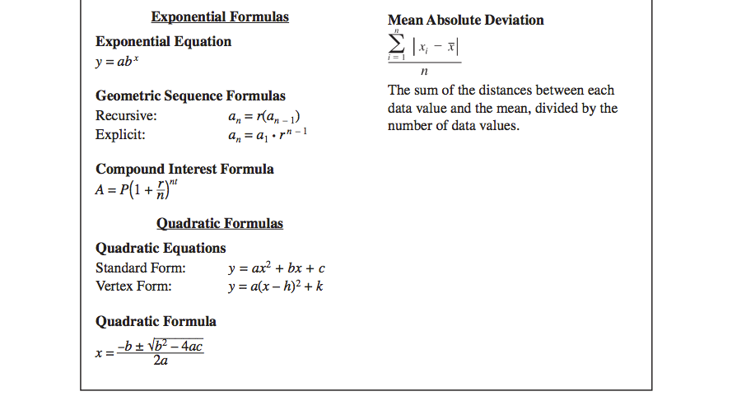

**Lesson 7 – 1: Geometric Sequences**

Write your Questions here!

**Learning Target: I understand that sequences are a function with a domain of natural numbers.**

**F.IF.3 & F.BF.2**

Begin 7−1 Video 1

Vocabulary:

- Discrete

- Explicit Expression

- Geometric Sequence

- Recursive Formula

Recall from Lesson 2-5: Arithmetic Sequences, that we use a special notation for sequences.

In sequence notation, an represents the ________ in the sequence. This becomes your output or *y* value. *n* serves as your ________ or *x* value. *n* stands for the term number. This is also known as the ________.

So $a_{4}=16$ means that the 4th term in the sequence has a value of 16.

In an arithmetic sequence, we add a common difference, *d*, to each term to get to the next term in the sequence.

Geometric sequences work a bit differently. Rather than adding a common difference to each term, we will be multiplying by a common value to move from one term to the next. This value is called the ____________and is represented by the variable *r.*

Determine whether the given sequence is arithmetic, geometric or neither.

**Example 1:** 3, 12, 48, 192, …. **Example 2:**  8, 4, 2, 1, $\frac{1}{2}$, …

Arithmetic, Geometric, Neither? Arithmetic, Geometric, Neither?

Domain: Domain:

Range: Range:

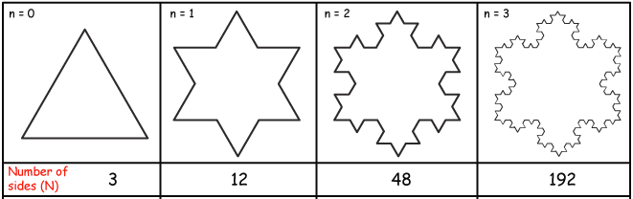

**You try:**

Determine whether the given sequence is arithmetic, geometric or neither.

1. 2, 10, 18, 26, … 2. 81, 27, 9, 3, 1, … 3. 4, 6, 12, 14, 28, …

Arith., Geo., Neither? Arith., Geo., Neither? Arith., Geo., Neither?

Domain: Domain: Domain:

Range: Range: Range:

Write your Questions here!

Begin 7−1 Video 2

To find a term in a geometric sequence, ________ the previous term by *r.*

We can represent this rule with a recursive formula. The recursive formula for geometric sequences is:

Formula

Sheet!

$$a_{n}=r(a_{n-1})$$

Write the recursive definition for each sequence. Use the recursive formula to find the next three terms in the geometric sequence.

**Example 3:** 1, 3, 9, 27, …

**Example 4:** 8, 4, 2, 1, $\frac{1}{2}$, …

**You try:**

Write the recursive definition for each sequence. Use the recursive formula to find the next three terms in the geometric sequence.

1. 2, 10, 50, 250, … 2. 81, 27, 9, 3, 1, $\frac{1}{3}$, …

Begin 7−1 Video 3

To find the output $a_{n}$ of a geometric sequence when $n$ is a large number, you need an equation, or function rule.

Formula

Sheet!

This is where we need the ________________:

$$a_{n}=a_{1}∙r^{n-1}$$

**Example 5:** The first term of a geometric sequence is 128, and the common ratio is 0.5. What is the 10th term in the sequence?

**Example 6:** What is the 13th term of the geometric sequence: 8, -16, 32, -64, …?

**You try:**

Write your Questions here!

1. The first term of a geometric sequence is 1 and the common ratio is 4. What is the 8th term?

2. What is the 8th term of the sequence 625, 125, 25, 5, …?

Begin 7−1 Video 4

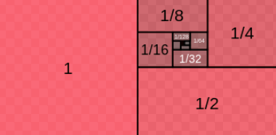Determine whether the following are examples of explicit or recursive definitions and find the indicated term.

**Example 8: Example 9:**

If $a_{1}=-4$ and $a_{n}= {2(a}_{n-1})$ If $a_{n}=5({-1)}^{n-1}$

Find $a_{4}$ Find $a_{6}$

Explicit or Recursive?____________ Explicit or Recursive?________________

Begin 7−1 Video 5

**Example 10:** Write a recursive and explicit definition for the sequence shown in the coordinate plane below.

**Example 11:** Write a recursive and explicit definition for the sequence shown in the table below.

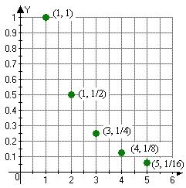

|  |  |  |  |  |
| --- | --- | --- | --- | --- |
| x | 1 | 2 | 3 | 4 |
| y | 50 | 10 | 2 | 0.4 |

**You try:**

Write your Questions here!

1. Write a recursive and explicit definition for the sequence shown in the coordinate plane below.

2.Write a recursive and explicit definition for the sequence shown in the table below.

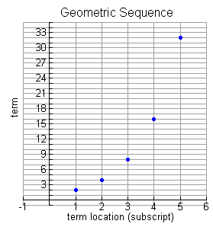

|  |  |  |  |  |
| --- | --- | --- | --- | --- |
| n | 1 | 2 | 3 | 4 |
| $$a_{n}$$ | 4 | 12 | 36 | 108 |

Begin 7−1 Video 6

**Example 7:**

A culture of bacteria doubles every hour.  Mr. Bolton checks the bacteria every hour and records the amount of bacteria. If there are 500 bacteria at the end of the first hour, how many bacteria will there be after 24 hours? Write the problem as a sequence; state the common ratio and write an explicit formula to find the answer.

**You try:**

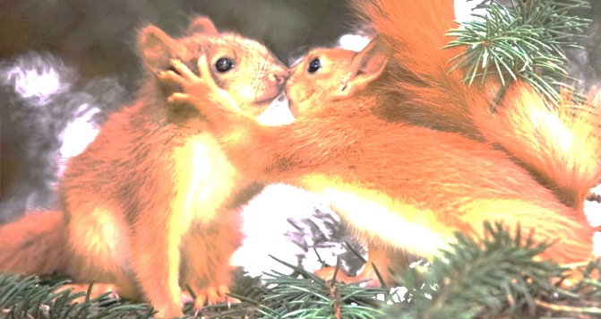A squirrel population triples every month. The park ranger monitors the population at the end of each month. If there are 20 squirrels in the park at the at the end of the first month, how many squirrels will there be at the end of one year? Write the problem as a sequence; state the common ratio and write an explicit formula to find the answer.



Write your Questions here!

**Practice 7-1 Geometric Sequences**

Determine whether the following are examples of explicit or recursive and find the indicated term.

1. If and 3. If $a_{1}=16$ and $a_{n}=\frac{1}{4}(a_{n-1})$

Find $a_{4}$ Find $a_{6}$

Explicit or Recursive?____________ Explicit or Recursive?________________

2. If and 4. If $a_{n}=3({-2)}^{n-1}$

Find $a_{3}$ Find $a_{5}$

Explicit or Recursive?____________ Explicit or Recursive?_____________

5. Determine whether the following sequences are geometric, arithmetic or neither. If they are arithmetic or geometric, write an explicit definition of the sequence.

**a.** 16, 8, 4, 2, …

**b.** 4, 8, 12, 16, …

**c.** 2, 4, 8, 10, …

**d.** 1, 3, 9, 27, …

6. The deer population of northeast GA is dwindling due to human expansion. Each year, the deer population is cut in half. Ranger Rick checks the population at the end of each year. If there are currently 8,000 deer in northeast GA at the end of the first year, how many deer will be left in ten years? Write the problem as a sequence; state the common ratio and write an explicit formula to find the answer.

7. A bacteria population is killed by penicillin. By the end of each day, the population is reduced to $\frac{1}{4}$ its size. If there are 100,000 bacteria in your body at the end of the first day of your treatment, how many bacteria will be left in your body after a seven-day course of penicillin? Write the problem as a sequence; state the common ratio and write an explicit formula to find the answer.

**For each sequence below, find the explicit formula, recursive formula, and the given term.**

9. 16, 32, 64, 128, …

Explicit:______________________________

Recursive:____________________________

Find a7:______________________________

Write your Questions here!

8. 5, 10, 20, 40,…

Explicit:______________________________

Recursive:____________________________

Find a8:______________________________

10. 729, 243, 81, 27, …

11. 4, 8, 16, 32, …

Explicit:______________________________

Recursive:____________________________

Find a10:______________________________

Explicit:______________________________

Recursive:____________________________

Find a8:______________________________

12.

13.

Explicit:______________________________

Recursive:____________________________

Find a7:______________________________

Explicit:______________________________

Recursive:____________________________

Find a6:______________________________

|  |  |
| --- | --- |
| x | y |
| 1 | 3 |
| 2 | 4.5 |
| 3 | 6.75 |
| 4 | 10.125 |

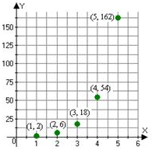14. 15.

Explicit:______________________________

Recursive:____________________________

Find a8:______________________________

Explicit:______________________________

Recursive:____________________________

Find a4:______________________________

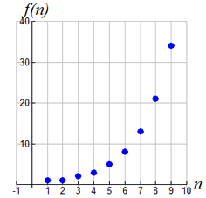16. 17.

Write your Questions here!

|  |  |  |  |  |
| --- | --- | --- | --- | --- |
| n | 1 | 2 | 3 | 4 |
| $$a_{n}$$ | 72 | 24 | 8 | $$2.\overline{6}$$ |

Explicit:______________________________

Recursive:____________________________

Find a6:______________________________

Explicit:______________________________

Recursive:____________________________

Find a7:______________________________

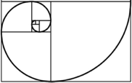

**This WILL be on your mastery check!**

Spiral Practice

**Graph the following equations. Tell the solution to the system.**

$1) \left\{\begin{aligned}x=2 \\ 2x-y=-1\end{aligned}\right.$

2)f(x) = 2(4)x – 2 find

a) f(2) b) f(-1)

3) Given the function

$f\left(x\right)=3^{x+1}$, find the rate of change over the interval [1,2].

**Review your practice and notes to prepare for the mastery check.**

**Lesson 7 – 2: Intro to Exponential Functions**

Write your Questions here!

Vocabulary:

- Asymptote

- Average Rate of Change

- Continuous

- Domain

- End Behaviors

- Exponential Function

- Exponential Model

- Range

- x-intercept

- y-intercept

**Learning Target: I can graph an exponential function using a table.**

F.IF.7e & A.CED.2

Begin 7−2 Video 1

Formula

Sheet!

Standard Form of Exponential Equations is:

$y=ab^{x}$

**Steps for Graphing Exponential Functions:**

1. Chose 5 x-values (inputs).
2. Plug each of your chosen values into the equation.
3. Record the y-values (outputs) in the table.
4. Plot the ordered pairs from your table.
5. Connect the points.
6. Draw the asymptote line.

a = ________

b = ________________

x = input/x-value/domain

y = output/y-value/range

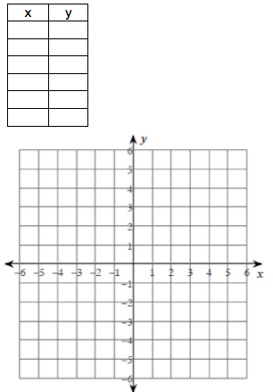

**Example 1:**

Graph $y=2^{x}$

Hint: Use the y-intercept as the center point of your table.



a. Asymptote:

b. X-intercept:

c. Y-intercept:

h. Interval of Positive:

i. Interval of Negative:

j. Rate of Change over [0,3]:

k. End Behavior:

$$As x→-∞, y→$$

$$As x→∞, y→$$

d. Domain:

e. Range:

f. Increasing or Decreasing?

**There will be a “you try” problem after video 3.**

Begin 7−2 Video 2

Write your Questions here!

**Example 2:**

Graph

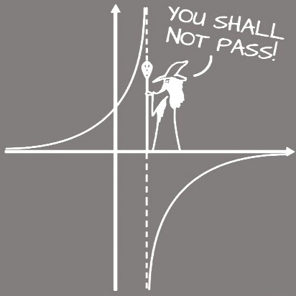





a. Asymptote: _________

b. X-intercept: _______

c. Y-intercept: ________

d. Domain: _________

e. Range:_________

f. Interval of Increasing:____________

g. Interval of Decreasing:___________

h. Interval of Positive:_____________

i. Interval of Negative:_____________

j. Rate of Change over [-1,0]:________

k. End Behavior:

$$As x→-∞, y→_____________$$

$$As x→∞, y→_____________$$

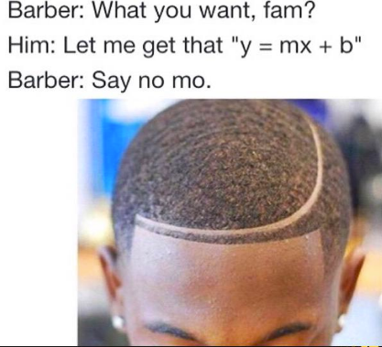

$y=ab^{x}$.

**There will be a “you try” problem after video 3.**

**Example 3:**

Begin 7−2 Video 3

Write your Questions here!

Graph $y={-2(1.5)}^{x}+3$



a. Asymptote:

b. X-intercept:

c. Y-intercept:

d. Domain:

e. Range:

f. Increasing or Decreasing?

h. Interval of Positive:

i. Interval of Negative:

j. Rate of Change over [0,2]:

k. End Behavior:

$$As x→-∞, y→_____________$$

$$As x→∞, y→_____________$$

**You try:**

1. Graph



j. Rate of Change over [-3,1]:

k. End Behavior:

$$As x→-∞, y→_____________$$

$$As x→∞, y→_____________$$

f. Increasing or Decreasing?

h. Interval of Positive:

i. Interval of Negative:

a. Asymptote:

b. X-intercept:

c. Y-intercept:

d. Domain:

e. Range:

**7-2 Practice**

Write your Questions here!

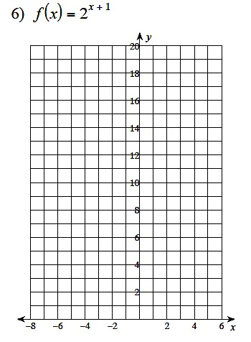

1)

h. Interval of Positive:

i. Interval of Negative:

j. Rate of Change over [0,2]:

k. End Behavior:

$$As x→-∞, y→______$$

$$As x→∞, y→______$$

a. Asymptote:

b. X-intercept:

c. Y-intercept:

d. Domain:

e. Range:

f. Increasing or Decreasing?

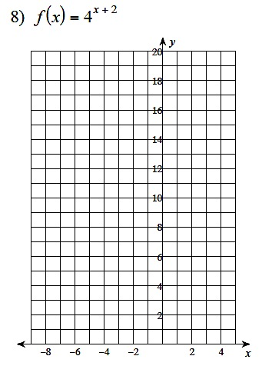

2)

h. Interval of Positive:

i. Interval of Negative:

j. Rate of Change over [-1,0]:

k. End Behavior:

$$As x→-∞, y→______$$

$$As x→∞, y→______$$

a. Asymptote:

b. X-intercept:

c. Y-intercept:

d. Domain:

e. Range:

f. Increasing or Decreasing?

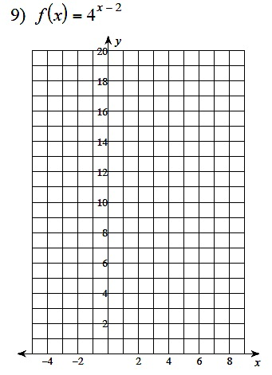

3)

h. Interval of Positive:

i. Interval of Negative:

j. Rate of Change over [2,3]:

k. End Behavior:

$$As x→-∞, y→______$$

$$As x→∞, y→______$$

a. Asymptote:

b. X-intercept:

c. Y-intercept:

d. Domain:

e. Range:

f. Increasing or Decreasing?

h. Interval of Positive:

i. Interval of Negative:

j. Rate of Change over [-3,-2]:

k. End Behavior:

$$As x→-∞, y→______$$

$$As x→∞, y→______$$

a. Asymptote:

b. X-intercept:

c. Y-intercept:

d. Domain:

e. Range:

f. Increasing or Decreasing?

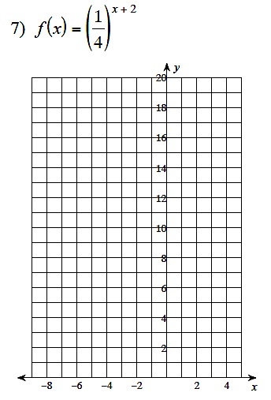

4)

Write your Questions here!

+ 2

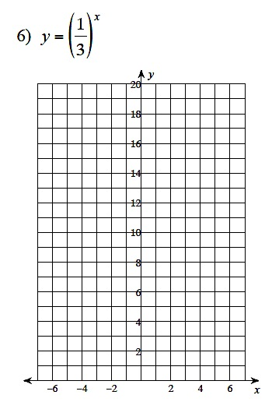

5)

h. Interval of Positive:

i. Interval of Negative:

j. Rate of Change over [-1,0]:

k. End Behavior:

$$As x→-∞, y→______$$

$$As x→∞, y→______$$

a. Asymptote:

b. X-intercept:

c. Y-intercept:

d. Domain:

e. Range:

f. Increasing or Decreasing?

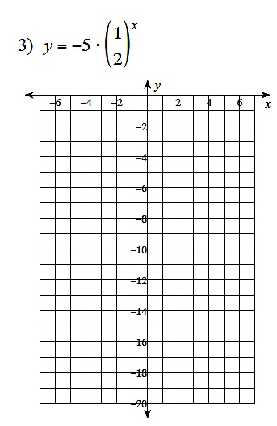

6)

h. Interval of Positive:

i. Interval of Negative:

j. Rate of Change over [-1,0]:

k. End Behavior:

$$As x→-∞, y→______$$

$$As x→∞, y→______$$

a. Asymptote:

b. X-intercept:

c. Y-intercept:

d. Domain:

e. Range:

f. Increasing or Decreasing?

h. Interval of Positive:

i. Interval of Negative:

j. Rate of Change over [-2,-1]:

k. End Behavior:

$$As x→-∞, y→______$$

$$As x→∞, y→______$$

a. Asymptote:

b. X-intercept:

c. Y-intercept:

d. Domain:

e. Range:

f. Increasing or Decreasing?

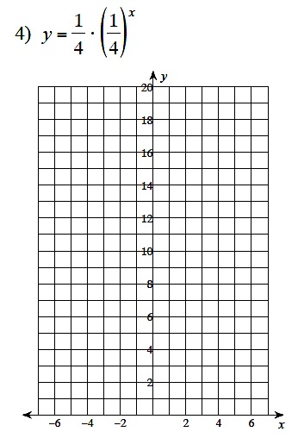

7)

Write your Questions here!

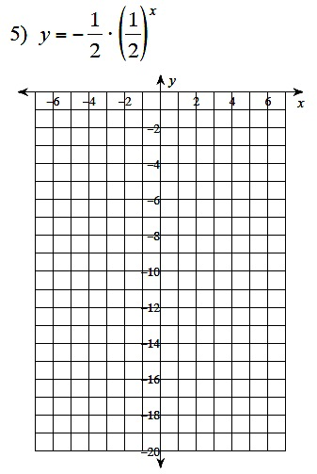

8)

h. Interval of Positive:

i. Interval of Negative:

j. Rate of Change over [-3,0]:

k. End Behavior:

$$As x→-∞, y→______$$

$$As x→∞, y→______$$

a. Asymptote:

b. X-intercept:

c. Y-intercept:

d. Domain:

e. Range:

f. Increasing or Decreasing?

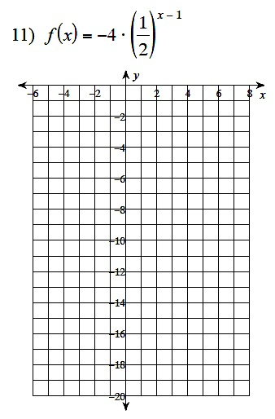

$$-3$$

9)

h. Interval of Positive:

i. Interval of Negative:

j. Rate of Change over [-1,1]:

k. End Behavior:

$$As x→-∞, y→______$$

$$As x→∞, y→______$$

a. Asymptote:

b. X-intercept:

c. Y-intercept:

d. Domain:

e. Range:

f. Increasing or Decreasing?

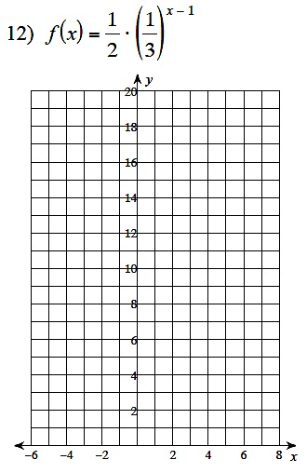

10)

Write your Questions here!

h. Interval of Positive:

i. Interval of Negative:

j. Rate of Change over [-1,1]:

k. End Behavior:

$$As x→-∞, y→______$$

$$As x→∞, y→______$$

a. Asymptote:

b. X-intercept:

c. Y-intercept:

d. Domain:

e. Range:

f. Increasing or Decreasing?

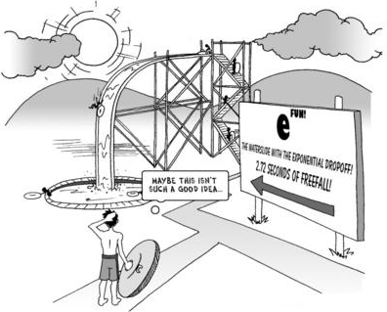



**This WILL be on your mastery check!**

Spiral Practice

1) Convert 978 centimeters to meters.

2) Convert 65 miles per hour to feet per second.

3) Distance can be described by the formula *d=rt,* where *r* is rate in miles per hour and *t*is time in hours.

What would be the unit for distance (*d)*?

**Review your practice and notes to prepare for the mastery check.**

**Lesson 7 – 3: Constructing Exponential Equations**

Write your Questions here!

**Learning Target: I can write an exponential equation to model a given situation.**

A.CED.1

Begin 7−3 Video 1

The general form of an exponential function is:

Starting Value

Input

$y=ab^{x}$

Growth Factor

Output

**People use this?**

Exponential functions are often used by scientists to model population changes.

An exponential function has the form $f(x)=ab^{x}$, where $a≠0, b≠1$, and $b>0$.

**Example 1:** The function $f(x)=2({3)}^{x}$ models an insect population after *x* days. What will the population be on the 5th day?

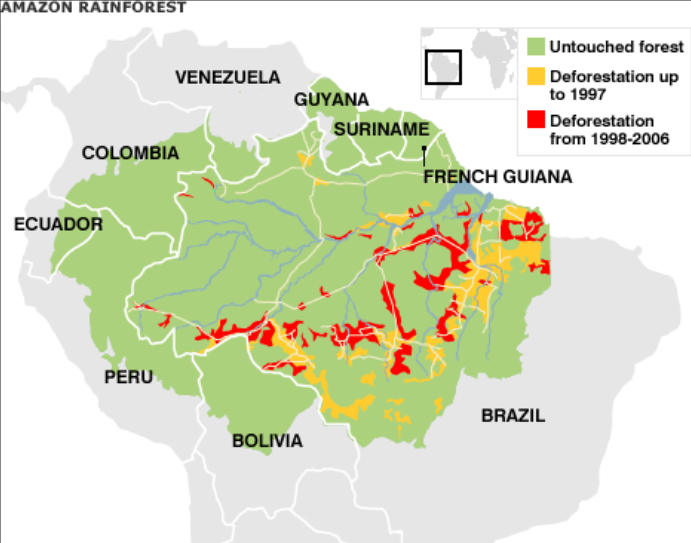**Example 2:** It was estimated that approximately one-twentieth of the Amazon Rainforest disappeared each year in 1970. This leaves $19/20$ of the rainforest. Write an equation to represent the death of the rainforest assuming a starting size of 4 million km2 (The estimated size in 1970). If this trend had continued, how many square kilometers would be left in 2020?

**You try:**

Dracula decides to build himself a vampire army. His will double each day. Write an equation to model the population growth of the vampires assuming Dracula was the only one when he hatched his plan. How people will be turned into vampires on day 28?

Begin 7−3 Video 2

Write your Questions here!

Recall that in a linear function, you will see a constant rate of change. Exponential relationships will _____have a constant slope (which is why we need the **average rate of change**). Rather, they will have a constant ________.

For the following examples, tell whether the set of ordered pairs could represent an exponential function. If so, write a function to model the relationship.

**Example 3**

{(-1, 1.5), (0, 3), (1, 6), (2, 12)}

**Example 4**

|  |  |
| --- | --- |
| x | f(x) |
| 0 | 20 |
| 1 | 10 |
| 2 | 5 |
| 3 | 2.5 |

**You try:**

For each problem, tell whether the set of ordered pairs could represent an exponential function. If so, write the function that models the relationship.

1.

{(0, 2), (1, 4), (2, 6), (3, 8)}

2.

|  |  |
| --- | --- |
| x | f(x) |
| 0 | 2 |
| 1 | 10 |
| 2 | 50 |
| 3 | 250 |

Begin 7−3 Video 3

**Example 5**

The half-life of Zn-71 is 2.4 minutes. If a sample started with 100.0 g at the beginning, how many grams would be left after 7.2 minutes has elapsed?

**You try:**

The half-life of Polonium-214 is 0.001 seconds. How much of a 10g sample is left after 0.003 seconds?



Write your Questions here!

**7-3 Construct Equations - Practice**

1. There are 20,000 owls in the wild. Every decade the number of owls is halved. a) Write an exponential function to model the owl population, *y*, after *t* decades.

b) How many owls would there be after 40 years.

2. There are 4,000 squirrels in the Great Smokey Mountain National park. Each year, the population doubles.

a) Write an exponential function to model the squirrel population, y, after *t*  years.

b) How many squirrels would there be after ten years?

3. A scientist is conducting a new drug trial on a bacterial culture of 50,000 bacteria. Every hour, the drug kills one-fourth of the bacteria population. This leaves $3/4$ of the bacteria.

a) Write an exponential function to model the bacteria population, y, after *t* hours.

b) How many bacteria would be left after one day?

4. The elephant population in Zimbabwe is 5,000. The elephant population is reduced by half each year.

a) Write an exponential function to model the elephant population, y, after t years.

b) How many elephants would be left at the end of ten years?

**Tell whether the set of ordered pairs could represent an exponential function. If so, write the function that models the relationship.**

1. {(-2, 2.75), (-1, 2.5), (0, 2), (1, 12)}

2. {(0, 3), (1, 6), (2, 9), (3, 12)}

3. {(-2, 3), (-1, 0), (0, -1), (1, 0)}

4. {(0, 100), (1, 20), (2, 4), (3, 0.8)}

**Solve the following half–life problems.**

Write your Questions here!

1. Os-182 has a half-life of 21.5 hours. How many grams of a 10.0 gram sample would have decayed after exactly three half-lives?

2. The half-life of iodine-131 is 8.040 days. How many grams of a 200 gram sample of iodine-131 will remain after 40.20 days?

3. Potassium-42 has a half-life of 12.4 hours. How much of an 848 g sample of potassium-42 will be left after 62.0 hours?

4. An isotope of cesium-137 (cesium-137) has a half-life of 30 years. If 1.0g of cesium-137 disintegrates over a period of 90 years, how many g of cesium-137 would remain?

**Write the function modeled by each table.**

1.

|  |  |
| --- | --- |
| x | f(x) |
| 0 | 20 |
| 1 | 10 |
| 2 | 5 |
| 3 | 2.5 |

2.

|  |  |
| --- | --- |
| x | f(x) |
| 0 | 4 |
| 1 | 8 |
| 2 | 16 |
| 3 | 32 |

3.

|  |  |
| --- | --- |
| x | f(x) |
| 0 | 125 |
| 1 | 75 |
| 2 | 45 |
| 3 | 27 |



**This WILL be on your mastery check!**

Spiral Practice

**Simplify**

$-2\sqrt{63x^{2}y^{3}}$

1. $2\sqrt{5}(3\sqrt{9}+\sqrt{5}$)

$-4\sqrt{2}-4\sqrt{72}-2\sqrt{8}$

$-2\sqrt{{432x}^{2}y}-5\sqrt{12x^{2}y}$

**Review your practice and notes to prepare for the mastery check.**

**Lesson 7 – 4: Compound Interest & Growth/Decay**

Vocabulary:

- Growth Factor

- Growth Rate

Write your Questions here!

**Learning Targets:**

* **I can use the compound interest formula to calculate interest.**
* **I can solve problems involving exponential growth and decay.**

F.BF.1, A.CED.1 & A.CED.2

Begin 7−4 Video 1

Translation:

Sit up.

Listen closely. This is real life.

☺

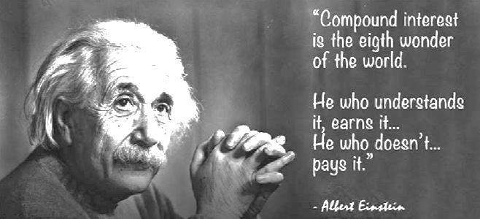One of the most practical skills you will learn in this course is the Compound Interest Formula. This is the formula that banks use to calculate how much interest you earn for investments. It’s also used to determine how much interest will be charged on a credit card or loan.

Compound Interest Formula:

Formula

Sheet!

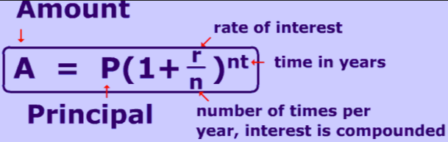

What do all those letters mean?

**A** = the ________ accumulated after *n* periods of time

**P** = the ________ invested (your starting amount)

**r** = annual ________________.

(This is usually given as a percentage and you will need to change it to a decimal before performing calculations.)

**n** = the number of times per year interest is ________

**t** = the length of the term (measured in ________)

**Example 1:**

You deposit $1,600 in a bank account. Find the balance after 3 years for each of the following situations.

a) The account pays 2.5% annual interest compounded monthly.

b) The account pays 1.75% annual interest compounded quarterly.

c) The account pays 4% annual interest compounded yearly.

**You try:**

Write your Questions here!

$10,000 invested at a rate of 1% compounded monthly for 20 years.

Begin 7−4 Video 2

When an exponential function increases over time we refer to it as growth.

When an exponential function decreases over time we refer to it as decay.

The compound interest formula we used in the last lesson can be tweaked a bit to encompass many different types of exponential problems. The main difference is that n will always be 1. So…

$A=P{(1+\frac{r}{n})}^{nt}→A=P{(1+\frac{r}{1})}^{1∙t}→$ $A=P{(1+r)}^{t}$

**Example 2:** A colony of 10,000 ants can increase by 15% in a month. How many ants will be in the colony after one year?

A = number of ants after a year

P = Starting number of ants

r = rate of increase

t = how many months are we letting the colony grow?

**You try:**

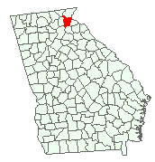According to the U.S. Census Bureau, the population of Habersham County has increased 2.8% over the last 10 years. If this rate continues and our current population is 44,246 people, what will the population be in 50 years?

Begin 7−4 Video 3

Write your Questions here!

In growth and decay problems we do have a bit of extra vocabulary to consider. We’ve already discussed that the growth rate is the __________ of increase given. In problems of this type, you will also be asked about the growth factor. The growth factor is the amount that’s being ________ repeatedly. You might also hear it referred to as the common ratio.

$$A=10,000{(1+0.15)}^{5}$$

So for our ant problem:

the growth rate is given as ________.

The growth factor would be ________.

**Example 3: Example 4:**

$y=2{(3)}^{x}$ $f\left(x\right)=20{(1-0.6)}^{x}$

Growth or Decay?______ Growth or Decay?______

Growth Rate:______ Growth Rate:______

Growth Factor:_____ Growth Factor:_____

**You try:**

$y=5{(1+0.8)}^{x}$ $f\left(x\right)=4{(0.3)}^{x}$

Growth or Decay?______ Growth or Decay?______

Growth Rate:______ Growth Rate:______

Growth Factor:_____ Growth Factor:_____

Begin 7−4 Video 4

**Example 5:** A car purchased for $24,500 will depreciate at a rate of 18% each year.

Hint: For decay problems, you’ll need to subtract “r”!

1. 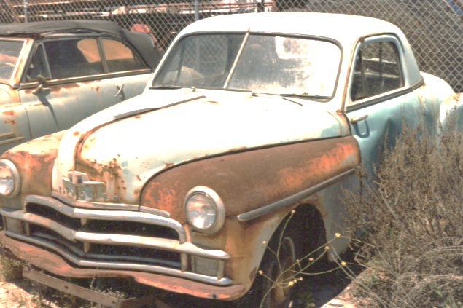Would this be exponential growth or decay?
2. Identify the initial amount.
3. Identify the growth/decay factor.
4. Write an equation to represent the loss in value.

A =

P =

r =

n =

t =

Write your Questions here!

e. According to this model, approximately how much will the car be worth after 2 years?

f. After how many years will the value of the car drop below $10,000?

**You try:**

On your 16th birthday, you plan to buy a brand new BMW 7 Series. The average price of a new 7 Series is just over $100,000. These cars depreciate at a rate of 62.6% every five years.

1. Would this be exponential growth or decay?

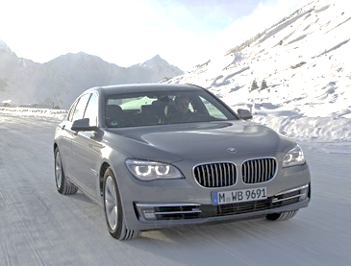

1. Identify the initial amount.
2. Identify the growth/decay factor.
3. Write an equation to represent the loss in value.
4. How much will your car be worth by the time you graduate med school in 10 years?



Write your Questions here!

**7-4 Compound Interest and Growth/Decay Practice**

**Write a compound interest function to model each situation. Then find the balance after the given number of years.**

1. $20,000 invested at a rate of 3% compounded annually; 8 years

2. $35,000 invested at a rate of 6% compounded monthly; 10 years

3. $35,000 invested at a rate of 8% compounded quarterly; 5 years

4. $30,000 invested at a rate of 6% compounded annually; 5 years

**Identify whether each function is exponential growth or decay. Then give the growth rate and growth factor.**

5.  6.  7. 

Growth or Decay?______ Growth or Decay?______ Growth or Decay?______

Growth Rate:______ Growth Rate:______ Growth Rate:______

Growth Factor:_____ Growth Factor:_____ Growth Factor:_____

8.  9.  10. 

Growth or Decay?______ Growth or Decay?______ Growth or Decay?______

Growth Rate:______ Growth Rate:______ Growth Rate:______

Growth Factor:_____ Growth Factor:_____ Growth Factor:_____

**Answer each question.**

11. You start an account with $500 and an interest rate of 6% compounded yearly.

a) Exponential growth or decay: b) Identify the initial amount:

c) Identify the growth/decay factor: d) Write an equation to model the situation:

e) How much is in the account after 3 years?

12. From 2000 - 2010 a city had a 2.5% annual decrease in population. The city had

Write your Questions here!

2,950,000 people in 2000.

a) Exponential growth or decay: b) Identify the initial amount:

c) Identify the growth/decay factor: d) Write an equation to model the situation:

e) Determine the city’s population in 2008.

13. Your new computer cost $1500 but it depreciates in value by about 18% each year. Write an equation that would indicate the value of the computer at x years. How much will your computer be worth in 6 years?

14. A population of 800 beetles is growing each month at a rate of 5%. Write an equation that expresses the number of beetles at time x. About how many beetles will there be in 8 months?

15. Since January 2000, the population of the city of Brownville has grown according to the mathematical model $y=720,500{(1.022)}^{x}$, where *x* is the number of years since January 2000.

a) Explain what the numbers 720,500 and 1.022 represent in this model.

b) What would the population be in 2020 if the growth continues at the same rate.

c) Use this model to predict about when the population of Brownville will first reach 1,000,000.

16. You invest $100,000 in an account with 1.01% interest, compounded quarterly. Assume you don’t touch the money or add money other than the earned interest.

a)How much money will you have in the account after 10 years?

b) How much money will you have in the account after 25 years?

17. Your parents are giving you a choice to take your $5000 that you have saved and deposit it into a savings account at either Bank of America or Wells Fargo. Below is the information the two banks give you:

Write your Questions here!

|  |  |
| --- | --- |
| Bank of America | Wells Fargo |
| Requires you to invest money for 5 years | Requires you to invest money for 3 years |
| Lets you earn a 2.5% interest rate | Lets you earn a 5% interest rate |
| Interest rate is compounded monthly | Interest rate is compounded twice a year |

**a)** Write an exponential model to represent the situation for each bank.

Bank of America:_________________________________

Wells Fargo:_____________________________________

**b)** What would the ending balance be for each bank at the end of the specified time?

Bank of America:_________________________________

Wells Fargo:___________________________________

**c)** What would be the interest paid on each account?

Bank of America:_________________________________

Wells Fargo:_____________________________________

**d)** Which bank would be a better option for you? Explain

18. You buy a car for $8000 that depreciates at a rate of 11% a year. How much is the car worth after 5 years?

Write your Questions here!

19. You start an account with $2500 and an interest rate of 6.5% compounded yearly. How much is in the account after 7 years?

20. A newly hatched channel catfish typically weighs about 0.06 gram. During the first 6 weeks of life, its weight increases by about 10% each day. Write a function to model the situation. How much does the catfish weigh after 6 weeks? (Hint: 1 week = 7 days)

21. $15,000 invested at a rate of 4% compounded monthly; 12 years

22. $45,000 invested at a rate of 7% compound monthly; 12 years

23. $60,000 invested at a rate of 3.5% compounded annually; 6 years

24. $32,500 invested at a rate of 2.5% compounded quarterly; 2 years



**This WILL be on your mastery check!**

Spiral Practice

**Solve**

1) -6 – d2 = -6 + 2d

**Solve for x:**

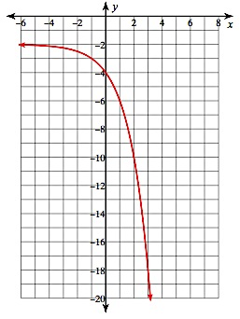2) 

3) Find the average rate of change over the interval [–1, 2] for the graph below.

**Review your practice and notes to prepare for the mastery check.**

**Lesson 7 – 5: Solving Exponential Equations**

Write your Questions here!

**Learning Target: I can solve simple exponential functions.**

A.CED.1

Begin 7−5 Video 1

Solving most exponential functions for x is beyond the scope of this course. However, simple equations can be solved by applying prior knowledge and a bit of number sense.

**Example 1:**

Solve for x.

$5^{x}=125$

**Example 2:**

Solve for x.

$18=2(9^{x})$

**Example 3:**

Solve for x.

$2-\left(2^{x}\right)<18$

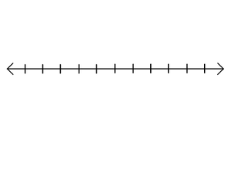

**You try:**

1. 2.

Begin 7−5 Video 2

One possible application for this skill would be finding the _______________of an equation when you don’t have the graph in front of you. We know that the x-intercept is the point where the function crosses the ____. This is also the point at which your y-value is ____. So in order to find the x-intercept algebraically, you will simply plug zero in for your ________.

**Example 4: Example 5:**

Find the x-intercept.

Find the x-intercept.

$f(x)=5(3^{x})$

$f(x)=3^{x}-9$

**You try:**

Find the x-intercept.

1. $y=15(7^{x})$



**7-5 Practice: Solving Exponential Equations**

Write your Questions here!

**Solve for x.**



$4^{x}=16$

$3^{x}=27$

${16}^{x}=16$

${243}^{x}=1$

$7^{x}=49$

$3\left(2^{x}\right)=48$

$4^{x}-10=6$

$6^{x}-16=200$

$5{\left(5\right)}^{x}=125$

$4{(2}^{x})+10=138$

**Solve for x and graph on the number line provided.**

11. 13.





12. 14.





**Find the x-intercept:**

Write your Questions here!

15. $y=5^{x}-125$

16. $y=4^{x}-64$



**This WILL be on your mastery check!**

Spiral Practice

17. $y=7^{x}-343$

18. $y=3{(4)}^{x}-192$

**Use the situation below to answer the following questions:**

A sample of 1,000 bacteria becomes infected with a virus. Each day, half of the bacteria sample dies due to the virus. A biologist studying the bacteria models the population of the bacteria with the function P(t) = 1,000(0.5)t, where t is the time in days.

a) What is the range of this function in this context?

b) What is the domain of this function in context?

c) Tell the intervals of increase and decrease.

d) Tell where the function would be positive and negative.

e) Describe the end behavior of this function.

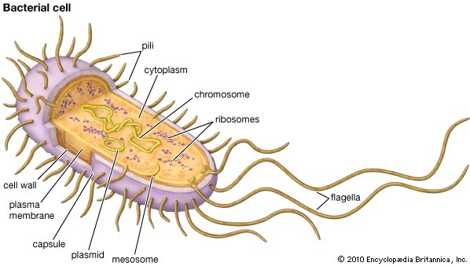f) Tell the intercepts of this function.

g) Tell the average rate of change over the interval [0, 3].

**Review your practice and notes to prepare for the mastery check.**

**Study Guide**

What is the asymptote of the following exponential functions?

1) f(x) = -3(2)x 2) f(x) = 2(1/2)x + 1 3) f(x) = 4(5)x -3

Find the y-intercept. (To find the y-intercept replace x = 0 and solve for y.)

4) f(x) = 4x 5) f(x) = 2x – 1 6) f(x) = 3(2)x + 4

7) f(x) = 3x – 6 8) f(x) = 4x – 2

Write the function modeled by each table.

9) 10) 11)

|  |  |
| --- | --- |
| x | F(x) |
| 0 | 6400 |
| 1 | 3840 |
| 2 | 2304 |
| 3 | 1382.4 |

|  |  |
| --- | --- |
| x | F(x) |
| 0 | 2000 |
| 1 | 1000 |
| 2 | 500 |
| 3 | 250 |

|  |  |
| --- | --- |
| x | F(x) |
| 0 | 40 |
| 1 | 120 |
| 2 | 360 |

What is the range of each of the following functions? (You may sketch a graph to help you.)

12) f(x) = 2x + 1 13) f(x) = 3x 14) f(x) = 3x – 2

Find the x-intercept for each of the following functions. (To find the x-intercept replace y=0 and solve for x.)

15) f(x) = 3x - 27 16) f(x) = 2x – 16 17) f(x) = 3(2x) - 12

For each of the following functions describe the interval of increase and/or decrease.

18) 19) 20)

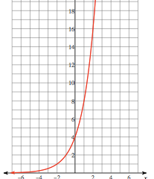 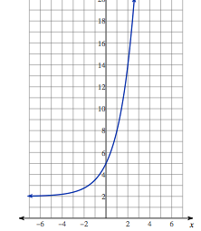 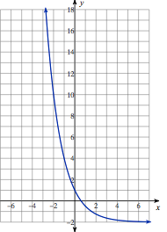

21) For which of the above graph is the following statement true. “as x decreases, f(x) approaches 0”

22) For which of the above graphs is the following statement true. “ as x increases, f(x) approaches -2”

23) For which of the above graphs is the following statement true. “as x increases, f(x) approaches infinity”

24) What is the asymptote for 18 ________________ for 19_______________ and 20_________________?

25) What is the average rate of change for the functions f(x) from x = 1 and x = 3?

f(x) = -3x + 2

26) A ball is dropped from 80 after 1 bounce it is at 40 ft, after 2 bounces it is at 20 ft. Write a model to describe the height of the ball after its xth bounce?

27.) Your parents are giving you a choice to take your $5000 that you have saved and deposit it into a savings account at either Citizens Bank or Regions Bank. Below is the information the two banks give you: (F.LE.1c)

|  |  |
| --- | --- |
| Citizens Bank | Regions Bank |
| Requires you to invest money for 2 years | Requires you to invest money for 3 years |
| Lets you earn a 7.5% interest rate | Lets you earn a 6.5% interest rate |
| Interest rate is compounded quarterly | Interest rate is compounded monthly a year |

**a)** Write an exponential model to represent the situation for each bank.

Citizens Bank:_________________________________

Regions Bank:_______________________________________

**b)** What would the ending balance be for each bank at the end of the specified time?

Citizens Bank:_________________________________

Regions Bank:_______________________________________

**c)** What would be the interest paid on each account?

Citizens Bank:_________________________________

Regions Bank:_______________________________________

**d)** Which bank would be a better option for you? Explain

28) Solve and graph the solution set that make the inequality true.

A) 3 + 3x > 30 B) 2x < 16

29) What is the domain and range of the sequence {3, 6, 12, 24, 48, …}?

30) Write the explicit and recursive formula for the sequence. {3, 6, 12, 24, 48,…}.

31) What are the first 4 terms of an= 2(5)n-1?

32) Which has a greater rate of change from x = 0 to x = 4, f(x) or g(x)?

|  |  |
| --- | --- |
| x | g(x) |
| 0 | 2 |
| 1 | 16 |
| 2 | 25 |
| 3 | 50 |
| 4 | 100 |

f(x) = 3x + 1

33) A person purchased a used Malibu for $8000. The car is expected to decrease in value by 18% each year over the next several years. What will the value be at the end of 4 years?