Unit 9
Comparing Linear, Quadratic, and Exponential Functions

Table of Contents
Title Page

Formula Sheet……………………………………………………..…………………...2

9-1 Comparing Linear, Quadratic, and Exponential Models Graphically……3

9-2 Comparison of Specific Characteristics…………………………..…………6

9-3 Restricted Domain and Range………………………………………………..10

9-3 Explaining Parameters of Functions………………………………………...13

9-4 Linear vs. Exponential Scenarios…………………………………………….15

9-4 Sequence Review………………………………………………………………..18

Unit 9 Study Guide…………………………………………………………………...26

This packet belongs to:

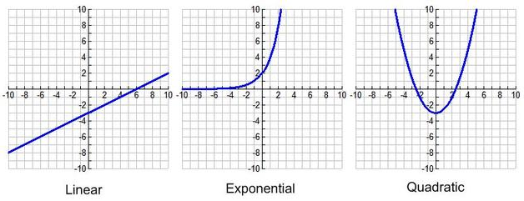
____________________________________________________

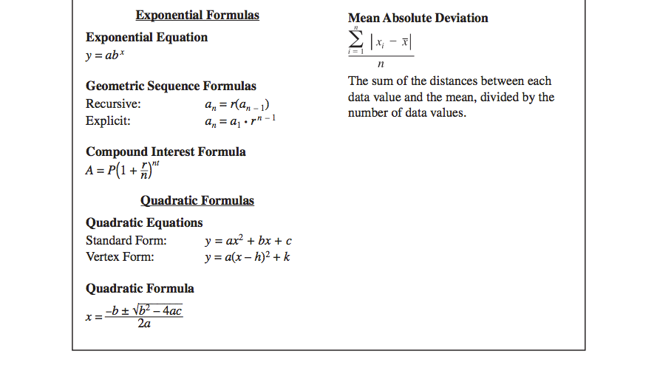
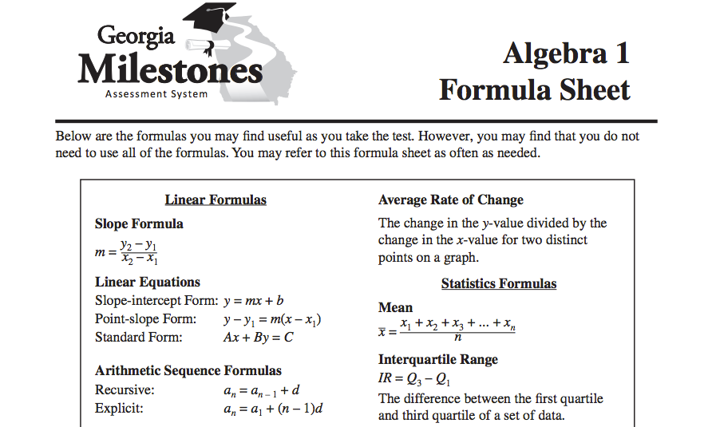
GRAPHICAL EXAMPLES
LINEAR FUNCTIONS | QUADRATIC FUNCTIONS | EXPONENTIAL FUNCTIONS
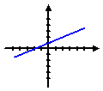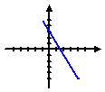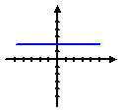 | 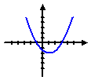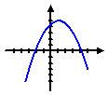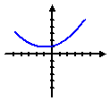 | 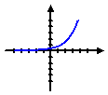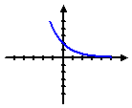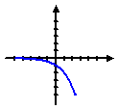

- Graphically identify which type of function model might best represent each scatter plot.
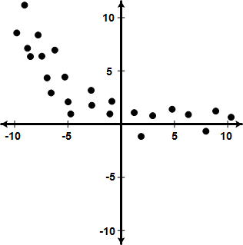
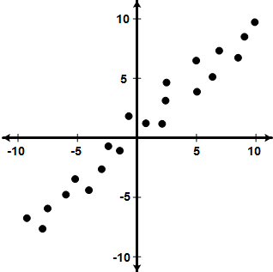
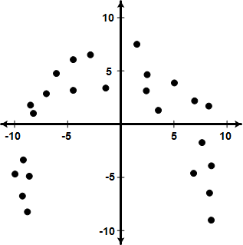
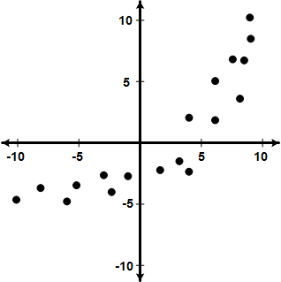
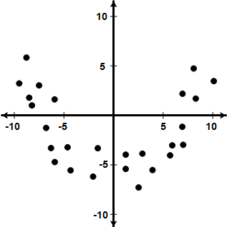

Linear Quadratic Exponential
Model (circle one):
Linear Quadratic Exponential
Model (circle one):
Linear Quadratic Exponential
Model (circle one):
Linear Quadratic Exponential
Model (circle one):
Linear Quadratic Exponential
Model (circle one):

To recognize if a function is linear, quadratic, or exponential without an equation or graph, look at the differences of the y-values.
- If the difference is constant, the function is linear.
- If the difference is not constant but the second set of differences are constant, the function is quadratic.
- If the differences share a common ratio, the function is exponential.

- Based on the partial set of values given for a function, identify which description best fits the function.
x | 1 | 2 | 3 | 4 | 5
c(x) | 0 | 2 | 6 | 14 | 30

x | 1 | 2 | 3 | 4 | 5
b(x) | 1 | 2 | 1 | - 2 | - 7

x | 0 | 1 | 2 | 3 | 4
a(x) | 1 | 5 | 9 | 13 | 17

Linear Quadratic Exponential
Growth
Growth
(Local Max)
Linear Quadratic Exponential
Decay
Decay
(Local Min)
Model (circle one):
Linear Quadratic Exponential
Growth
Growth
(Local Max)
Linear Quadratic Exponential
Decay
Decay
(Local Min)
Model (circle one):
Linear Quadratic Exponential
Growth
Growth
(Local Max)
Linear Quadratic Exponential
Decay
Decay
(Local Min)
Model (circle one):

x | 1 | 2 | 3 | 4 | 5
f(x) | 9 | 7 | 5 | 3 | 1

x | 1 | 2 | 3 | 4 | 5
e(x) | 65 | 33 | 17 | 9 | 5

x | 0 | 1 | 2 | 3 | 4
d(x) | 3 | 0 | -1 | 0 | 3

Linear Quadratic Exponential
Growth
Growth
(Local Max)
Linear Quadratic Exponential
Decay
Decay
(Local Min)
Model (circle one):
Linear Quadratic Exponential
Growth
Growth
(Local Max)
Linear Quadratic Exponential
Decay
Decay
(Local Min)
Model (circle one):
Linear Quadratic Exponential
Growth
Growth
(Local Max)
Linear Quadratic Exponential
Decay
Decay
(Local Min)
Model (circle one):

- Match each graph with its description.

______ I. An exponential function that is always increasing. |  | a. | 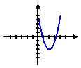
______ II. An exponential function that is always decreasing. |  | b. | 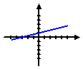
______ III. A quadratic function with a local maximum. |  | c. | 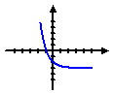
______ IV. A quadratic function with a local minimum. |  | d. | 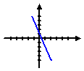
______ V. A linear function that is always increasing. |  | e. | 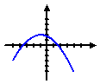
______ VI. A linear function that is always decreasing. |  | f. | 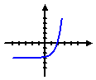
- Which is the only type of function below that has an asymptote when graphed?

- Linear Function B. Quadratic Function C. Exponential Function

- Which is the only type of function below that could have a local maximum?

- Linear Function B. Quadratic Function C. Exponential Function

- Which is the only function that might have end behavior such that as x approaches infinity, f(x) approaches 4?

- Linear Function B. Quadratic Function C. Exponential Function

- Which is the only function below that might have end behavior such that:

- As x → − ∞, f(x) → ∞
- As x → ∞, f(x) → ∞

- Linear Function B. Quadratic Function C. Exponential Function
- Which is the only function below that might have end behavior such that:

- As x → − ∞, f(x) → − ∞
- As x → ∞, f(x) → ∞

- Linear Function B. Quadratic Function C. Exponential Function

- Which is the only function below that might have end behavior such that:

- As x → − ∞, f(x) → − ∞
- As x → ∞, f(x) → − ∞

- Linear Function B. Quadratic Function C. Exponential Function

- Describe the end behavior of each of the function below.
A. | 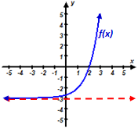 | B. | 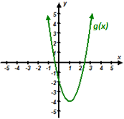 | C. | 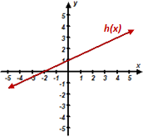
 | Name:  As x → − ∞, f(x) →  As x → ∞, f(x) → |  | Name:  As x → − ∞, g(x) →  As x → ∞, g(x) → |  | Name:  As x → − ∞, h(x) →  As x → ∞, h(x) →
- Based on the function given identify which description best fits the function.

- $f\left(x\right)=x\left(2x+3\right)$ B. $g\left(x\right)=3\left(1-2x\right)-4$ C. $h\left(x\right)=2+{\left(\frac{1}{2}\right)}^{x}$

Linear Quadratic Exponential
Growth
Growth
(Local Max)
Linear Quadratic Exponential
Decay
Decay
(Local Min)
Model (circle one):
Linear Quadratic Exponential
Growth
Growth
(Local Max)
Linear Quadratic Exponential
Decay
Decay
(Local Min)
Model (circle one):
Linear Quadratic Exponential
Growth
Growth
(Local Max)
Linear Quadratic Exponential
Decay
Decay
(Local Min)
Model (circle one):

D. $m\left(x\right)=3∙{\left(2\right)}^{x}+1$ E. $p\left(x\right)=2-3x^{2}+x$ F. $q\left(x\right)=\frac{1}{2} x-1$

Linear Quadratic Exponential
Growth
Growth
(Local Max)
Linear Quadratic Exponential
Decay
Decay
(Local Min)
Model (circle one):
Linear Quadratic Exponential
Growth
Growth
(Local Max)
Linear Quadratic Exponential
Decay
Decay
(Local Min)
Model (circle one):
Linear Quadratic Exponential
Growth
Growth
(Local Max)
Linear Quadratic Exponential
Decay
Decay
(Local Min)
Model (circle one):

Linear, Quadratic, or Exponential Functions Name:

- Find the average rate of change from x = – 1 to x = 2 for each of the functions below.
Sec 9-2 –Comparison of Specific Characteristics

- $a\left(x\right)=2x+3$ b. $b\left(x\right)=x^{2}-1$ c. $c\left(x\right)=2^{x}+1$

d. Which function has the greatest average rate of change over the interval [ – 1, 2]?

- Find the average rate of change on the interval [ 2, 5] for each of the functions below.

- $a\left(x\right)=2x+1$ b. $b\left(x\right)=x^{2}+2$ c. $c\left(x\right)=2^{x}-1$

d. Which function has the greatest average rate of change over the interval x = 2 to x = 5?

- In general as x→∞, which function eventually grows at the fastest rate?

- $a\left(x\right)=2x$ b. $b\left(x\right)=x^{2}$ c. $c\left(x\right)=2^{x}$

- Find the average rate of change from x = – 1 to x = 2 for each of the continuous functions below based on the partial set of values provided.
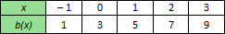
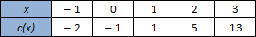
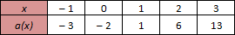
- b. c.

d. Which function has the greatest average rate of change over the interval [ – 1, 2]?

- Consider the table below that shows a partial set of values of two continuous functions. Based on any interval of x provided in the table which function always has a larger average rate of change?
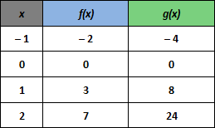

- Find the average rate of change from x = 1 to x = 3 for each of the functions graphed below.
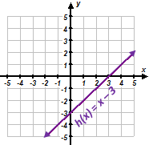
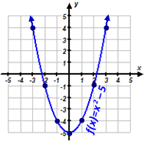
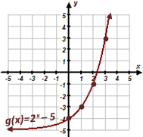
- b. c.

d. Find an interval of x over which all three graphed functions above have the same average rate of change.

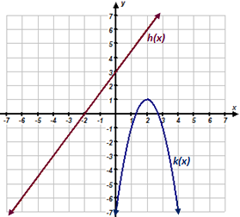
- Consider the following graphed functions; fill in the blank comparing the functions with an inequality symbol.
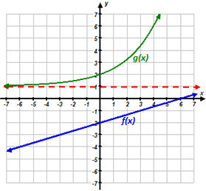
A. B.
For all values of x,
f(x) g(x)
For all values of x,
h(x) k(x)

- For which values of x is f(x) > g(x)? (Write the interval using set notation and interval notation.)
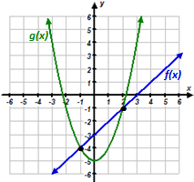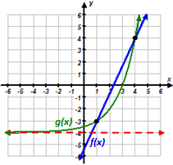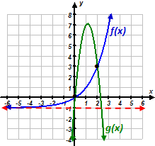
A. B. C.

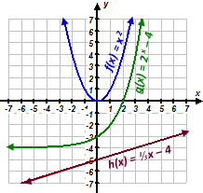
- Consider the following functions.
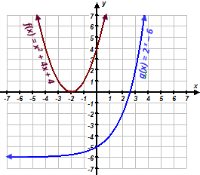
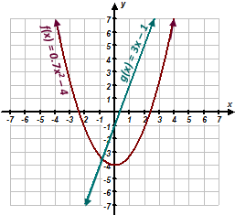
A. B. C.

As x → ∞, which function becomes the largest?
As x → ∞, which function becomes the largest?
As x → ∞, which function becomes the largest?

- A partial set of values is provided for two functions in each problem below. For all x≥0, which function would most likely be greater. If the greater function changes determine the appropriate intervals.
A. B.
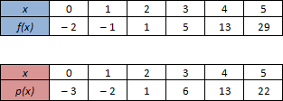
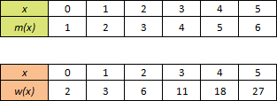

- Ada (age 5) and Isaac (age 3) are having a competition to see who can throw a ball the highest. Below, you will find the information on their first attempt.
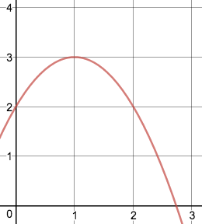
Did Ada or Isaac throw the ball higher on the first attempt? Give evidence.
Height of Isaac’s Ball versus Seconds
Height of Ada’s ball per second
Seconds | Height (ft)
0 | 3
1 | 5
1.5 | 5.25
2 | 5
3 | 3
4 | 0

- Ada (age 5) and Isaac (age 3) are having a competition to see who can throw a ball the highest. Below, you will find the information on their second attempt.
Height of Isaac’s ball per second
Seconds | Height (ft)
0 | 2
1 | 5
2 | 6
3 | 5
4 | 2
5 | 0

Did Ada or Isaac throw the ball higher on the second attempt? Give evidence.
Ada’s 2nd attempt followed
the path of the following equation.

$y=-2x^{2}+4x+3$

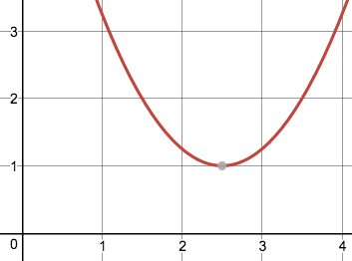
13. Examine the functions below. Which function has the smaller minimum? How do you know?
$f\left(x\right)=x^{2}-4x+3$
g(x)

9-3 Restricted Domain and Range
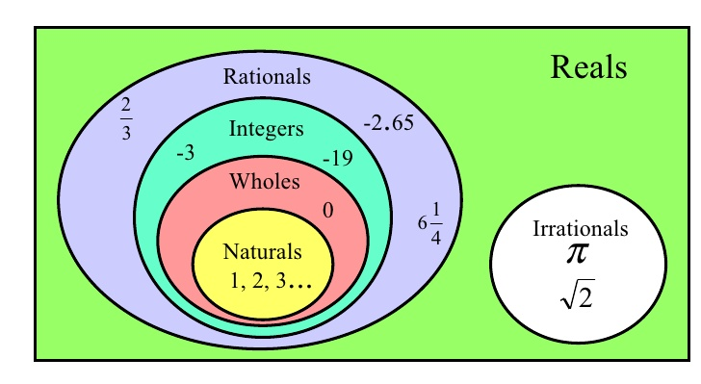
*In a sequence, the domain will be all natural numbers. The range of a sequence will be defined by the recursive rule.

1. A tub drains at a rate of 2 gallons every 30 seconds. The typical tub holds approximately 36 gallons of water. Let y be the amount of water in the tub for a given x amount of time in seconds. Describe the domain and range of the function.
Domain:

Range:

2. A postal company delivers packages based on their weight but will not ship anything over 75 pounds. The company charges $1.50 per pound to deliver the package anywhere in the United States. If we consider this situation a function where the number of pounds, x, is the independent variable and the cost in dollars, y, is the dependent variable determine the domain and range.
Domain:

Range:

3. When jogging, you burn 8 calories per minute. Each day, you have an hour and a half to dedicate to exercise. If we consider this situation a function where the time in minutes, x, is the independent variable and the number of calories burned, y, is the dependent variable, determine the domain and range.
Domain:

Range:

4. An author is selling autographed copies of his book at a stand in a bookstore in the mall and charging $15 per copy. The author brought 50 copies of the book with him. If the function $p\left(x\right)= 15x$ represents the gross profit the author could make during the time he is sitting at the stand, determine the appropriate domain and range.

Domain:

Range:

5. A limousine company rents their limousine by the hour. The company charges $55 per hour. You are charged for the entire hour, even if the limousine is only used for part of the hour. The minimum time is 4 hours and a maximum of 15 hours. If we consider this situation a function where the number of hours, x, is the independent variable and the cost in dollars of renting the limousine, y, is the dependent variable determine the domain and range.

Domain:

Range:

6.Patrick starts a job at a restaurant. He deposits $25 from each paycheck into his savings account. Before he started the job, his balance was $150. If we consider this situation a function where the number of paychecks, x, is the independent variable and the account balance, y, is the dependent variable determine the domain and range.
Domain:

Range:

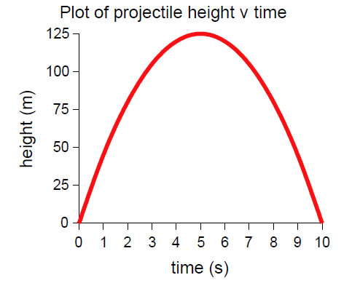
7. The path of a rock launched by a catapult is displayed on the graph to the right. Give the domain and range of the function and interpret their meaning in the context of the situation.

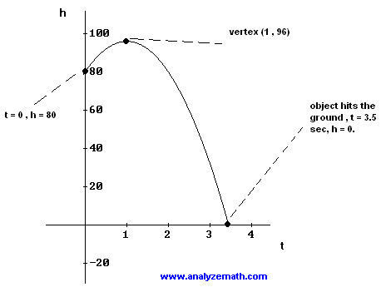
8. The ball thrown off the top of a cliff is graphed to the right. Give the domain and range of the function and interpret their meaning in the context of the situation.

9. A culture of bacteria doubles every day. Mr. Kitchings checks the bacteria once a day every day for a week and records the amount of bacteria. The culture starts with 200 bacteria. Describe the domain and range of this function.

10. A squirrel population triples every year. The forest service department measures the population at the end of each year. The first year they recorded the population, there were 100 squirrels in the park. Describe the domain and range of the function.

11. Each year, one-fifth of the Amazon Rainforest is harvested. There is currently 200,000 acres in the Amazon rainforest. If this rate continues, describe the domain and range of the function.

12. Currently there are 200 rabbits in Cornelia park. Each year, the population is reduced by one half. If this rate continues, describe the domain and range of the function.

9-3 Explaining Parameters of Functions
Explain what each parameter of each model means.
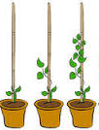
1. A student was marking the growth of a corn stalk plant and at least for the first several weeks the plant’s height in inches could be described by the following model (where t is the time in weeks).

h(t) = 5(1.40) ^{t}

a) What does the 5 represent? b) What does the 1.40 represent?

2. A person purchased a new car which depreciates in value. The car owner determined the value of the car in dollars could be modeled by the following function (where t is in years after the car was purchased).
v(t) = 23000(0.93) ^{t}

a) What does the 23000 represent? b) What does the 0.93 represent?

3. A physical therapist charges an initial fee and then charges another amount per hour of therapy. The charges could be described by the following function model (where t is in hours of therapy).
c(t) = 140 + 40t
a) What does the 40 represent? b) What does the 140 represent?

4. A baseball is struck by a bat. The height in feet of the ball can described by the following function (where t is in seconds after the ball was struck).

h(t) = – 16(t – 2.4) ² + 70

a) What does the 2.4 represent? b) What does the 70 represent?

Create a function model for each of the following:

5. Some kids are selling lemonade for $1.50 per cup at a high school baseball game. They spent $14 on all of the items needed for the lemonade stand (cups, lemonade, table cloth, sign, etc.). Create a function that would represent their profit based on the number of cups of lemonade they sold.

6. A first year teacher is paid $38,000. Each year she is paid an additional 5% over the previous year. Create function that would represent the teacher’s salary based on the number of years that the teacher worked.

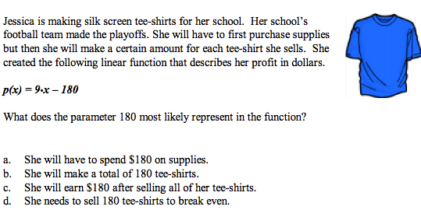
7.

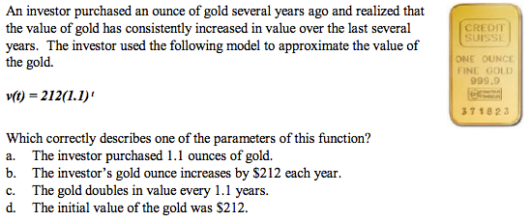
8.

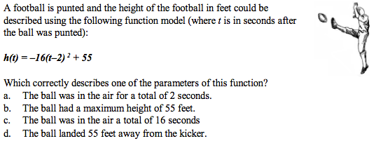
9.

9-4 Linear vs. Exponential Scenarios
1. The function $g\left(x\right)=5{(2)}^{x}$ can be used to model bacterial growth. Let g(x) be the number of bacteria where x is the number of days the bacteria population increases. Use this information to discuss some of the key features of the function.
• There were initially _____ bacteria prior to population of bacteria increasing. (y-intercept)
• The bacteria ______ each day. (growth factor)
• The bacteria population _________ as the number of days increases. (end behavior: as $x→∞, y→_____$)
• There is ____ maximum value.
• The minimum will not be lower than ______ bacteria.
• The number of bacteria will always range from ________ to ________.

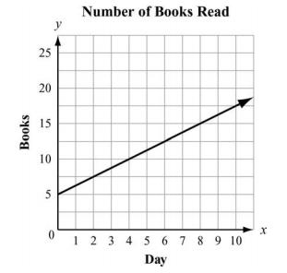
2. Juan and Patti decided to see who could read the most books in a month. They began to keep track after Patti had already read 5 books that month. This graph shows the number of books Patti read for the next 10 days.

If Juan has read no books before the fourth day of the month and he reads at the same rate as Patti, how many books will he have read by day 12?

3. Consider the functions of f(x) and g(x). Both functions represent money increasing in two different accounts.
The equation $f\left(x\right)=30x+20$ can be used to represent the first account while the second account is represented in the graph below.
g(x)
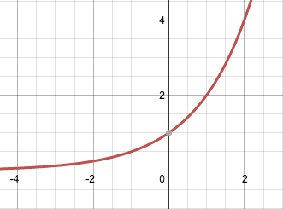

From the graph or the functions, which account initially contains more money? This is also the y-intercept.
Although we are not able to see the y-intercept of f(x) in a graph, we can determine the y-intercept if given an equation. The account at week zero contained _______.
In this model, the y-intercept can be seen for g(x). The account at week zero only contained ______.

Both functions appear to be increasing as x increases. This means the money in both accounts _________ as the number of weeks increase. So we can say the range for the first account is ___________ and the range for the first account is ___________.

At what rate is each account increasing?
The first account increases at an average rate of _______ per week. The second account increases by a factor of _____ each week.

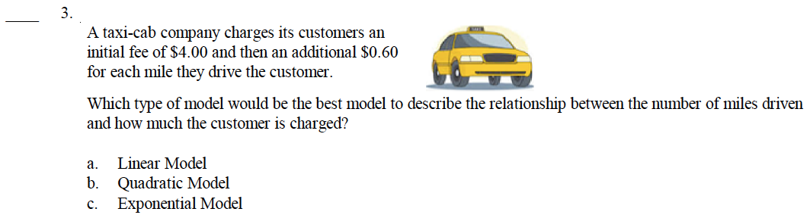
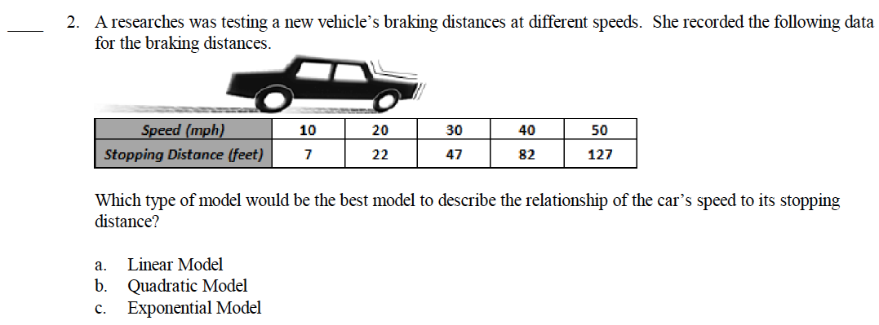
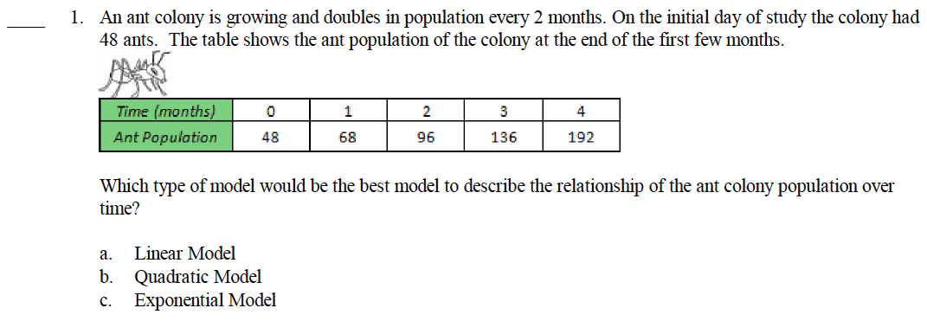
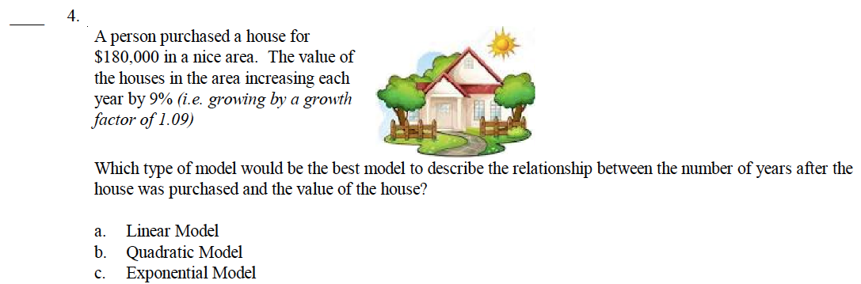

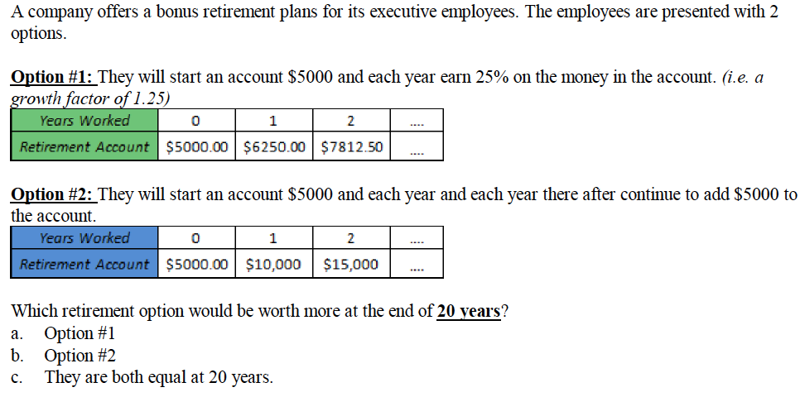
Two different computer programmers are trying to hack in to a computer file that has been protected by an encryption key using a brute force method in which a computer begins trying all possible passwords. A company is going to higher the programmer that successfully retrieves the file first.

The first computer programmer, Bill, wrote a brute force program that will try 50 thousands passwords each minute.
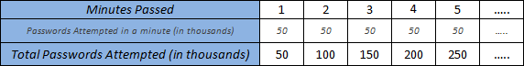

The second computer programmer, Marcy, wrote an adaptive program that leveraged the hardware more efficiently that will try 5 thousand passwords the first minute, 10 thousand the next minute, 20 thousand the next minute, and continue doubling the attempts each minute.

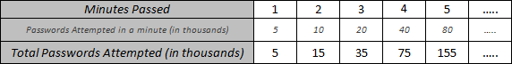

Which programmer will have tried the most passwords to break the code at the end of 5 minutes? How much difference is there between the two programmers?

Which programmer will have tried the most passwords to break the code at the end of 10 minutes? How much difference is there between the two programmers?

9-4 Sequence Review
For each sequence, state if it is arithmetic, geometric or neither. Then give the recursive definition, the explicit definition and the 8th term.

- $15.2, 17.9, 20.6, 23.3, 26, …$
- $-1, -5, -25, -125, -625,…$
- $-10.4, -8, -5.6, -3.2, -0.8, …$
- $1, 2, 4, 8, 16, …$
- $-1, 4, -16, 64, -256,…$
- $-2, 12, -72, 432, -2592, …$
- $-7, 2, 11, 20, 29, …$
- $-1, 3, -9, 27, -81, …$
- $-36, 64, 164, 264, 364, …$
- $1, 9, 25, 49, 81, …$

- Suppose on January 1st, you deposit $2.00 in an empty piggy bank. On January 8th, you deposit $3; on January 15th you deposit $4; and each week thereafter you deposit $1 more than the previous week. Use the scenario to answer the following questions:
  - What kind of sequence do these deposits generate?
  - Write the explicit formula for deposits as a sequence above.
  - What amount would you deposit in week 52?

- Suppose on January 1st, you deposit $0.01 in an empty piggy bank. On January 8th, you deposit $0.02; on January 15th you deposit $0.04; and each week thereafter you deposit double what you deposited the previous week. Use the scenario to answer the following questions:
  - What kind of sequence do these deposits generate?
  - Write the explicit formula for deposits as a sequence above.
  - What amount would you deposit in week 52?
- Suppose on January 1st, you deposit $2.50 in an empty piggy bank. On January 8th, you deposit $3.00; on January 15th you deposit $3.50; and each week thereafter you deposit $0.50 more than the previous week. Use the scenario to answer the following questions:
  - What kind of sequence do these deposits generate?
  - Write the explicit formula for deposits as a sequence above.
  - What amount would you deposit in week 52?

